
San Bernardino County
4-H Headlines
September 2006

COOPERATIVE EXTENTION/4-H OFFICE
777 E. Rialto Ave.
San Bernardino, Ca 92415
(909)387-2179 Fax: (909)387-3306 E-mail: caeggleston@ucdavis.edu

Mark Your Calendar
~September 9 So. Section Leaders Meeting.
~September 12 - County Council Meeting Existing members' enrollment is due.
~September 23 - Achievement Night.
~October 1-7 -National 4-H week.
~October 10 - New Leader Orientation
~October 14 -Youth Leadership day
~November 11 - Food Fiesta
Child Health & Safety Policy
Clarification
On July 1, 2006, one of the most significant changes in the California 4-H Youth Development Program is the implementation of the revised Youth Protection Policies (Section 815 of the 4-H Policy Handbook) requiring every 4-H event or activity to have two adults available at all times to supervise youth. What is important to remember is:
1. These adults should, whenever possible, stay within view of one another.
2. The best practice is that both of these adults are appointed 4-H volunteers. If the adults are appointed volunteers, this is the best practice no mater their age. An additional approach to implement this policy includes one appointed volunteer and one “outside” adult. The 4-H volunteer must be in charge

of the event or activity. The second adult must be over age twenty-one (21) and must never be left alone with the youth. This is not optimal, but it is an acceptable approach to implementing the “two adults at all times” policy.

West Nile Virus:
Your Horse and You

Be aware and be prepared. An unvaccinated horse died of West Nile Virus in Tulare County in July. Though we like simple technical answers, life is often complex. Just as we are being asked to educate people to do their outdoor chores in early morning and evenings to cope with heat, we are now being urged to advise people against being outdoors at dusk or at dawn. Two technical solutions to two different problems tend to cancel one another out. If you must go out during prime mosquito feeding hours (dusk and dawn) wear long sleeves and insect repellent.
All considered there have been relatively few incidents of West Nile this season. But this is no time to be complacent. There has reportedly been a rise in the number of dead birds testing positive for West Nile and the latest horse death only punctuates this issue. Drain the horse trough (water the garden with it) and refill it—twice a week—clean the muck off the sides and bottom too to

and pupae are washed out. Make sure you re-fill the trough and put the stopper in the drain. Horses don’t make tasty jerky when dried on the hoof. Be sure to always double and triple check the water source for animals in this triple digit weather. Keep an eye out for standing water under potted plants, old tires, in trash piles, and in garden drains, anywhere it might be. Plants need more water during the heat but water running off of lawns and landscapes in the gutter or puddles in the yard are signs of over-watering.
make sure all small wiggler mosquito larvae
and pupae are washed out. Make sure you re-fill the trough and put the stopper in the drain. Horses don’t make tasty jerky when dried on the hoof. Be sure to always double and triple check the water source for animals in this triple digit weather. Keep an eye out for standing water under potted plants, old tires, in trash piles, and in garden drains, anywhere it might be. Plants need more water during the heat but water running off of lawns and landscapes in the gutter or puddles in the yard are signs of over-watering.
A wealth of knowledge is available online at the California Department of Food and Agriculture (CDFA) website. Type “CDFA West Nile Virus” into a search engine and you will get there or use the URL“http://www.cdfa.ca.gov/ahfss/ah/wnv_info.htm”. The CDFA page has hotline numbers for various areas and purposes, information for veterinarians to submit blood samples for testing, places to call and report dead birds, and the latest statistics on horse disease and death.
West Nile Virus is spread by mosquitoes from birds to humans and to horses. The horse is considered a “dead end” recipient in the disease transmission cycle since mosquitoes don’t seem to be able to pick up the virus from infected horses to transmit to other animals or humans. In the wild, infected birds are the “reservoirs” and mosquitoes are the vectors spreading the disease from bird to bird and bird to humans and to horses. Dead birds are an indicator of disease prevalence in an area. Mosquito control is the key to controlling West Nile Virus. Be a good neighbor as well and don’t breed mosquitoes.
Vaccinations and follow –up boosters is the key to keeping a healthy horse. By all means keep yourself safe as well—be smart.
A wealth of knowledge is available online at the California Department of Food and Agriculture (CDFA) website. Type “CDFA West Nile Virus” into a search engine and you will get there or use the URL“http://www.cdfa.ca.gov/ahfss/ah/wnv_info.htm”. The CDFA page has hotline numbers for various areas and purposes, information for veterinarians to submit blood samples for testing, places to call and report dead birds, and the latest statistics on horse disease and death.
West Nile Virus is spread by mosquitoes from birds to humans and to horses. The horse is considered a “dead end” recipient in the disease transmission cycle since mosquitoes don’t seem to be able to pick up the virus from infected horses to transmit to other animals or humans. In the wild, infected birds are the “reservoirs” and mosquitoes are the vectors spreading the disease from bird to bird and bird to humans and to horses. Dead birds are an indicator of disease prevalence in an area. Mosquito control is the key to controlling West Nile Virus. Be a good neighbor as well and don’t breed mosquitoes.
Vaccinations and follow –up boosters is the key to keeping a healthy horse. By all means keep yourself safe as well—be smart.
County Projects
County Projects
There are some projects that used to be recognized at the State level that are no longer considered a project, but we still use them at our county level. For instance, Beginning 4-H – this project introduces new members in 4-H to different projects throughout the year so they can choose a project they would be interested in. Although there are no guidelines at the state level for this project anymore, we still consider it a project at the county level and members can receive credit in their record books at the county level only.
National 4-H Week
October 1 - 7. National 4-H Week is fast approaching. Now it the time to start planning what your club would like to do to celebrate National 4-H Week. Community services and educational exhibits are always great ways to get the 4-H name out in the public. If you need any assistance, please call the 4-H Office.

Congratulations!

Congratulations to
Stephanie Sornoso
a member of the
Bloomington Boosters
Club. She represented
us at the state fair and
won the wool “Lads
and Lassies”
competition.

Doesn't she look great!

There are some projects that used to be recognized at the State level that are no longer considered a project, but we still use them at our county level. For instance, Beginning 4-H – this project introduces new members in 4-H to different projects throughout the year so they can choose a project they would be interested in. Although there are no guidelines at the state level for this project anymore, we still consider it a project at the county level and members can receive credit in their record books at the county level only.
National 4-H Week
October 1 - 7. National 4-H Week is fast approaching. Now it the time to start planning what you club would like to do to celebrate National 4-H Week. Community services and educational exhibits are always great ways to get the 4-H name out in the public. If you need any assistance, please call the 4-H Office.

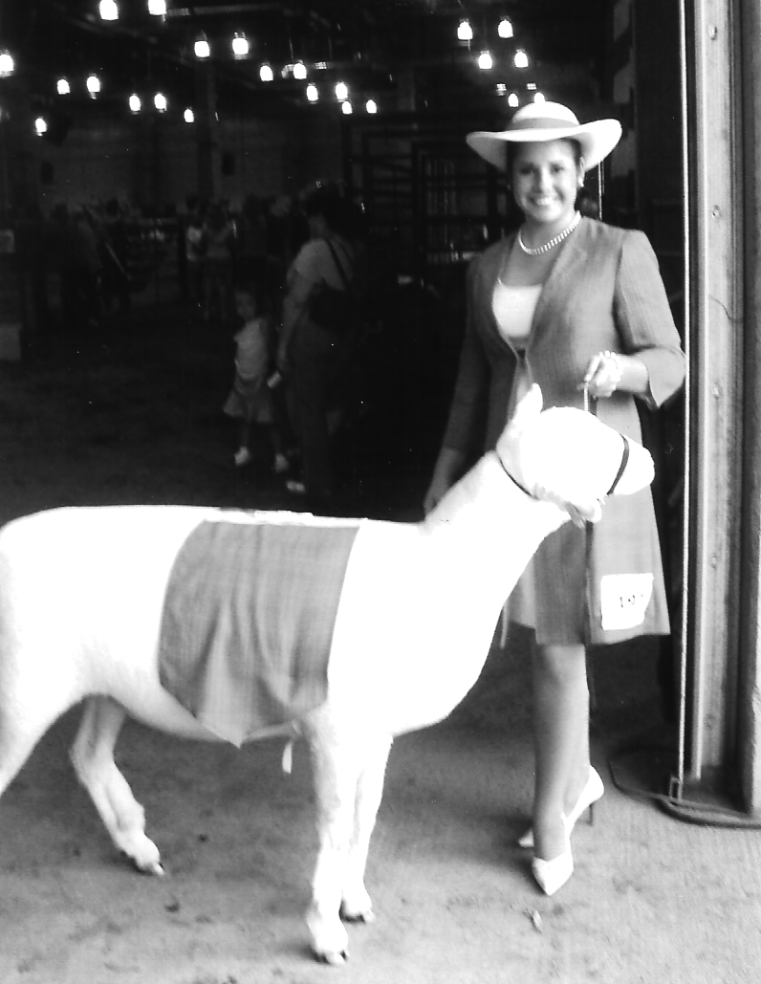
Congratulations!

Congratulations to
Stephanie Sornoso
a member of the
Bloomington Boosters
Club. She represented
us at the state fair and
won the wool “Lads
and Lassies” competition
at the State Fair. Doesn't
she look great!

Achievement Night
The Happy Days of 4-H
Achievement Night
The Happy Days of 4-H
Come join the fun and celebration of achievement night. Good food, friends, and meet our own COUNTY MASCOT.

Where: Bloomington Christian School
9904 Bloomington Avenue
Bloomington
When: Saturday, September 23, 2006
Dinner- 5:30 P.M.
Awards- 7:30 P.M.

Leadership Day 2006

Leadership day will be held on Saturday, October 14th at 9:00 a.m. at the county 4-H office. Any youth in grade 6th or above are welcome to attend. There will be workshops on the new junior/teen leader forms, how to complete your leadership records, officer training, developing leadership beyond the club level and much more. This is a great way to meet new friends, learn skills to take back to your club and participate in the county teen council meeting.
This year, we are collecting canned goods to be sent to the Ronald Mc Donald House in Loma Linda. This will count as part of your citizenship, community service project, so bring your donation to the meeting.
We will be electing new teen council officers and yes, we will be voting on the design for our TIC sweatshirt. Bring your ideas and designs. All teens are welcome to come.

Memory Book

We have had our first organizational meeting to produce our 2006-2007 4-H MEMORY


Come join the fun and celebration of achievement night. Good food, friends, and meet our own COUNTY MASCOT.

Where: Bloomington Christian School
9904 Bloomington Avenue
Bloomington
When: Saturday, September 23, 2006
Dinner- 5:30 P.M.
Awards- 7:30 P.M.

Leadership Day 2006

Leadership day will be held on Saturday, October 14th at 9:00 a.m. at the county 4-H office. There will be workshops on the new junior teen leader forms, how to complete your leadership records, officer training, developing leadership beyond the club level and much more. This is a great way to meet new friends, learn skills to take back to your club and participate in the county teen council meeting.
This year, we are collecting canned goods to be sent to the Ronald Mc Donald House in Loma Linda. This will count as part of your citizenship, community service project, so bring your donation to the meeting.
We will be electing new teen council officers and yes, we will be voting on the design for our TIC sweatshirt. Bring your ideas and designs. All teens are welcome to come.

Memory Book

We have had our first organizational meeting to produce our 2006-2007 4-H MEMORY BOOK. Each club has been allotted one page, if you need more space you can buy an additional page for $100.00. (Contact the 4-H office) The club page should have a photograph and the balance of the page is yours to use. Contact the 4-H office if you would like a youth representative from the committee to help you. The deadline for submitting photographs and club layouts is December 1st, so everyone needs to be working on this endeavor. Again, if you need assistance, please call, we are more than willing to help, come take photos or what ever you need.
BOOK. Each club has been allotted one page, if you need more space you can buy an additional page for $100.00. (Contact the 4-H office) The club page should have a photograph and the balance of the page is yours to use. Contact the 4-H office if you would like a youth representative from the committee to help you. The deadline for submitting photographs and club layouts is December 1st, so everyone needs to be working on this endeavor. Again, if you need assistance, please call, we are more than willing to help, come take photos or what ever you need.

2007 California
Focus Group

Are you interested in learning about California and how it is run? Then Cal. Focus is the program for you. California Focus is a unique 4-H Citizenship educational experience that combines hands-on participation in workshops, debates, and simulations with outstanding speakers and visits to historical, cultural, and governmental sites. California's capital city, Sacramento, becomes a "living classroom" for this five-day, action packed adventure.
We are currently forming a group of teens that will represent our county this year. You must have completed the 8th grade by the time of the event in June 2007. The delegates will extend their learning as they prepare and present a "Plan of Action" to implement back home in their respective communities. Outstanding plans are showcased at the conference and an award is given each year for the one that is judged the most effective. California Focus can be the beginning of a life of public participation that leaves you with a strong determination to become involved with the political process.



2007 California
Focus Group

Are you interested in learning about California and how it is run? Then Cal. Focus is the program for you. California Focus is a unique 4-H Citizenship educational experience that combines hands-on participation in workshops, debates, and simulations with outstanding speakers and visits to historical, cultural, and governmental sites. California's capital city, Sacramento, becomes a "living classroom" for this five-day, action packed adventure.
We are currently forming a group of teens that will represent our county this year. You must have completed the 8th grade by the time of the event in June 2007. The delegates will extend their learning as they prepare and present a "Plan of Action" to implement back home in their respective communities. Outstanding plans are showcased at the conference and an award is given each year for the one that is judged

the political process.
A non-refundable deposit is due January 31, 2007. The group will be doing fundraisers to help with the cost of the event. You can get more information of Cal. Focus you can go to ca4h.org/citizenship/
A $100.00 non-refundable deposit is due January 31, 2007. The group will be doing fundraisers to help with the cost of the event. You can get more information of Cal. Focus you can go to ca4h.org/citizenship/
focus/index.asp. If you would like more information and when the next meeting will be held please contact Michele Grainger at (909) 795-8663.

CALIFORNIA STATE 4-H LEADERS’ FORUM
NOVEMBER 17-19, 2006

What 4-H University, Leadership 101 has to offer you. You asked for it usable materials that you can put to use in your clubs. Now we are offering it to you from expert volunteers. In addition, all attendees will take home an abundance of materials that they can put right to use in their clubs.
Sessions being offered include but not limited to those listed as follows:

--Now that I volunteered to be a leader, what do I do? -
--Judging events for learning and fun –
--Dig In! – Youth gardening project
--CPR certification
--4-H Food Safety with certification
--Photography for every project – could lead to publicizing your club.
--4-H Plant Science – A preponderance of Potential Activities with a Dash of Panache
--Breaking the Code of Experiential Learning Using Effective Questioning
--Tools of the Trade – Officer training
--Embracing Cultural Diversity through the Arts

--Make your own “Mug Rug”
--Beginning/Mini 4-H age appropriate projects
--Beginning Cake Decorating
--Impromptu and Extemporaneous speeches in every project
--Citizenship: In Every Project
Back to Basics—Focusing on the Mission 4-H International Exchange
--Project books: Beginning Record Keeping
Advance Record Keeping – transition from old to new
--E-Forms (filling-out existing 4-H forms)
--4-H Presentations using Microsoft Power Point
--Backyard Wildlife Gardens and Beyond with CAL WHEP
--4-H Statewide: Member Opportunities
: Incentives and Recognition Opportunities
: County 4-H Tech Teams
: GPS and Geocaching

If you have any questions you can contact Bernardine Marquez – 909-721-4806
bmarquez5@cox.net

focus/index.asp. If you would like more information and when the next meeting will be held please contact Michele Grainger at (909) 795-8663.

CALIFORNIA STATE 4-H LEADERS’ FORUM
NOVEMBER 17-19, 2006

What 4-H University, Leadership 101 has to offer you. You asked for it usable materials that you can put to use in your clubs. Now we are offering it to you from expert volunteers. In addition, all attendees will take home an abundance of materials that they can put right to use in their clubs.
Sessions being offered include but not limited to those listed as follows:

--Now that I volunteered to be a leader, what do I do? -
--Judging events for learning and fun –
--Dig In! – Youth gardening project
--CPR certification
--4-H Food Safety with certification
--Photography for every project – could lead to publicizing your club.
--4-H Plant Science – A preponderance of Potential Activities with a Dash of Panache
--Breaking the Code of Experiential Learning Using Effective Questioning
--Tools of the Trade – Officer training
--Embracing Cultural Diversity through the Arts
--Make your own “Mug Rug”
--Beginning/Mini 4-H age appropriate projects
--Beginning Cake Decorating
--Impromptu and Extemporaneous speeches in every project
--Citizenship: In Every Project
Back to Basics—Focusing on the Mission 4-H International Exchange
--Project books: Beginning Record Keeping
Advance Record Keeping – transition from old to new
--E-Forms (filling-out existing 4-H forms)
--4-H Presentations using Microsoft Power Point
--Backyard Wildlife Gardens and Beyond with CAL WHEP
--4-H Statewide: Member Opportunities
: Incentives and Recognition Opportunities
: County 4-H Tech Teams
: GPS and Geocaching

If you have any questions you can contact Bernardine Marquez – 909-721-4806
bmarquez5@cox.net

