ep
UCCE/4-H Office
777 E. Rialto Ave.
San Bernardino, CA 92415

San Bernardino County
4-H Headlines
September 2008



Leader Recognition and Achievement Night

Everyone get ready for our special end of the year award ceremony and recognition night. This year’s theme is Mardi Gras and this will be a fun night. The date is Sat. Sept. 20th. Dinner will begin at 5:30 pm with the program actually taking place at 7:00. It will be held at the Church of Jesus Christ of Latter-Day Saints 1375 N. Willow in Rialto. If you need directions, please call the 4-H Office.

September County Council Date Changed

Due to a schedule conflict with the State 4-H Office, we will need to move the September County Council night from Sep. 9th to Sep. 16th. Please let everyone involved know about this change.




COOPERATIVE EXTENTION/4-H OFFICE
777 E. Rialto Ave. • San Bernardino, Ca 92415
(909)387-2179 • Fax: (909)387-3306
E-mail: caeggleston@ucdavis.edu
County Website: sbc4h.org

See Calendar inside for upcoming events!

Sheriff’s Rodeo – Sep. 27th

In conjunction with the Sheriff’s Rodeo on Sat. Sep. 27th the 4-H members have the opportunity to showcase projects that they are involved with. We have a large grassy area where we can set up demonstrations or exhibits on our 4-H member’s projects. Also this year we have the opportunity to camp out overnight. So bring your tents, food, and whatever you need if you would like to take advantage of this fun event. Please contact Cheryl if you would like to take part in the exhibits or camp.
Remember, this is a great opportunity for community service for your record books. There will be many Boy Scouts and Girl Scouts around to learn about 4-H.

Food Safety Trained Leaders

A big thank-you for those of you who attended the “Train the Trainer Food Safety Class” . We now have leaders on the desert and in the valley who can train clubs that were not represented on food safety. Remember it is the University’s policy that you must be trained in food safety in order to have any food at any 4-H function, including Community meetings. If you would like to set an appointment with one of these trainers, please call the 4-H Office. Remember, that we need the certified leaders to do this training, although we had youth who attended this training and learned valuable information, only certified leaders may train other leaders.


Ventura Fairgrounds Seaside Park
10 West Harbor Boulevard

Entries due Thursday, October 30th

Find Flyer & Premium Books at http://ceventura.ucdavis.edu/

For more information contact Show Superintendent:
Susan Trockey 805-480-9976 or stdesign@roadrunner.com

Mojave Desert

The Mojave Desert 4-H Club is located in Lucerne Valley in the High Desert. The Community Leader is Ginger Miller and they have 5 adults and 18 youth. Their major projects are: Beef, Dairy goat, dog care and training, foods & nutrition, horses, meat goat, poultry, sheep, and swine.

WASHINGTON FOCUS MEETING

Anyone who is interested in attending the Washington Focus trip next year can come to this meeting and find out what it is all about. Washing Focus has a few different trips to choose from and they take place the end of June or beginning of July next year. This meeting will be held at the 4-H Office at 6:00 Tuesday, Sep. 16th.


Grand Terrace 4-H Club
The Grand Terrace 4-H Club Quilting Committee is working hard on a blue and red Mickey Mouse quilt with denim squares. Last year, the Quilting Committee completed a lavender quilt with flowery patches. It won “Best of Show” at the San Bernardino County Fair and it won 2nd place at the State Fair in Sacramento. GOOD JOB QUILTERS!!! We are going to donate the quilts to the Ronald McDonald House. Our club plans on doing other community service projects this year.
At our most recent business meeting, we had elections. Our new President is Stephanie Lehto. Our Vice President is Daniel Pryde. Our new Treasurer is Kayla Pjerrou. Our Communications Manager is Autumn Jacobo. Our Secretary is Lisa Barger. With this great line up of leaders, we will definetly have a fantastic year!

Submitted by: Autumn Jacobo
Communications Manger, Grand Terrace 4-H

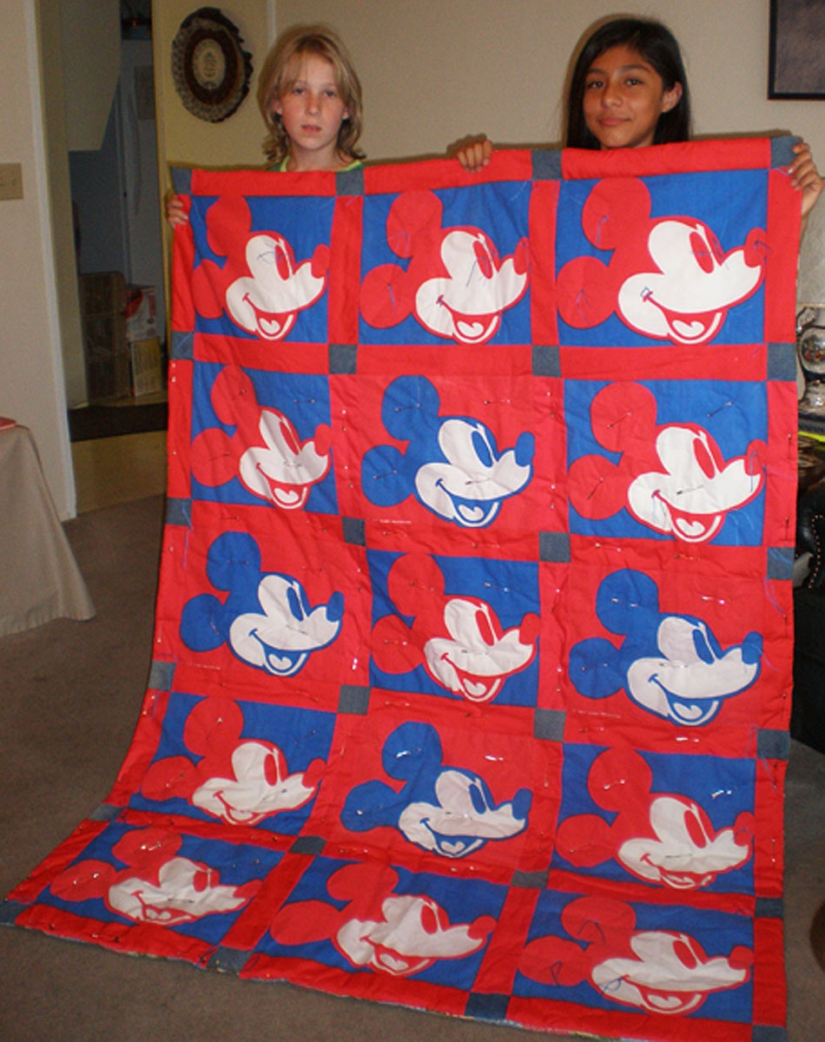

Kid Fest
2008

The Apple Valley Rattlers attended the annual kids fest held on August 23 at the parks and Recreations Epicenter on Hercules Drive in Hesperia. This is a wonderful program that encourages local kids to participate in different levels of youth activities offered in the community.
Besides the Apple Valley Rattlers attending, also in attendance were the Girls Scouts, Boys Scouts, and the Wagon Wheel Day horse Camp.
We were able to help some kids make crafts and talk about what 4-H was about. We had a few families fill out forms for us to get back to them with more details.
If any of you ever have the chance to participate in an activity of this caliber, I would highly suggest it. It is very rewarding to see the smiles on the little kids faces when you pay attention to them.

Submitted by:
Andrew Viloria

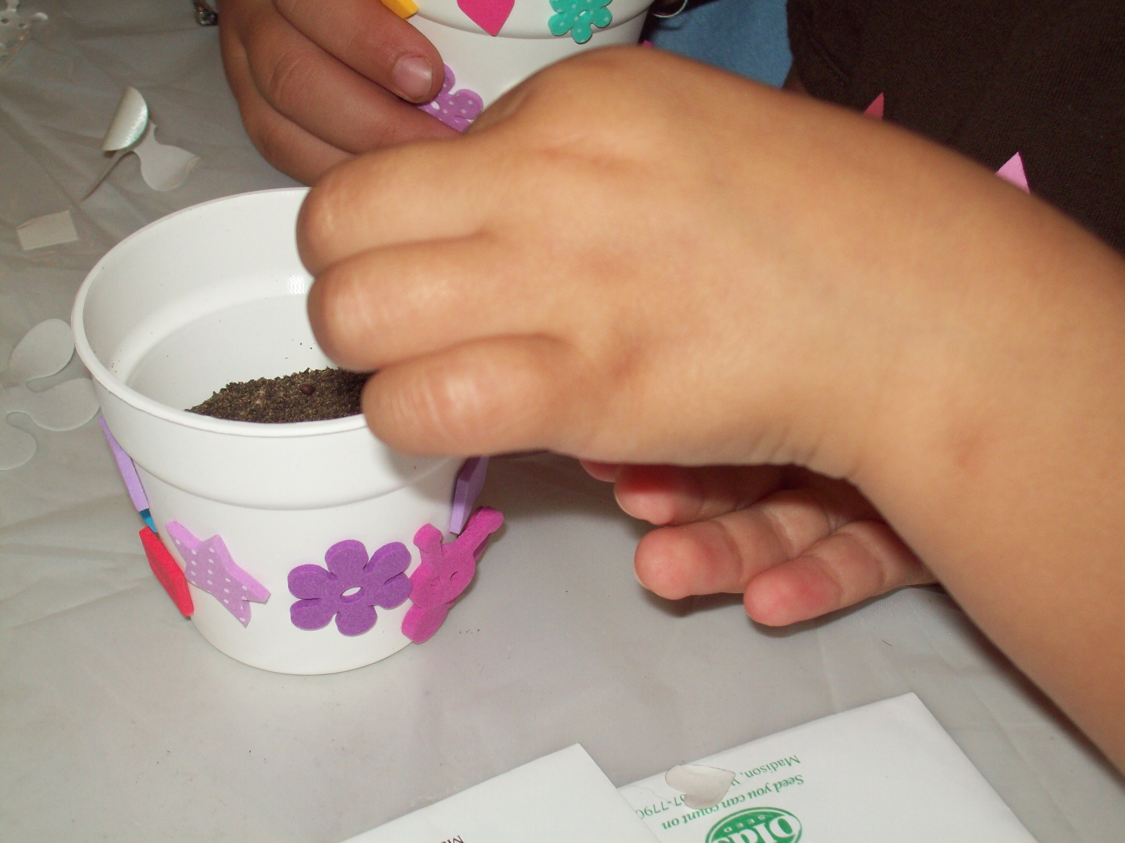

Congratulations!!

A big congratulations to Danielle Johnson who won a Golden Bear at our State Fair in Sacramento. Danielle won Junior Master Showmanship and received a $500 College Scholarship along with the Golden Bear Trophy.

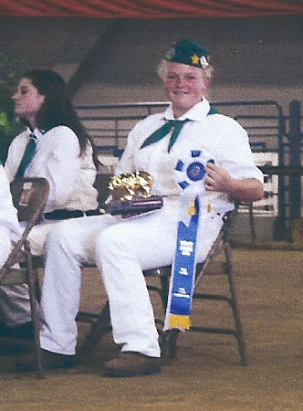

4-H Shooting Sports Workshop
Rifle Discipline
Corona, CA
Saturday, October 11, 2008 – 8:00 a.m. – 5:30 p.m.
Sunday, October 12, 2008 – 8:00 a.m. – 4:30 p.m.

A 4-H shooting sports workshop for the rifle discipline will be held at Raahauge Shooting Enterprises, 14995 River Road in Corona. Participants must attend both days of training to receive certification. Upon successful completion of the course, the participant will be certified as rifle trainer and can lead a rifle project at the club level or serve as county trainer to certify other leaders. There is no cost for the course. Continental breakfast and lunches will be provided both days courtesy of the Monte Vista Diamonds 4-H Club. To register for the course contact John Borba at: jaborba@ucdavis.edu

For information about he facility and directions, please visit the range website at:
http://www.raahauges.com

September 2008
Sun | Mon | Tue | Wed | Thu | Fri | Sat
 | 1 | 2 | 3 | 4 | 5 | 6
7 | 8 | 9 | 10 | 11 | 12 | 13
14 | 15 | 16 County Council 7:00  Horse 6:00  WA Focus 6:00 | 17 | 18 | 19 | 20 Achievement Night
21 | 22 | 23 | 24 | 25 | 26 | 27  Sherriff’s Rodeo
28 | 29 | 30

October 2008
Sun | Mon | Tue | Wed | Thu | Fri |  | Sat
 |  |  | 1 | 2 |  | 3 | 4
5 | 6 | 7 | 8 | 9 | 10 |  | 11 Shooting Sports – Rifle Training
12 Shooting Sports – Rifle Training | 13 | 14Task Force – 6:00 pm | 15 | 16 | 17 |  | 18
19 | 20 | 21 | 22 | 23 | 24 |  | 25
26 | 27 | 28 | 29 | 30 | 31

