San Bernardino County
4-H Headlines
November 2004 ♥ Vol. 8 ♥ No. 11

Cooperative Extension/4-H Office
777 E. Rialto Ave., San Bernardino, CA 92415
Phone: (909) 387-2179 Fax: (909) 387-3306
E-Mail: caeggleston@ucdavis.edu
Web: http://cesanbernardino.ucdavis.edu/ and http://clubs.ca4h.org/sanbernardino/
State 4-H Web: http://www.ca4h.org/

Upcoming Events
November 5-7, 2004 State Leaders’ Forum
CANCELED County Horse Bowl Competition
November 9, 2004 Junior and Teen Leader Plans due to the County
4-H Office
November 9, 2004 Club Goals due to the County 4-H Office
November 9, 2004 Cal Focus Meeting, 6:00 pm at the County 4-H Office
November 9, 2004 Horse Advisory Meeting, 6:00 pm at the County 4-H Office
November 9, 2004 County Council Meeting, 7:00 pm
November 13, 2004 Food Fiesta change in date
November 19, 2004 Summer Camp Staff Applications due to LA County 4-H Office
December 4, 2004 Toys for Tots Horse Show
December 11, 2004 Summer Camp Staff Interviews at 9:00 am at the LA County 4-H Office
December 31, 2004 Member Enrollment Closes

Record Book Tips
October:
Achievement Night and Leader Recognition: Medalist - O; Attended - U; County Winner - V; Emerald Star, Leadership Development Award, Sectional and or State placings, Outstanding Member, Citizenship Focus program participant - W; Outstanding Club or Club Seal - X
Leadership Day: Attended - U; Made backpack and wrote letter for child of Soldier - Y
County Teen Council Meeting: Attended - U (may only count once for the year no matter how many you attend)

Introducing…
The Junior All-Stars, Kayla Pauwels of the Bloomington Boosters 4-H Club and Sarah Roethlisberger of the Hesperia Highlighters 4-H Club. These two young ladies were selected on June 5, 2004 and have been serving our county well ever since. Congratulations, and welcome to the team!
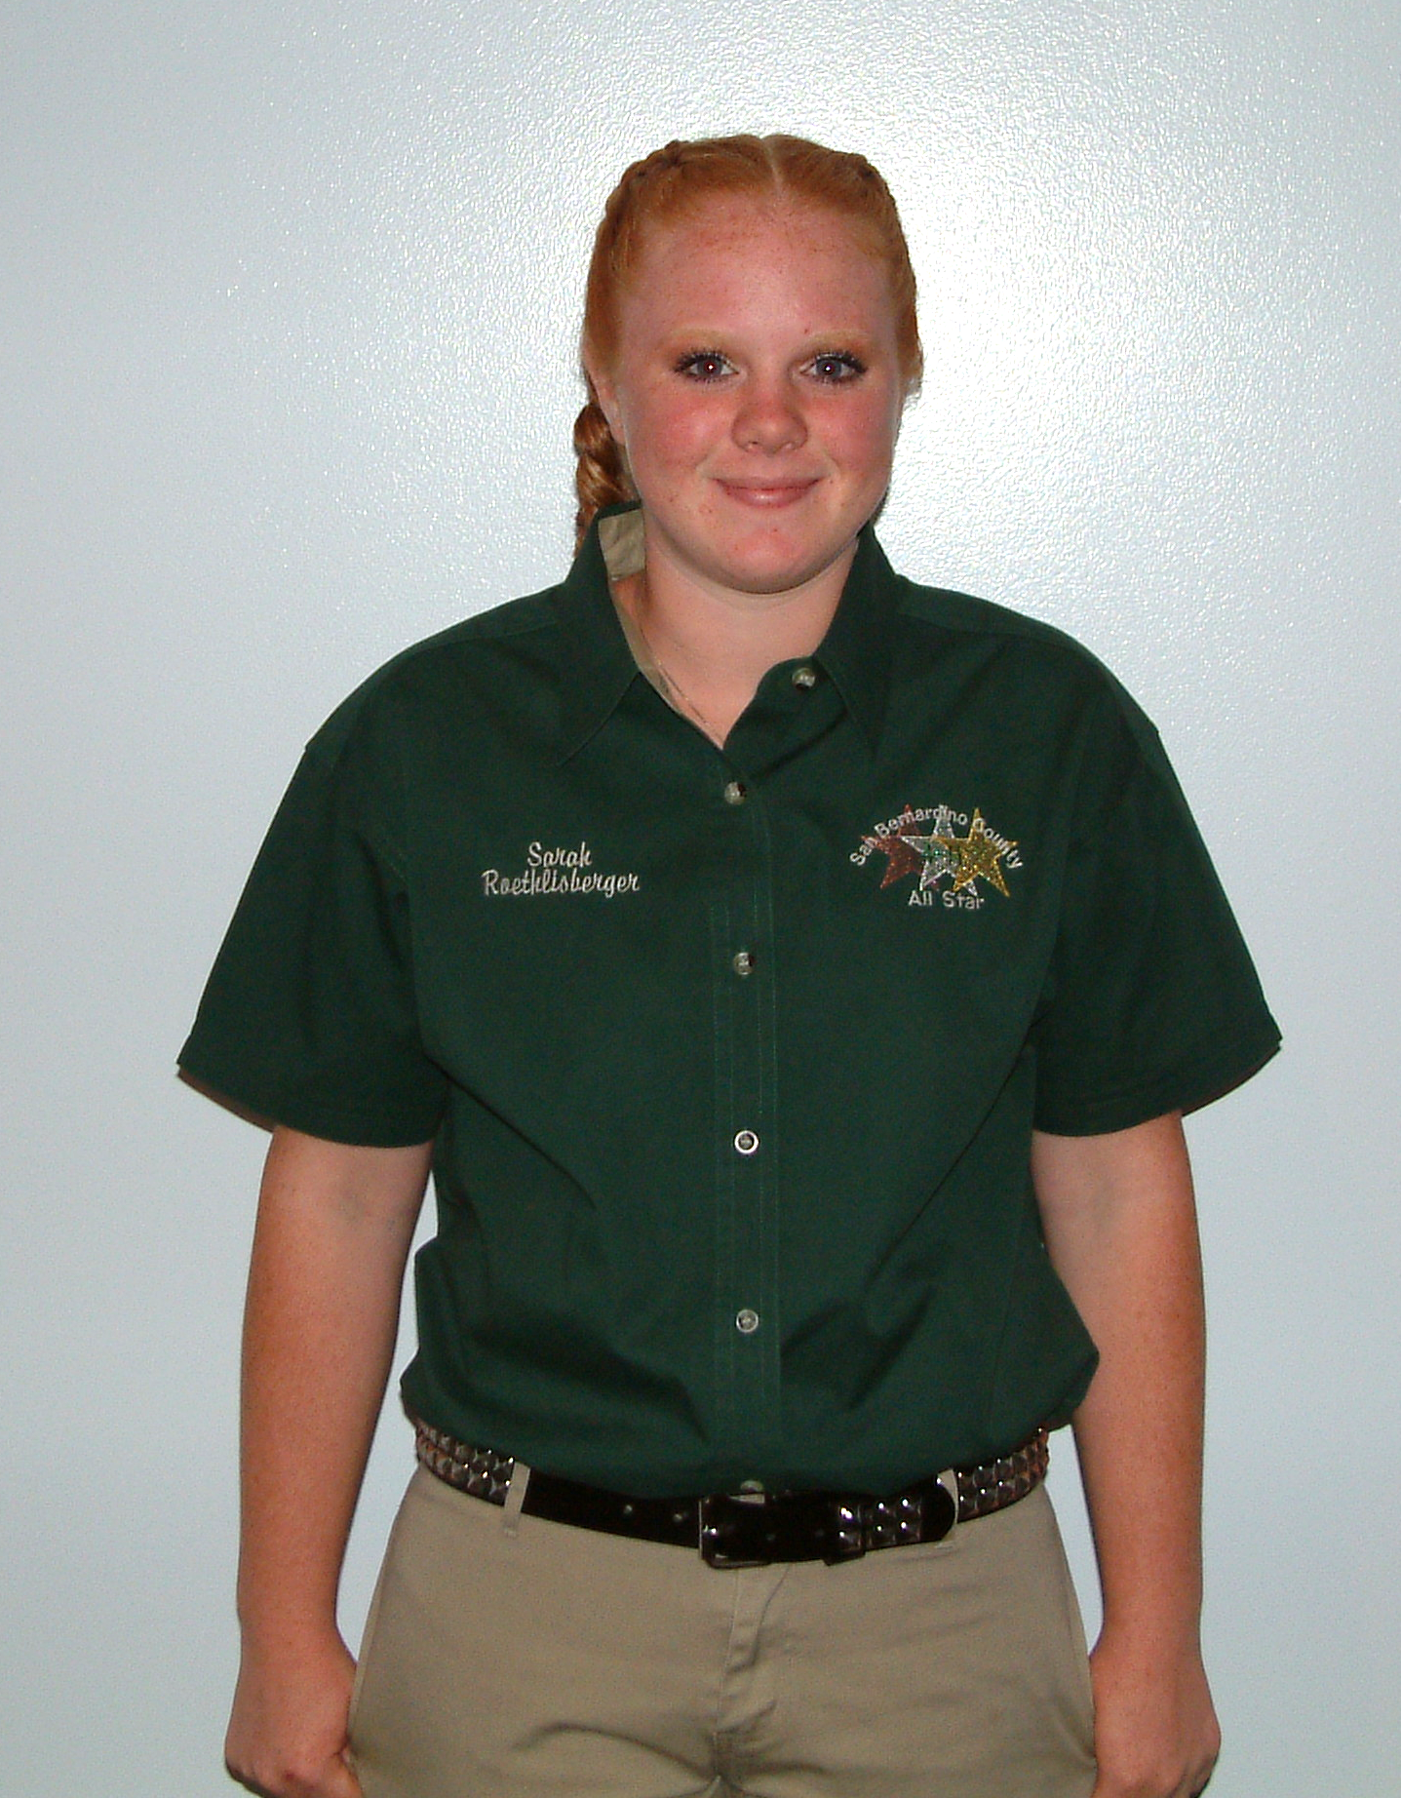
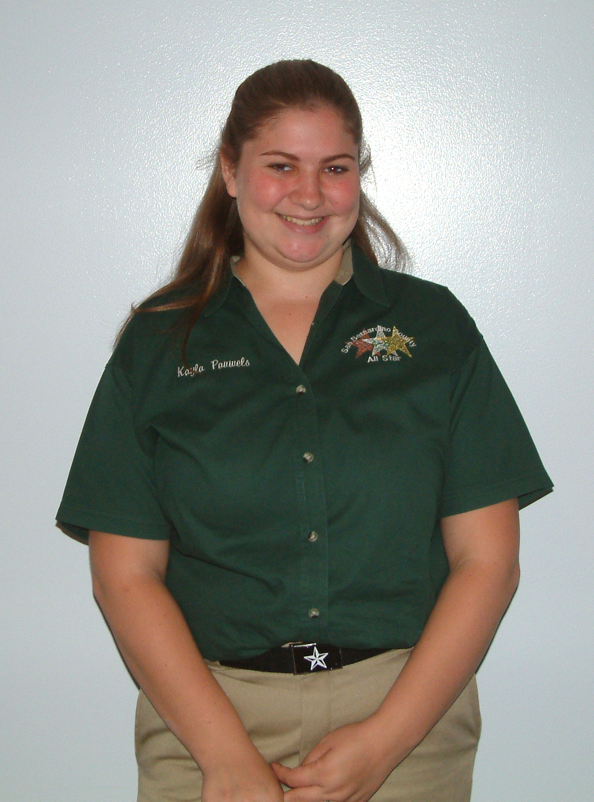
Kayla Pauwels Sarah Roethlisberger

San Bernardino County 4-H Website

Visit and bookmark the new San Bernardino County 4-H Website at http://clubs.ca4h.org/sanbernardino/ this website is maintained by John Trammell. You can find 4-H forms, information, the county calendar, and much, much more. The website is being updated often. Be sure to check it out!

Legacy Forms
Legacy Forms are now available on the County 4-H Website. You can download them and fill them out right on your computer or print them out and fill them out the old fashioned way, with a pen. Either way, you can download them and fill them out, then send them in to the County 4-H Office and the Legacy Committee will meet when we have several forms to be considered.

Project Leader Meeting Report Forms
Project Meeting Report Forms are now available on the County 4-H Website. These forms are for Project Leader use and should be filled out for each meeting, it is now easier, as you can do so on your computer and print them out. The directions have also been posted in case you have any questions.

All-Star Report
The 2004-2005 All-Stars have started their year off with their Achievement Night “Afterglow” presentation which was a tremendous success. They also attended the 2004 State Leadership Conference and All-Star Luncheon held at the Mission Inn in Riverside. Leadership Day was held at the Sheriff’s Headquarters with approximately 30 youth attending. The workshops were very informative and well received by all the attendees. As part of our day, the group assembled 50 backpacks with donated items for the kids who have parents serving in Iraq. We would like to thank Sgt. David Cadill for making the arrangements for the facilities, the Bloomington Boosters for their donation to provide lunch, and Michael Grainger for donating the morning donuts. We have prepared presentations on Cal Focus and Washington Focus that we can present at your club meetings, as well as the “Afterglow” if you missed the Achievement Night presentation. There is only one hitch, you must invite us to your meeting. We have our new All-Star shirts and we are ready to attend meetings and hope you will include us on your meeting agenda.

2004-2005 All-Stars

Teen Council News
We held our meeting at Leadership Day, presenting information on TIC and making plans for our Holiday Party. The group agreed to have a Broom Hockey event between Thanksgiving and Christmas. We are working on the final arrangements, make sure that you are on the Teen Council e-mail list, by contacting Cody Johnson at the 4-H office, so that you get all the information when it is complete.
Each year, our county will have a “county sweatshirt” so that all the other counties can easily recognize SAN BERNARDINO. This year’s winning design was submitted by Cody Johnson, and the majority vote was for brown sweatshirts with cream writing. The price of the shirts will remain the same as last year:

Hooded pullover S-XL $25.00
Hooded pullover XXL $30.00
Hooded zip front S-XL $30.00
Hooded zip front XXL $35.00

Last year we made a profit of $250.00 on the sales, and we didn’t have to have a fundraiser. Please place your sweatshirt orders by club and submit to the 4-H office by December 17th. TIC applications are available online or contact the 4-H office. Our next meeting will be in January to distribute the sweatshirts and review the code of conduct and dress code for TIC.

Russell Champlin, Teen Council President

Ways to Give
You can support 4-H while you shop! Thanks to the Albertson’s Community Partner program, all you have to do is link your Albertson’s Preferred Savings Card to a local 4-H club and/or to The California 4-H Foundation for statewide 4-H support. Register online by going to www.albertsons.com/abs_inthecommunity and follow the Community Partners link at the bottom of the page. Log in using your zip code, then enter your Albertson’s Preferred Savings Card number and phone number. Click on “Find a Partner” from the menu. Enter 4-H as the name and enter which city and state to search for. Then select your local 4-H club and/or The California 4-H Foundation to support. You will need to renew this link once a year in order to continue supporting 4-H.

Go nuts for 4-H! The California 4-H Youth Development Office has developed a partnership with OC Roasters Gourmet Roasted Nuts. Simply entering our Partner Code (4HYDP) into the "Special Instructions" box when confirming your order on-line and a portion of the sales will be donated to 4-H. Visit their web site and go nuts for 4-H! www.ocroasters.com/partners.shtml

Donate on-line through Network for Good. Go to www.networkforgood.org, enter the key word 4-H and select California in the Quick Search to find The California 4-H Foundation listed as 4-H Clubs & Affiliated 4-H Organizations. Click on that link to make your donation today!

Going…going…gone! Do you have anything that you are thinking about selling? Register as a seller on E-Bay and participate in E-Bay’s Giving Works program, which offers sellers the option of donating a percentage of the earnings from an item to support a favorite charity – we hope you will choose The California 4-H Foundation! www.ebay.com

California 4-H Hosts Labo Students From Japan
For one month this summer, your family can take part in a special 4-H exchange which gives Japanese students the opportunity to visit the U.S. and learn more about American life. The California 4-H Youth Development Program is currently looking for families that would like to host a Japanese student, ages 12 to 16, from July 23 to August 21. The Japanese teens are matched with a family that shares similar interests and has a child of the same gender and close in age. Two Japanese chaperones accompany the delegation and each chaperone lives with two different families for two weeks each. Host families of chaperones do not need to have children in the household.

You don’t need a fancy home or a separate bedroom to host —just a desire to make room in your lives for a new family member. And you don’t need to spend a lot of money or time traveling the U.S. — the students are not here as tourists. They are here to live with your family and participate in your normal summer activities. The costs are minimal and the Japanese youth come with their own spending money and medical insurance.

Please consider offering this priceless educational experience to your family. Teens that participate in exchange opportunities are better prepared for life in a global society. Through this first-hand experience they gain a deeper understanding of another culture and gain insight into the values and lifestyle of their own family and community.

If you’re interested in getting involved or would like more information, contact Pat English at (530) 754-8520 or pnenglish@ucdavis.edu.

Pat English, Program Representative

Fundraising
"Share Your Story": As a follow-up to a County Fundraising Kit sent to county offices in September, The California 4-H Foundation is launching a web-based "Share Your Story" system that will allow youth, volunteers, and staff to share their fundraising success stories and learn about what is working for others. The "Share Your Story" system will be available for preview at the 4-H State Leaders' Forum in Asilomar on November 5-7, 2004. The system will be launched at http://ca4h.org/foundation/fundraising/. There is now a Fundraising Kit in the County 4-H Library available for check out.

National 4-H Salute to Excellence Award
The National 4-H Council is seeking nominations for the National 4-H Salute to Excellence Awards for 4-H Volunteers. The California State 4-H Office will nominate one volunteer for each category: Volunteer of the Year and Lifetime Achievement. (No monetary reward is associated.) The deadline to submit an application to the State 4-H Office is November 30, 2004. More information is available at http://ca4h.org/4hresource/ir/

2005-2006 State Ambassador Applications
2005-2006 4-H State Ambassador Applications are now available on-line. Ambassadors are selected to plan the State Leadership Conference, complete a service project, and represent the California 4-H Youth Development Program. Applications are due March 31, 2005. More information is available at http://ca4h.org/leadership/ambassador/

4-H Programs of Distinction
National 4-H Headquarters is seeking 4-H Programs of Distinction that reflect the high quality of 4-H Youth Development Programs. Programs that demonstrate contributions to youth development, innovative methods and changes in knowledge, behaviors and aspirations of 4-H youth and adults should be submitted. Submissions are accepted on an on-going basis. More information may be obtained at http://ca4h.org/4hresource/updates/attach/ProgramsofDistinction.doc

4-H Cooperative Curriculum System
The 4-H Cooperative Curriculum System (CCS) is looking for 4-H clubs to pilot many new curricula! Curricula being piloted include Dog Care and Training (Kerrs@wsu.edu), Communications (jamisonk@vt.edu) and Cat (mgregg@aces.edu) for youth, grades 3 – 12. For more information, please visit http://www.n4hccs.org/new2004.shtml or contact the County 4-H Office.

Summer Camp Staff
Believe it or not it is time to start planning and preparing for Summer Camp 2005 and we need your help! If you are interested in serving on the Summer Camp staff in 2005 now is the time to act, the applications are available at www.4hsummercamp.com and due to the L.A. County 4-H Office by November 19, 2004. The Interviews will take place on December 11, 2004 at 9:00 am. Mark your calendars and get those applications filled out and sent in. You may be asking yourself “How old do I have to be?”, if you are 14 by January 1, 2005 you are old enough and we would love for you to apply. If you have any questions or would like more information you can contact me at home at (760) 949-2276 teenangel86@earthlink.net or at work at (909) 387-2171 ctjohnson@ucdavis.edu, I hope to hear from you soon!
Cody Johnson, 2005 Head Youth Director

Toys for Tots Horse Show
The Toys for Tots Horse Show will be held on December 4, 2004 at McCoy’s Equestrian Center in Chino Hills. The proceeds from the show go to benefit the Nicole Peacock Scholarship Fund. We need Hi-Point awards donated, there are a total of 13 Hi-Point awards needed. Any club or individual interested in providing awards, or for more information please contact Cheryl Eggleston at (909) 387-2719.

4-H Shooting Sports Workshop
Location: Modesto, CA
Dates: Saturday, December 11 & Sunday, December 12, 2004
(Participants must attend both days to complete the course.)
Times: 8:00 a.m. - 5:00 p.m. each day
Disciplines offered: Black Powder & Rifle (Participants may only take one
discipline.)
Upon successful completion of either course, the participant will be certified to be a shooting sports leader and trainer for her/his county/region. For more information contact:
John Borba at (661) 868-6216 jaborba@ucdavis.edu or
Jim Atherstone at (209) 993-7971 jpatherstone@ucdavis.edu.
John Borba, 4-H Youth Development Advisor
UCCE Kern County

TIC 2005
The Teen Involvement Conference (TIC) this year is going to take place on January 21-23, 2005. This year’s theme is “Reaching for the Stars”. The forms for TIC can be found on the County 4-H Website, http://clubs.ca4h.org/sanbernardino/, under Teen Council or at the State 4-H Website, http://ca4h.org, under sectional conferences in the conference section to the left of the screen. Remember, TIC is first come first served so sign up today. For more information contact John Trammell at johnsphotography@msn.com.

John Trammell, TIC Planning Committee

Workshop proposals are being sought for the South Section "Teen Involvement Conference" scheduled for January 21 - 23, 2005 at Pathfinder Ranch. The conference is designed for high-school aged 4-H members learning citizenship, leadership, and life skills. Proposal forms may be obtained at http://ca4h.org/conference/secconf/ or contact the County 4-H Office

2005 4-H Horse Leadership Conference
The 2005 4-H Horse Leadership Conference is scheduled for February 12 and 13, 2005 to be held at California State University, Fresno in the Livestock Pavilion. Registration information will be available November 1, 2004. For more information please visit http://www.cal4hhorse.com/ or contact Jazz Stables at 530-754-5809 or jstables@ucdavis.edu

Citizenship Focus 2005
California Focus 2005 dates are set for June 17 – 21, 2005. Focus will return to the Holiday Inn Capitol Plaza in downtown Sacramento. If you are interested in California Focus contact Rozie Trammell at (909) 864-2653. The group will be meeting on November 9, 2004 at 6:00 pm at the County 4-H Office. Washington Focus 2005 dates are tentatively set for "Road to Democracy" - June 18 – 27; "Global Journey" - July 9 – 20; and "Heritage Trail I & II" - June 18 – 25 and July 9 – 16. Washington Focus dates will be confirmed in October. If you are interested in Washington Focus contact Kamie Champlin at (909) 877-0692, they will be starting fundraising for the trip.

Citizenship Focus 2005
Are you interested in becoming the California Secretary of State or the U.S. Secretary of Agriculture? Or would you just like to be an active, involved member in your community? Are you interested in expanding your citizenship savvy? Come and learn more about California and see inside Washington, D.C. Information about the California Citizenship Focus Program will be arriving in county offices the week of October 11. Check it out.

At California Focus, you become a registered voter in the state of Sierra Cascade and take on all the rights, privileges, and responsibilities of citizenship. Washington Focus allows you to travel and study in the nation’s Capitol, Washington, D.C. You learn how government works and enjoy the traditions and history of the Capitol. A visit with your elected officials is the highlight of both programs.

Come get involved in this hands-on experience with government and community involvement. Applications, with a non-refundable deposit, are due in the California 4-H Youth Development Office on January 10, 2005 for Washington Focus and on January 31, 2005 for California Focus. Financial assistance and scholarship opportunities will be available.

California Focus June 17 - 21
4-H members must have completed the 8th grade.

Washington Focus #1
- “Road to Democracy” 10 day trip in mid to late June
Take advantage of this study travel trip to Gettysburg, Washington, D.C., Philadelphia, and New York.
- “Heritage Trail 1” 7 day trip in mid to late June
For those who wish to travel during this week but prefer to limit their travel to Gettysburg and Washington, D.C.

Washington Focus #2
- “Global Journey” 12 day trip second week of July
For those who wish to take advantage of this study travel trip to Gettysburg, Washington, D.C., Jamestown, Yorktown, and Williamsburg.
- “Heritage Trail 11” 7 day trip second week of July
For those who wish to travel during this week but prefer to limit their travel to Gettysburg and Washington, D.C.
(To travel on the Heritage Trail I or II trips, a 4-H leader from the county must accompany the delegation)

Washington Focus programs are open to all adult 4-H leaders and to all youth members who have completed their sophomore year in high school or will be 16 years of age by the time of travel.

Pat English, Program Representative
(530) 754-8520
pnenglish@ucdavis.edu

California 4-H Citizenship Focus Program
Come and develop your citizenship and leadership skills. Get involved with the 4-H Citizenship Focus Program. Participate in one of the five programs that are available to 4-H members and leaders across the state.

California Focus June 17 – 21, 2005 Adults $535.00 Teens $450.00
Washington Focus #1
Road to Democracy June 25 – July 4, 2005 $1,690.00
Heritage Trail I June 25 – July 2, 2005 $1,470.00
Washington Focus #2
Global Journey July 9 – 20, 2005 $1,985.00
Heritage Trail II July 9 – 16, 2005 $1,470.00

Check for more information on the web site: http://ca4h.org/citizenship/index.asp

County delegations work through the program year to prepare for these special opportunities. Besides participating in an educational study/travel program, teams work to impact their own communities and live-out their citizenship experience through a plan of action.

The application packet will be in the county 4-H office in October. Applications, with a non-refundable deposit, are due in the California 4-H Youth state office on January 10, 2005 for Washington Focus and January 31 for California Focus. Information about financial assistance and the Young Civic Leader merit scholarships will be included in the county mailing.

