ep
UCCE/4-H Office
777 E. Rialto Ave.
San Bernardino, CA 92415

San Bernardino County
4-H Headlines
November/December 2008

CHANGE IN COUNTY
COUNCIL MEETING

Do to veteran’s day on November 11th county council has been moved to Tuesday, November 18th. Please change your calendars.

Soldier Packs

There are 33 men &women from our area that we will be sending packs to. We still need the following items for our soldier packs:
30 Tooth Brushes
31 Tooth Paste (travel size)
13 Individual Chap Sticks or 7 double packs
29 Decks of cards or dominos
We also need sanitary wipes (individual are best as they dry out in large quantity), and AA Batteries. We would also like to include beef jerky and either corn nuts or sunflower seeds in each pack. If you would like to donate money instead of the items, that would also be appreciated. For more information contact Gayle at (909)877-0037.




COOPERATIVE EXTENTION/4-H OFFICE
777 E. Rialto Ave. • San Bernardino, Ca 92415
(909)387-2179 • Fax: (909)387-3306
E-mail: caeggleston@ucdavis.edu
County Website: sbc4h.org

See Calendar inside for upcoming events!

Teen County Council Report

Teen Council met on October 25th at the San Bernardino County Fairgrounds. We talked about the Sweatshirts for TIC and the new design, Washington Focus and what we can do to earn money for it. We also talked about winter camp and the see's candies fundraiser to help with some of the cost.
New officers were elected: Tori Grainger-President, Claudia Conver-Vice President, Brianna Thompson-Secretary, Brittany Haynes-Treasurer and Andrew Viloria-County Reporter.
I would like to encourage each club to have at least one representative at Teen Council meetings. This way you can know what is going on in our County.

Andrew Viloria
County Reporter

Food Fiesta

Food Fiesta will be held on Sat. Nov. 15 at the County 4-H Office. Deadline for entries is Nov. 11th. Packets have gone out to community leaders, so ask yours for a copy. You can also download a copy at the 4-H Website at sbc4h.org or call the 4-H office to request one. You can also contact Kamie Champlin for more information at (909)275-0719



San Bernardino County Youth Leadership Day

First of all I would like to thank all of those who attended Leadership Day. This was held on October 25th, 2008 at the San Bernardino County Fairgrounds. We had 31 kids from the County attend we played games, had a speaker on how to set goals and achieve them. The All-Stars talked about SLC, Parliamentary Procedures, Teen Council Officer and what they each do, and we ate GOOD PIZZA!!! This is my 3rd year attending Leadership Conference, I would highly recommend that if you have the idea that you would like to be an All-Star or a Teen County Counsel Member then you should attend this event. We had a good time and I hope to see some new faces next year.

Andrew Viloria

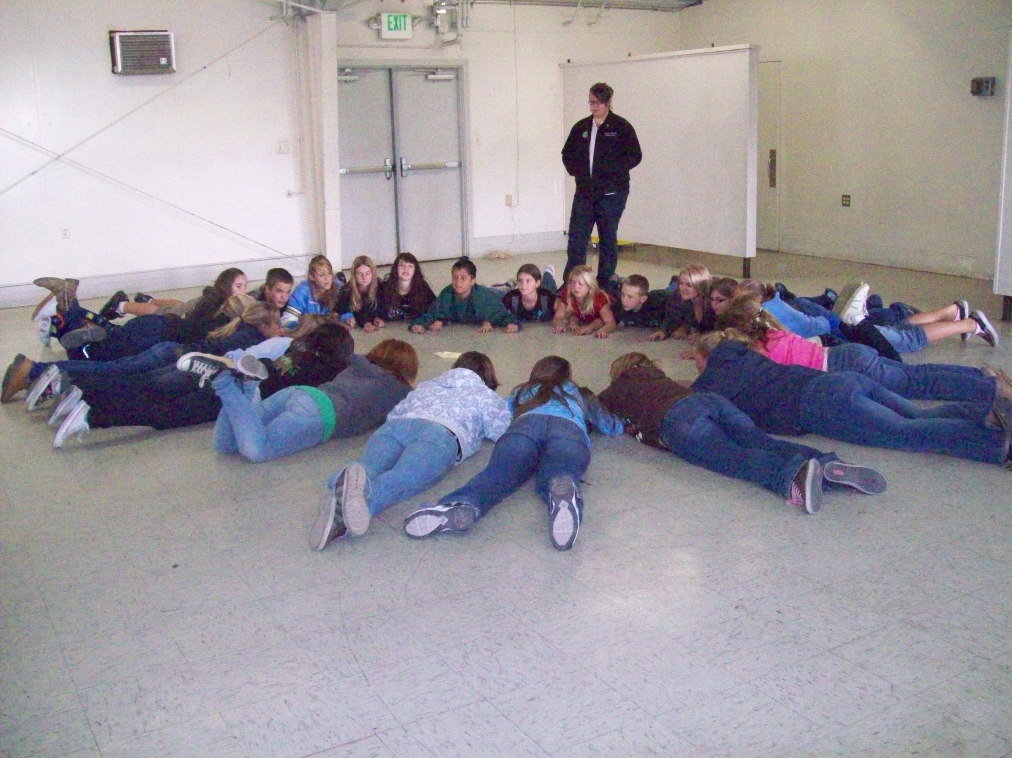

2009 State 4-H Fashion Revue
Challenge

The challenge Category for the 2009 State 4-H Fashion Revue will be an apron using Simplicity pattern # 9565.

Get ready, get creative!
The 2009 STATE FASHION REVUE
CHALLENGE PATTERN IS

SIMPLICITY APRON # 9565

Start with Simplicity pattern #9565. Change it to suit your needs! Will you wear it in the kitchen, to barbecue, for woodworking, while you paint or for animal grooming? The possibilities are endless! For example, you could adjust the neck strap; make it shorter, longer, smaller or larger; change the pockets or eliminate them; add trim or appliqués; experiment with fabrics, colors or details. Purchase or sew an outfit to coordinate with your apron. This pattern was chosen for the 2009 Challenge because it is suitable for beginners to advanced. Happy Stitching!

For more information about State 4-H Fashion Revue, go to http://www.ca4h.org/projresource/fashion/index.asp or contact Kylie Deal, youth chair at
dmtigers06@yahoo.com or Sue Moore, staff liaison at samoore@ucdavis.edu or 209.533.6990.

State Office is looking for 4-H Stories

The State 4-H Office is looking for innovative and impactful 4-H stories. Stories feature 4-H groups, projects or activities on the State 4-H Homepage (www.ca4h.org). The State 4-H Office will even write the story for you! If you have a story, please contact Emily Lane, State 4-H Office student assistant, at erlane@ucdavis.edu Current stories may be found at http://www.ca4h.org/4HDelivers.asp


Teen Council Winter Camp

Teen Council Winter Camp will be held on March 27 – 29, 2009 at Singing Pines Lodge in Big Bear. All teens 13 and up are welcome. Space is limited so mark you calendar and watch for more information. To off-set the price if winter camp, the teens will be selling See’s Candy for the holidays. If you don’t want to fight the mall and need candy, please contact the 4-H office. Last year the candy sales reduced the price of camp by $40.00 per person and paid more than 50% for the chaperones. You can also earn money toward your own registration, up to $50.00. Winter Camp is totally supported by Teen Council, so please support your youth. Thank you.

San Bernardino 4-H is starting up a county wide SET committee. The 4-H Science, Engineering, and Technology (SET) Initiative is the 4-H program’s response to our nation’s and state’s concern for improving human capacity and workforce abilities in the areas of science, engineering, and technology (SET). Working with community partners, San Bernardino 4-H is going to start a county wide Global Positioning System (GPS)/Geographical Information Systems (GIS) project to help the community, and the county 4-H program. Youth and adults will work together as a team to build maps with GPS data on computers. The San Bernardino County 4-H SET Committee is looking for adult volunteers and 4-H youth to be on the committee. If you or someone you know would be interested in joining the San Bernardino 4-H SET Committee, get into contact with John Trammell at techdude4h@gmail.com or (909)844-1747.

Perfect Wings 4-H Club

The Perfect Wings 4-H Club is located in the Morongo Basin. The leader is Sukulina Das and they have approximately 10 youth members. This group loves their horses and has participated in the Horse Summer camp the last 2 years. They were a big help putting on the camp this year as it was San Bernardino County’s turn to host it. Everyone from camp would like to thank them for the great crafts they taught us to make!

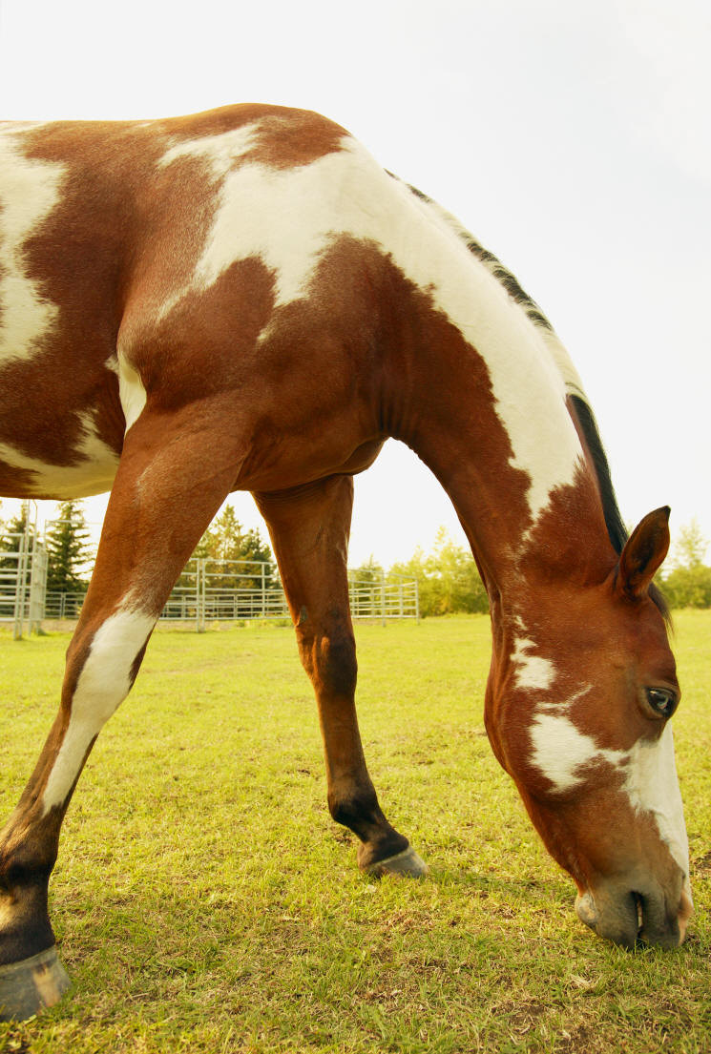

Cal Poly Pomona presents
25th Anniversary Edition
Feeder Calf Sale

35 head of gentled, quality feeder calves will be sold
Saturday, November 15, 2008
Calves will fit your spring or fall fairs
Heifers available by Private Treaty

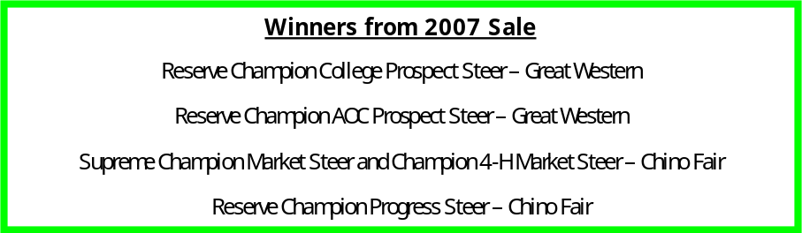

3801 W. Temple Ave, Pomona, CA 91768
Office - (909) 869-2141 Sale day phone – (909) 229-9641

Schedule of Events
- 9:00 AM - Cattle on Display
- 10:00 AM – Seminars on Selection, Feeding, Fitting and Showing
- 12:00 PM – Tri Tip Lunch
- 1:30 PM – Auction

Consignors
~Mission Club Calves – CA
~Star Cattle Company – CA
~Perkins Livestock – Danny Perkins – Utah
~Excell Livestock – Greg and Jason Excell - Utah
~Cal Poly Pomona - CA


Since its inception in March, 2008, over 6,600 4-Hers in 26 states have become participants in the 4-H Million Trees Project (4HMT), registering over 20,000 trees to date. The 4-H Million Trees Project wants to renew the invitation to all 6.5 million 4-H youth so they can benefit from the leadership, citizenship, community service, and life skills opportunities associated with this project. Time is of the essence because we hope that 4-H clubs and units will adopt this project as one of their monthly community service projects this Fall, 2008. Please help us to spark greater interest in this large-scale service-learning project by sharing this information with 4-H members in your area. Please click here for an invitation to participate in the project. Click here for newsletter and newspaper article samples, and here for sample photos to use of the project. For more information, visit: http://www.4hmilliontrees.org
State 4-H Equine Field Day

Mark your calendars for Nov. 22nd for the State 4-H Equine Field Day to be held at Cal Poly Pomona. It will be a great day with many sessions on Equine health and some for the riders! Some sessions planned are: Dental Health, showmanship, tours of the Breeding Facility at Cal Poly, how to relax after a hard day of riding or in between classes, Mini horses doing their thing, trail obstacles, saddle fitting, jumping, plus much more. Find more information at http://ca4h.org/projresource/horse/
EquineFieldDay2008.pdf
We will also be having a tack swap – so get your good used tack cleaned and ready to sell at this event. 10% of the profit will go toward the Equine National Team and the rest is for you!

4-H Million Trees Project



Halloween Party

On October 25, the Grand Terrace 4-H Club had a Halloween Party. The planning committee for the event was chaired by Kayla Pjerrou, the club treasurer. The party happened at Stephanie Lehto's house, our club president.
Everyone brought a pumpkin for carving. The final results were great! We had a happy jack-o-lantern, a couple of scary ones and there was one that was hard to describe, just plain strange.
After, the carving, we all sat in the dark outdoors, with our pumpkins all lit up with candles, and read scary stories and ate yummy snacks. Some of the stories were funny, some silly and some were very creepy. Although going to sleep, after hearing all of the stories, was not easy for some of us.
The evening was so much fun that we are already making plans for next year's party!

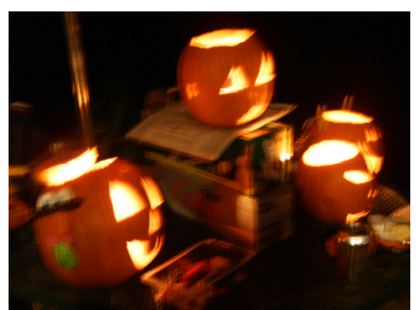

National 4-H Week

The Apple Valley Rattlers were able to hold a community service project during National 4-H week, which was October 5th through the 11th. We were at Ralphs and Wal-mart for 3 days each; we also had a drop box at the Newton bass library with a science board about 4-H and some brochures. Our community service project was a can drive for the Salvation Army this is our second year doing this specific project. Last year we received 59 cans. This year we received 291. We are extremely happy with this amount and plan of doing more next year.
Submitted by Andrew Viloria

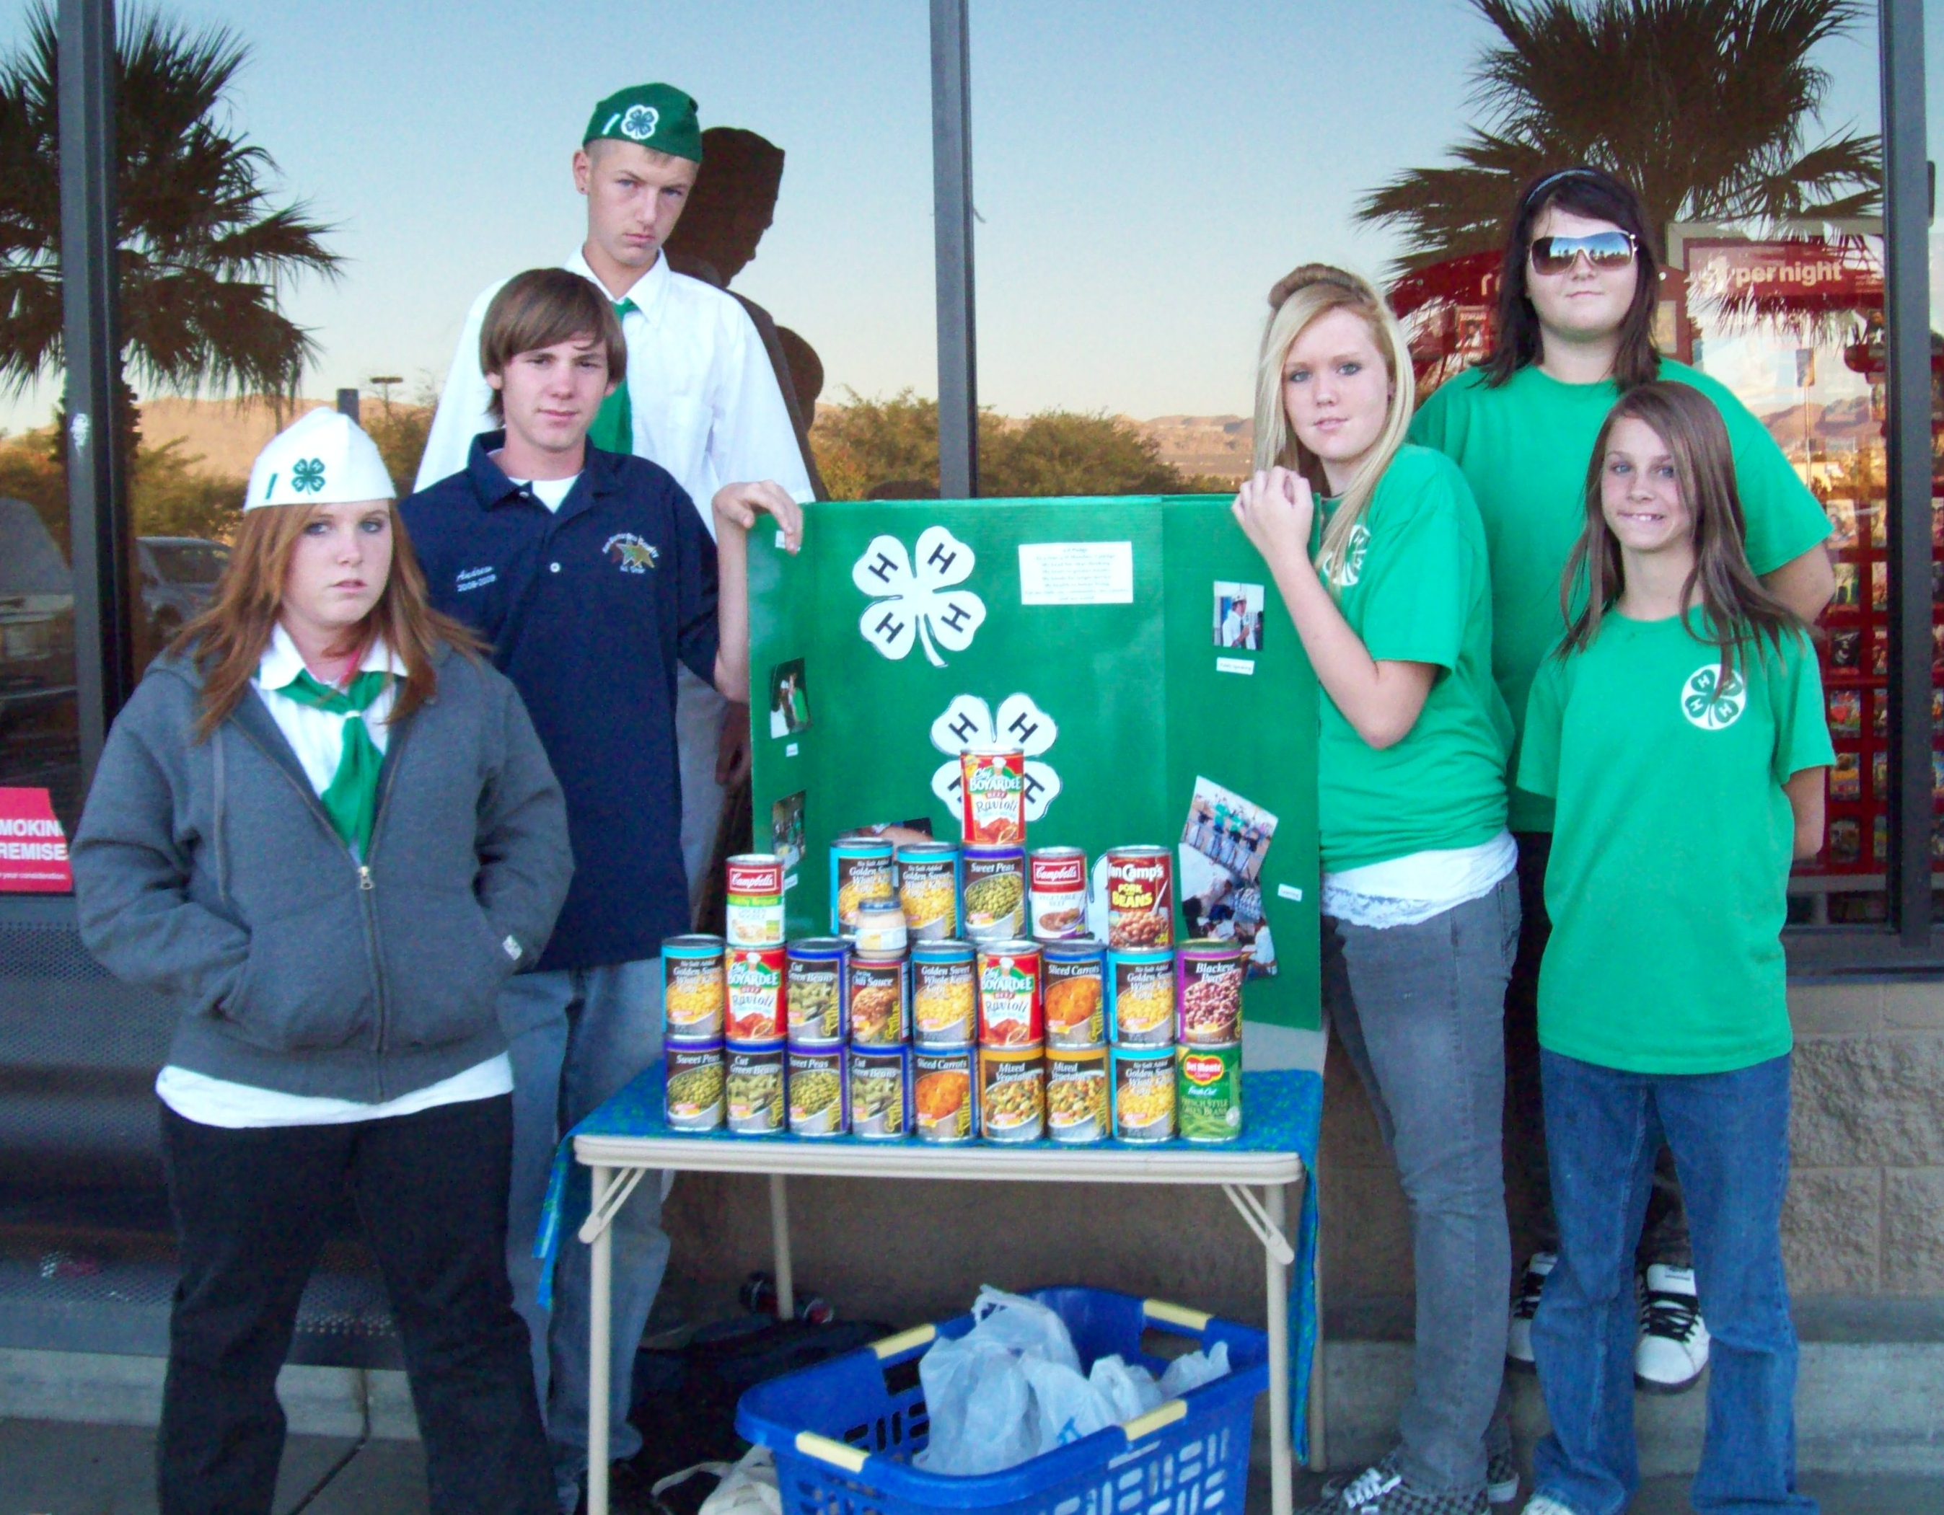

New – Sub-Sectional Field Day

Because some counties, including our own, have conflicts with the May date for our Regional Field Day, a new Sub-Sectional Field Day has been created. You must qualify at our county field day to attend this sub-sectional field day. Attending this field day will allow you to qualify to go on to the State Field Day and you won’t have to miss any of our County’s Fair. The following is a little bit of information on this Field Day which will be held in San Diego this year. More information will be coming.

SUB SECTIONAL 4-H PRESENTATION DAY
MARCH 14, 2009

REGISTRATION DEADLINE:
February 28, 2009 (please watch for more information as we may be able to register online)

PRESENTATIONS to be judged will include:
Demonstrations/Illustrated Talks
Scientific Demonstrations/Illustrated Talks*
Educational Displays
Interpretive Reading
Prepared Speech
Audio-Visual
State Format Impromptu



4-H is
Fun

November 2008
December 2008
Sun | Mon | Tue | Wed | Thu | Fri | Sat
 |  |  |  |  |  | 1  Nicole Peacock Horse Play Day
2 | 3 | 4 | 5 | 6 | 7  Asilormar Leaders Forum | 8  Asilormar Leaders Forum
9  Asilormar Leaders Forum | 10 | 11 | 12 | 13 | 14 | 15  Food Fiesta @4-H Office
16 | 17 | 18  County  Council | 19 | 20 | 21 | 22  State Equine Field Day @Cal Poly Pomona
23 | 24 | 25 | 26 | 27 | 28 | 29
30
Sun | Mon | Tue | Wed | Thu | Fri |  | Sat
 | 1 | 2 | 3 | 4 |  | 5 | 6
7 | 8 | 9 | 10 | 11 | 12 |  | 13
14 | 15 | 16 | 17 | 18 | 19 |  | 20
21 | 22 | 23 | 24 | 25 | 26 |  | 27
28 | 29 | 30 | 31 | 
No county meetings or events.
Enjoy the Holidays!

