ep
UCCE/4-H Office
777 E. Rialto Ave.
San Bernardino, CA 92415

San Bernardino County
4-H Headlines
March 2009

CA & Washington Focus Delegates

There is a mandatory orientation that you must attend on March 14th at Clement Middle School in Redlands. The address is 501 E. Pennsylvania Ave. Cal Focus will be held from 9:00 to 11:00 am and Washington focus from 1:30 to 3:30 pm You can call Rozie Trammell at (909) 864-2653 for more information.

County Fair Books are in!

The San Bernardino County fair books are in. If your club has not already picked theirs up, you may come to the 4-H office to get one.

All-Star Intent

Have you ever wondered what it takes to be a County All-Star? Come to the All-Star Intent Orientation and find out. You can pick up an All-Star application packet and talk to our current All-Stars and their Advisor. The meeting will be on Tuesday, April 14 at 6:00 pm at the 4-H Office.




COOPERATIVE EXTENTION/4-H OFFICE
777 E. Rialto Ave. • San Bernardino, Ca 92415
(909)387-2179 • Fax: (909)387-3306
E-mail: caeggleston@ucdavis.edu
County Website: clubs.ca4h.org/sanbernardino/

See Calendar inside for upcoming events!

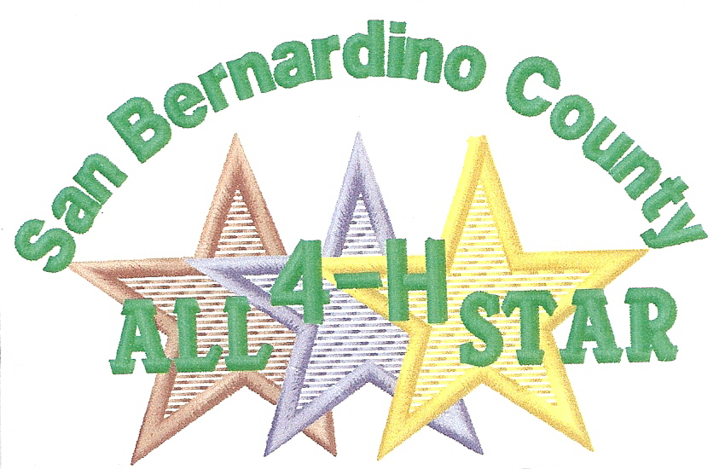

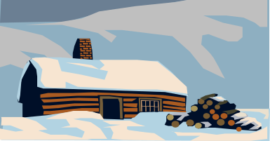
T E E N C O U N C I L W I N T E R C A M P

WHEN: March 27 - March 29, 2009
Check in March 27 4 - 9 P.M..
Where: Singing Pines Lodge
657 Modoc Drive
Big Bear Lake, California
Who: Teens 13 - 19 Years enrolled in 4-H
Cost: $80.00 / $100.00 After February 28,2009
Includes 2 nights lodging, 4 meals, (starting Saturday Morning
Does not include “lift tickets” at Snow Summit. There is a tubing facility (if there is no snow around the lodge) that costs $25.00 / per person. Teen Council will fund each youth $15.00 towards this activity
Note: We must have a hand written permission slip signed by your parents / guardian to participate in the tubing activity
Every Delegate is Responsible to:
* Act in accordance with the 4-H Code of Conduct
* Be responsible for yourself and your belongings
* Follow all facility rules
Registration: Send completed registration / tubing permission slip / two (2) medical releases / Signed code of conduct to:
UCCE/San Bernardino County
4-H Youth Program
777 E. Rialto Avenue
San Bernardino, CA 92415

Registration forms will be available on the county website: clubs.ca4h.org/sanbernardino/

SUB SECTIONAL 4-H PRESENTATION DAY
MARCH 14, 2009

Because some counties, including our own, have conflicts with the May date for our Regional Field Day, a new Sub-Sectional Field Day has been created. If you earned a gold medal at our county field day, you qualify to attend this presentation day. Entries are due March 2nd. Call the 4-H Office at (909)387-2179 for entry forms.

Watershed Restoration Project

Saturday, March 28 & Saturday, April 25
8:00 am to 2:00 pm

All ages welcome. Adult supervision of children is required. Meeting location is at the San Gabriel Canyon Environmental Education Center, across the street from the Ricon Fire Station. Poor weather may cause cancellation of an event. Call (626)443-2298 and press #5 anytime after 5:00 pm the day before an event to verify event status.
Remember to: wear sturdy, non-skid, closed-toe shoes; Dress in comfortable clothes; Bring work or garden gloves; Bring a lunch and water; Start with a full gas tank before driving up Azusa Canyon.
If you have a group of 6 or more people planning to attend, please call either: Karen Fortus, USDA Forset Service at (626)335-1251 or Ruben Gallegos, USGVMWD at (626)443-2298 or by emailing ruben@usgvmwd.org

Snowline 4-H Club

The Snowline 4-H Club is located in the High Desert. It has members from the Snowline area to the Hesperia area. The club leaders are Leslie Mackesy and Lisa Chamberlain. There are approximately 7 leaders and 21 members in this club. You can find Snowline members at county events participating and showing off what they have learned. The main projects offered in this club are Beef Cattle, Clothing & Textiles, Arts & Crafts, Horses, poultry, meat goats, swine, food & nutrition, record keeping, and sheep.

New South Section Officers

The South Section has elected new officers and they are as follows.

President- Tori Grainger
Vice President- Claudia Conver
Secretary- Savanna Barnett
Treasurer- Kaitlyn McDonald
Reporter- Andrea Eddleman

San Gabriel Valley 4-H Fair

The San Gabriel Valley fair will be held on April 24-26, 2009 at the Chino Fairgrounds. The fair is open to 4-H members, leaders, and families from San Bernardino County. You can get more information and entry forms on-line at http://www.sgv4hfair.com/ and if you have any questions you can call 909-374-8342 or e-mail infor@sgv4hfair.com

The Hesperia Highlighter’s Bringing Some Christmas Cheer
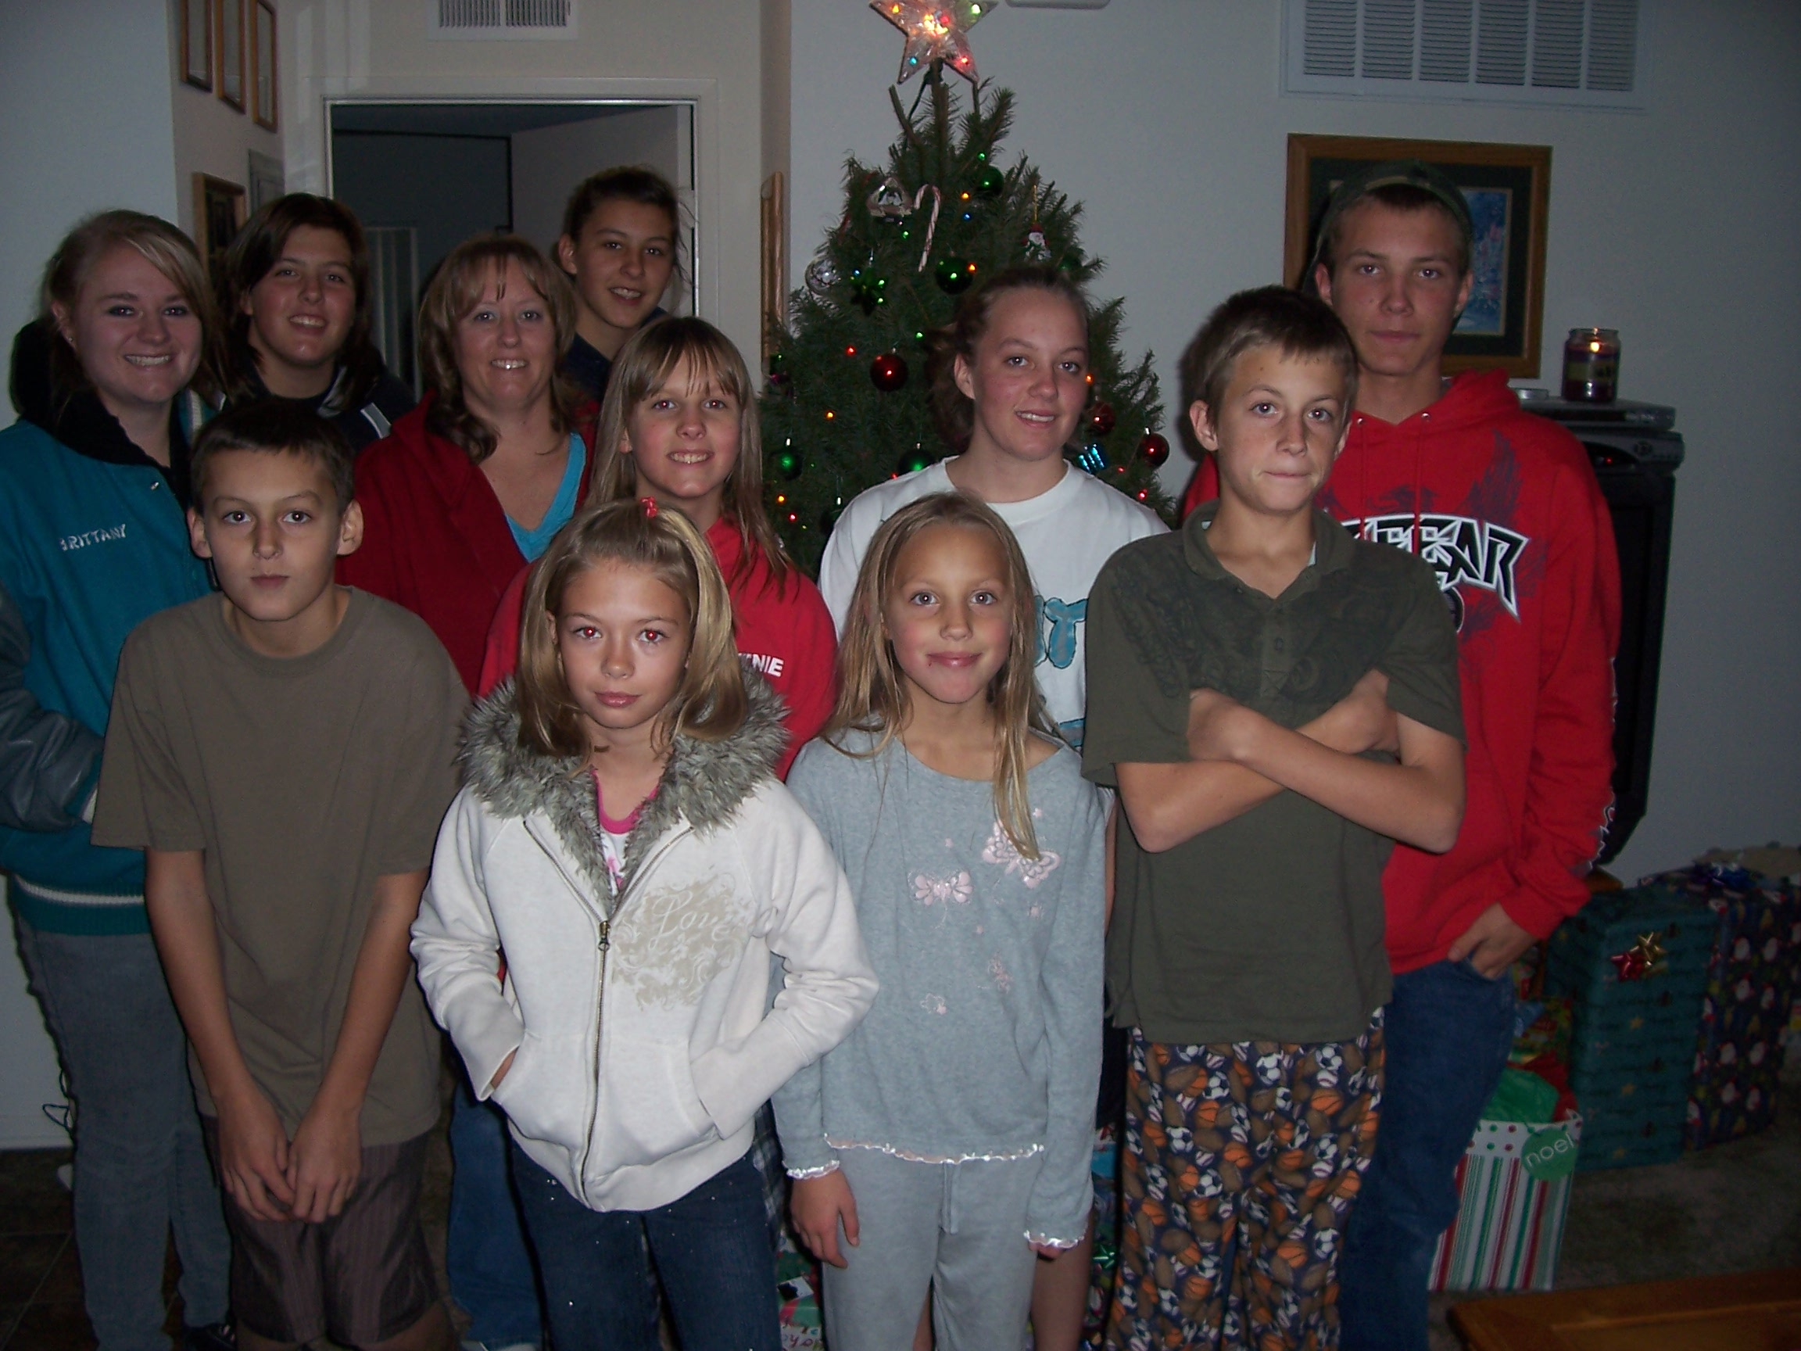
Photo Courtesy of Denise Peabody

Three days before Christmas, the Hesperia Highlighter’s group came together to put together presents for a mother and her family of five. We bought each kid a present off their wish list, and unbeknown to the mother, we got her one as well. We presented the family as well with a Christmas dinner: Turkey, canned goods, candy canes, and some hot cocoa (enough food to fill two boxes!).
The family was very ecstatic to see us that day, and I could only imagine the sheer joy they had Christmas morning opening their presents. I cannot wait to help out again at any given time!!
Brittany Haynes
Hesperia Highlighter’s Historian

County Field Day/Expressive Arts/ Fashion Revue Results

County Field Day/Expressive Arts and Fashion Revue was held on Sat. Feb. 21st at Bloomington Christian School in Bloomington. We had a great time and the members in our county are getting better and better every year! Congratulations to the leaders who encouraged, parents who helped and the members who participated to make this a great event.

Fashion Revue:
Primary Decorate Your Duds (Participation only)
Rebekah Hundric Bloomington Boosters Participation
Intermediate Decorate Your Duds
Tori Church Redlands Grove Blue
Intermediate Purchased
Janet Champlin Inland Rockin Rebels Medalist
Allison Eggleston Monte Vista Diamonds County Winner
Intermediate Traditional
Tori Church Redlands Grove Medalist
Senior Traditional
Tori Grainger Inland Rockin Rebels County Winner
Special Challenge - Aprons
Seniors
Amber Meek (1) Monte Vista Diamonds Blue
Tori Grainger Inland Rockin Rebels Medalist
Amber Meek (2) Monte Vista Diamonds County Winner
Intermediate
Saige Stewart Redlands Gove Medalist
Allison Eggleston Monte Vista Diamonds Medalist
Tori Church Redlands Grove County Winner
Juniors
Tiffany Marino Monte Vista Diamonds Medalist
Marty Marino Monte Vista Diamonds County Winner

Field Day:
Impromptu Talks
Seniors
Danielle Johnson Bloomington Boosters Gold
Sarah Wilson High Desert Challengers Blue
Amber Meek Monte Vista Diamonds Red
Taylor Kerr Bloomington Boosters Red
Megan Chiatovich Bloomington Boosters White
Intermediate
Shannon Palmer Monte Vista Diamonds Gold
John Kane Monte Vista Diamonds Red
Junior
James Palmer Monte Vista Diamonds Gold
Elizabeth Wang Monte Vista Diamonds Blue
Tiffany Marino Monte Vista Diamonds Blue
Murate Coe Snowline Blue
Kayla Pjerrou Grand Terrace Red
Primary (Participation only)
Harley Benoit Rancho Rebels Green
Ester Coe Snowline Green
Prepared Talk
Senior
Sarah Wilson High Desert Challengers Gold
Illustrated Talk
Intermediate
Shannon Palmer Monte Vista Diamonds Gold
Extemporaneous
Sarah Wilson High Desert Challengers Gold
Interpretive Reading
Senior
Brittany Haynes Hesperia Highlighters White
Junior
Elizabeth Wang Monte Vista Blue
Audio Visual
Senior
Brittany Haynes Hesperia Highlighters Blue

Presentations
Seniors
Brittany Kelley Monte Vista Diamonds Gold
Amber Meek Monte Vista Diamonds Blue
Intermediate
Jacob Badal Monte Vista Diamonds Gold
John Kane Monte Vista Diamonds Gold
Junior
Murate Coe Snowline Gold
Devany Kelley Monte Vista Diamonds Blue
Tiffany Marino Monte Vista Diamonds Blue
Primary (Participation only)
Jared Badal Monte Vista Diamonds Green
Ester Coe Snowline Green
Teams/Seniors
Danielle Johns & Bloomington Boosters Gold
Chelsea Reid

Educational Displays
Senior
Amber Meek Monte Vista Diamonds Gold
Brittany Haynes Hesperia Highlighters Blue
Intermediate
Allison Eggleston Monte Vista Diamonds Gold
Alex Aldrich Monte Vista Diamonds Gold
Junior
Marty Marino Monte Vista Diamonds Gold

Fun with Food
Primary(Participation Only)
Ester Coe Snowline Green
Harley Benoit Rancho Rebels Green
Junior
Murat Coe Snowline Blue
Marty Marino Monte Vista Diamonds Blue
Kori Williams Hesperia Highlighters Red
Murat Coe Snowline Red
Tiffany Marino Monte Vista Diamonds Red
Marty Marino Monte Vista Diamonds Red
Intermediate
Jamie Kerr Bloomington Boosters Red
Senior
Chelsea Reid Bloomington Boosters Blue
Rumi Coe Snowline Blue
Danielle Johnson Bloomington Boosters Blue
Brittany Haynes Hesperia Highlighters Blue
Amanda Shaffer Hesperia Highlighters Blue
Savanna Paine Hesperia Highlighters Blue
Alexnader Lillie Hesperia Highlighters Blue
Amber Meek Monte Vista Diamonds Red
Taylor Kerr Bloomington Boosters White

Division Winners:
Junior
Murate Coe Apple Sauce Cake
Intermediate
Jamie Kerr Chocolate Chip Cookies
Senior
Chelsea Reid Banana Chocolate Chip Cookies

BEST OF SHOW
Murat Coe Apple Sauce Cake

All of these baked goods were auctioned off at the end of the judging and $190.50 was raised to help with the expenses of putting on this event. Thanks to all!



Expressive Arts

PRIMARY (PARTICIPATION ONLY)
Rebekah Hundric Bloomington Boosters Green
Isabel Wilshire East Valley Green
Harley Benoit Rancho Rebels Green
Sophia Frye East Valley Green
Esther Ruth Coe Snowline Green

JUNIOR
Benjamin Wilshire East Valley County Winner
Benjamin Wilshire East Valley Red
Benjamin Wilshire East Valley White
Tom Frye East Valley Red
Murat Coe Snowline Red
Allison Eggleston Monte Vista White
Autumn Jacobo Grand Terrace Red
Autumn Jacobo Grand Terrace White
Autumn Jacobo Grand Terrace White
Autumn Jacobo Grand Terrace White
Autumn Jacobo Grand Terrace White
Autumn Jacobo Grand Terrace County Winner
Autumn Jacobo Grand Terrace Red

Kayla Pjerrou Grand Terrace White
Kayla Pjerrou Grand Terrace White
Kayla Pjerrou Grand Terrace Red
Kayla Pjerrou Grand Terrace White
Kayla Pjerrou Grand Terrace White
Kayla Pjerrou Grand Terrace White

SENIOR
Sam Frye East Valley Red
Sam Frye East Valley Red
Sam Frye East Valley Red
Savanna Barnett East Valley White
Savanna Barnett East Valley White
Savanna Barnett East Valley White
Savanna Barnett East Valley White
Savanna Barnett East Valley White
Savanna Barnett East Valley Blue
Henry Frye East Valley Red
Rumiana Coe Snowline Red
Rumiana Coe Snowline Red
Rumiana Coe Snowline Red
Rumiana Coe Snowline Red
Rumaina Coe Snowline Red
Brittany Haynes Hesperia Highlighters White
Brittany Haynes Hesperia Highlighters White
Stephanie Lehto Grand Terrace White
Stephanie Lehto Grand Terrace White
Stephanie Lehto Grand Terrace Red
Stephanie Lehto Grand Terrace White
Stephanie Lehto Grand Terrace Red
Stephanie Lehto Grand Terrace White
Ashley Trammell East Valley County Winner
Ashley Trammell East Valley White
Ashley Trammell East Valley White
Savanna Paine Hesperia Highlighters Red
Savanna Paine Hesperia Highlighters White
Savanna Paine Hesperia Highlighters White
Amanda Shaffer Hesperia Highlighters Red

March 2009
Sun | Mon | Tue | Wed | Thu | Fri | Sat
1 | 2 | 3 | 4 | 5  Memory book Committee Meeting 6:00 pm county Office | 6 | 7
8 | 9 | 10  County Council | 11 | 12 | 13 | 14 Sub Sectional Field Day @San Diego
15 | 16 | 17 | 18 | 19 | 20 | 21  Shooting Sports Competition@  Apple Valley
22 | 23 | 24 | 25 | 26 | 27 | 28  State Equine Educational Contest
29  State Equine Educational Contest | 30
Teen Winter Camp
April 2009
Sun | Mon | Tue | Wed | Thu | Fri | Sat
 |  |  | 1 | 2 | 3 | 4
5 | 6 | 7 | 8 | 9 | 10 | 11  Trail Clinic
12  Easter | 13 | 14  Home Ec Committee Meeting 6:30 County Office  All-Star Intent Orientation  6:00 | 15 | 16 | 17 | 18
19 | 20 | 21 | 22 | 23 | 24 | 25
26 | 27 | 28 | 29 | 30



