UCCE/4-H Office
777 E. Rialto Ave.
San Bernardino, CA 92415

San Bernardino County
4-H Headlines
March 2008

Teen Council Winter Camp

Winter camp will be held at Singing Pines Lodge in Big Bear March 28-March 30th. Last year everyone had a great time. Teens 13-19 who are enrolled in 4-H are eligible. Cost is $100.00 after Feb. 29th. There is still time to apply – you can find the application at sbc4h.org under the events tab or you can call the 4-H Office at (909)387-2179.

ATTENTION: ALL CLUBS
SBC Memory Book Donation

We would like each club to go to their local libraries and talk to them about donating a Memory Book to their library. The 4-H Office has memory books left over and we want to get them out to the public. If your library would allow us to donate a memory book, I will send you one that your club can take to them. This could count as community service on your record books. Please let Cheryl know if you have any questions.

San Bernardino 4-H Website

Each club has an individual page on the sbc4h.org website to share what you are doing with the rest of the clubs in the county and local community. Please submit photos, stories, club information and 4-H officers to John Trammell at techdude4h@gmail.com. Thanks! There will also be a special tab for community leaders where you will find many forms needed for beginning/end of the year, enrollment, and finances.



COOPERATIVE EXTENTION/4-H OFFICE
777 E. Rialto Ave. • San Bernardino, Ca 92415
(909)387-2179 • Fax: (909)387-3306
E-mail: caeggleston@ucdavis.edu
County Website: sbc4h.org

See Calendar inside for upcoming events!

New State 4-H Policies –
effective immediately!

Several new policies for the State 4-H Policy Manual were adopted and presented in January 2008. Below is a brief summary of key areas on these policies. All club leaders will receive a complete copy and all 4-H members and leaders will be required to comply with the complete policy. If you would like a detailed copy of any of these policies, contact the 4-H office or download them from the State 4-H website: www.ca4h.org
Section 310.6 – Volunteers on VMOs (Councils), committees, and Taskforces - Members of these entities must be appointed 4-H volunteers or youth members in good standing.
Section 418.1 – Domestic Exchanges – Approval for all exchanges must come from the County Director. Youth participants must be at least 12 years of age. The California 4-H code of conduct is in full force at all times. All adults in the hosting household must undergo an adequate background check or the exchange will not be allowed. All adults (18 & over) in hosting household within California must be fingerprint screened. At least one host youth must be a 4-H member in good standing.
Section 418.2 – International Exchanges – In addition to the above domestic exchange policies, approval must also be given by the State 4-H Director and youth must be at least 14 years of age.
Section 704.2 – Bank Accounts – All 4-H clubs & units must be chartered to use the 4-H name and logo, to raise & disperse funds in support of 4-H programs, projects and groups. The County Director must approve the establishment of checking or savings accounts. No other accounts are allowed without approval. Guidelines in the Treasurer’s manual and the State 4-H Policy manual must be followed. All bank accounts must use the UCCE 4-H Office mailing address as the address of record. No UCCE or 4-H staff should be signatories on 4-H accounts. The County Director or designee must review all monthly statements. Failure to follow the policies can result in revoking of the club or unit’s charter. (All banking changes must be in place no later than July 1, 2008.)
Section 818 – Petting Zoos – Risks involved with petting zoos must be minimized by adhering to the specific guidelines listed in this policy for health and safety.
Section 819 – Search of Personal Property – The UC is responsible for maintaining a safe environment during the course of all 4-H YDP events. If there is reason to perform a search of personal property, the specific guidelines listed in this policy must be followed.

California Team Places 2nd Overall at National 4-H Horse Classic
More than eight hundred youth from more than thirty states along with Alberta, Canada participated in the 88th Annual Western National Roundup Conference January 9-13 2008 in Denver, CO. 4-H and FFA members between the ages of 14 and 19 qualify for the conference either by winning their home state’s contest or by being chosen as a state delegate. The National 4-H Horse Classic – Western Division is comprised of five separate contests: Horse Public Speaking, Horse Demonstration, Horse Bowl, Hippology & Horse Judging. All horse contests provide contestants an opportunity to demonstrate their knowledge of equine-related subject matter in a competitive setting.
Congratulations to the California team for placing 2nd overall. The High Overall State Award is given to the state with the overall high score based on placings. The teams are awarded points for first through tenth team placings in bowl, judging, demonstrations, and on individual placings for public speaking and individual demonstrations.
Our California delegates did very well. Chelsea Beeson, Fresno County, placed 5th in horse public speaking. Kaitlin Lawton, Kings County, earned 2nd place honors with her individual demonstration. The team demonstration by Allison Burg and Nicki Davidson, Orange County, placed 5th. The California Horse Bowl Team of Paige Ryan, San Bernardino County, Rebekah Warren and Allison Anthony, both of Riverside County, and Raquel Varela of San Diego County, placed 5th. Results of the Hippology individual judging are Annie Flocken, Orange County, 6th place, and Emily Berry, Tulare County, 7th place. With other team members Marissa Silva, Alameda County, and Masha Lefebvre, Riverside County, they placed 8th in the team exam phrase, 6th place Team Judging and 10th place Overall Team. The California Horse Judging Team did very well in the Individual reasons with Emily Cehrs, Fresno County, 8th place, and Rachel McPhail, Santa Barbara County, 10th place. As a team with Sarah Wilson and Jake Haeckl, both of San Bernardino County, the team placed 7th in Halter judging, 7th place in performance, 3rd place in team reasons and 6th place Overall
Congratulations to the California team for a job well done!

Online Survey for 4-H Youth Targets Improved
Bio-Security Measures for
4-H Animal Science Projects

Because backyard flocks and herds serve as potential vectors of disease, 4-H Animal Science projects represent potential bio-security risks. As a consequence, the State 4-H Office and several county programs have been working closely with Veterinary Medicine Extension over the past few years on innovative initiatives to address this critical issue. Our goal through these efforts is to strengthen our Animal Science Program through the adoption and implementation of timely and relevant materials and strategies.
One aspect of bio-security that is extremely important is predicting the spread of disease through computer modeling. To do this accurately, researchers must develop a program that can calculate where, when, and how a disease might spread using data on typical patterns of animal movement. Although such models exist for industry, there is much yet to learn about the potential of disease spread in the event of an unforeseen outbreak among animals from backyard flocks or herds.
California 4-H has a robust Animal Science Program that we want to protect from disease. To help accomplish this, we have worked with Veterinary Medicine Extension to design a survey for youth who raise market animals that that can help provide researchers with the type of data necessary to help develop a new disease spread model. This survey is completely voluntary, but we are asking 4-H youth in California who raise market animals to go to http://ca4h.org/wrp/survey/, read the information provided, and consider completing the survey to help with this important research. The results from this survey will strengthen 4-H Animal Science in California through enhanced bio-security measures that will help ensure the health and safety of 4-H youth and their project animals for years to come.
If you have questions about the survey, please contact Martin Smith, Associate CE Specialist in Veterinary Medicine Extension, at mhsmith@ucdavis.edu.

TEEN COUNCIL CANDY SALES

Teen Council is selling See’s Easter Eggs, chocolate bunnies and assorted candy boxes. The proceeds will benefit Winter Camp and a portion of your sales profits will be applied to your Winter Camp registration. Call the 4-H Office or Gayle Champlin (909) 877-0037 if you would like to participate. Because the supply of candy in our area is limited, the final day to order candy will be March 7th.
SUPPORT THE TEEN COUNCIL.

April 11-13, 2008
The South Section Leaders' Council announces its Sectional Leader's Retreat!!
Events will be held at the Nutrilite facility in Lakeview, CA (between Riverside and Hemet).
Early Bird registration fee ($55 by 02/15/08) includes sessions, meals, and entertainment. Participants are responsible for their lodging.
Registration forms, hotel listings, and more information will be available soon!

San Bernardino County Fair Books

We have received in the San Bernardino County Fair books and have them in the office. If you would like to receive a copy, contact Cheryl in the 4-H office. If your club asked for books they can be picked up at the County Council Meeting on March 11th.

First Annual San Bernardino County
Leaders Retreat

Since the county 4-H staff appreciates our SBC Leaders so much, we are hosting our First Annual Leaders Retreat. This will be a day dedicated to our leaders. This event is going to be held at the Pilgrim Pines camp and conference center, located in Oak Glen near Yucaipa, on June 7th from 9:30am to 4pm. It is designed as a day for the county staff to express their appreciation for every thing the leaders do for our county. We are going to have a catered lunch and activities. This retreat is at no cost to our leaders and will help provide you with more helpful resources. Dr. Leslie K. Grier with CS Fullerton and a facilitator with The California School-Age Consortium will be there to provide resources Developing Problem Solving Skills. There will be more information to come.

Food Safety News

There have been new regulations coming down about food safety. Soon we will be having a class to teach us about these changes so that we can continue to serve food at 4-H events and continue with fund raisers involving food. Please keep your eyes on our newsletter for the date of our training. It will probably been within the next few months. It is important to have someone from every club present in order to go back and teach the leaders in your clubs.



High Desert Challengers

The High Desert Challengers Club serves the Phelan area of the High Desert. Their club has 31 members and 8 leaders with Nikki Wilison and Stacy Ruemely Co-Community Leaders. This club’s main projects are Dog, Horses, Rabbits, Swine, Poultry, Livestock Judging, Foods and Nutrition and Arts and Crafts. The High Desert Challengers has been the club to put on the Large Livestock Master Showmanship Clinic for our County and also has run the Large Livestock Judging at our County Fair. Nikki and Marc Wilson have also been very active in the State Equine Education Field for many years. This club also has provided us with a County All-Star this past year. Good Job High Desert Challengers!

Clothing & Fashion Review
Members and Leaders
Field Trip – Sat. April 12th

Field trip to the Fashion Institute in L.A.
to tour the Art of Motion Picture Cos-
tume Design Exhibit. We will be taking
the Metrolink train from San Bernardino
to Union Station. The cost is $7.00 per
person. If you are interested in going,
please call Janet Champlin at (909) 275-
0719 to R.S.V.P by March 10th.



Christmas Cards for Summerford
Alzheimer's home in Redlands

The East Valley 4-H club made Christmas cards for the elderly during their December meeting. The club does this every year so they can distribute the cards to the residents at the Summerford Alzheimer’s Home in Redlands. This facility specializes in taking care of elderly men and women with Alzheimer’s disease. The club decided to do this because they wanted to spread the Christmas joy to everyone, with or without a family. They made about 60 cards and gave them to the center to distribute to their patients. The facility director said that the cards were so beautiful that they used them to stand on the food trays each meal throughout the holiday season. The East Valley 4-H members will use this activity to fulfill requirements for their citizenship project.
Submitted by Savanna Barnett

Club News

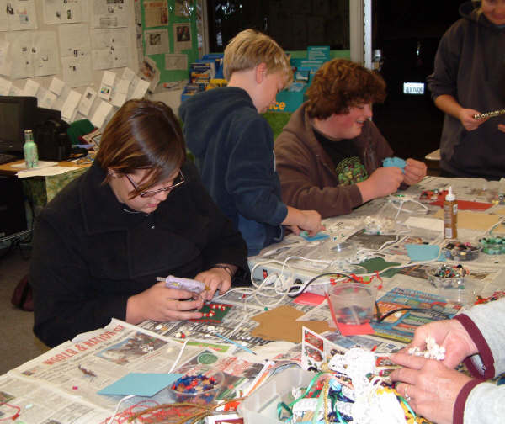
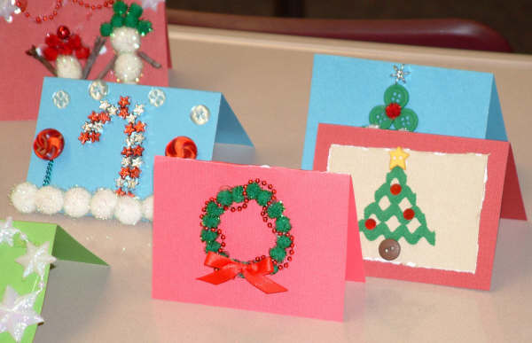

County Council Meeting

Tuesday March 11th will be our next county council meeting. It starts at 7:00 and is held at the County 4-H Office. This is a great opportunity to find out about events that are coming up and to remain informed regarding county activities. If you have any questions you can contact the 4-H office at 909-387-2179. We hope to see you there.

Horse Mastership

The new dates have been set for the San Bernardino County Horse Mastership Program. It is now going to be held on Saturday, May 3rd at the Chino Jr. Fairgrounds. If you have any questions contact the 4-H office or Laura Aldrich @ (626)332-7233.

Ft. Irwin Field Day

We are putting on a Field Day for the 4-H members at Ft. Irwin. It will be a smaller version of our County Field Day having speeches, demos, Fashion Revue and expressive arts. It will be held on Wednesday, April 30th. We are looking for anyone who can come and help us with this event. Since it is during the day we are hoping that there are some youth out there that can afford to take a day off school or are home schooled or may be off track. This would be a great citizenship or community service for your record book. We can reimburse for gas. Please contact Cheryl at (909)387-2179 if you can help.

Master Showmanship Clinic

The Master Showmanship Clinic will be held on Saturday March 22nd at the Victorville Fairgrounds. It is being put on this year by Sarah Wilson and Ashley Ramming. If you have any questions contact the 4-H office @ (909)387-2179.

March 2008
Sun | Mon | Tue | Wed | Thu | Fri | Sat
1 County Field Day
At Bloomington Christian
2 | 3 | 4 | 5 | 6 | 7 | 8  South Section Mtg
9 | 10 | 11  County Council Mtg. 7:00pm | 12 | 13 | 14 | 15  SBC Fair Weight-in for Large livestock
16 | 17 | 18 | 19 | 20 | 21 | 22 Master Showmanship Clinic
23 Easter | 24 | 25 | 26 | 27 | 28  Winter | 29  Camp
30 | 31
April 2008
Sun | Mon | Tue | Wed | Thu | Fri | Sat
 |  | 1 | 2 | 3 | 4 | 5 State Equine Educational Event
6 | 7 | 8 | 9 | 10 | 11 | 12 South Section Teen Council Meeting
13 | 14 | 15 | 16 | 17 | 18 | 19
20 | 21 | 22 | 23 | 24 | 25 | 26 State Leader's Council Meeting
27 | 28 | 29 All Star Orientation | 30 Ft. Irwin Field Day
South Section Leaders Retreat





