Volume 2, Issue 1 January 2010

Dairy Wage Survey 2009
In this issue…

Dairy Wage Survey – 1

Overfeeding Nutrients – 2

Retained Placenta – 3

Water Use by Cows – 4

Crop Irrigation – 5

Animal Welfare – 6

Forage Seminar – 6

Herdsman Course – 6

North Valley Dairy Day – 7

Gregorio Billikopf, UCCE Labor Management Advisor

It was up to each dairy farmer to pick one milker, and give us the number of years the person has been employed. Average milker wages were $9.95 (2009), $9.69 (2006), $9.25 (2003) and $9.26 (2000). Keep in mind that each dairy chose one worker to report on. In general, we see a relationship with higher wages for milkers who have worked the longest at the dairy. I have hypothesized that 1) the number of foreign-born milkers will increase through time, especially as Mexican and Central American workers move into regions where they were not utilized in the past: and 2) that as foreign- born milkers increase, the number of USA-born female milkers is likely to decrease. The average percentage of foreign-born milkers was essentially the same in the 2009 survey (66%) and the 2006 survey (69%). Given issues of sampling, it is best not to draw too many conclusions as to these numbers.

Forty-seven percent of the dairy farmers offered some type of incentive or bonus pay in 2009 (in contrast to 36.5% in 2006). Bonuses may include any sort of benefit, such as beef, money, or time off, which is not directly related to an individual’s work efforts. Incentives, on the other hand, are tied directly to worker performance. In these times of such economic stress, a well-designed incentive pay program can be of great benefit to dairy farmers and their employees. A well-designed incentive—such as pay tied to lowered somatic cell counts or increased calf health—means employees only get an incentive if they have helped to increase the profitability of the dairy.

A fourth of the employees (2009) received some sort of health insurance, down from a third who received health insurance in 2006. The average cost for this insurance for the dairy producer was $341/month in 2009 vs. $377 in 2006. Sixty-three percent of the dairy producers provided paid vacation to their milkers. These milkers earned an average of 9 days of vacation in 2009, compared to 10 days in 2006. A few dairymen also offered additional pay in lieu of vacation. Forty percent (2009) of the dairies supplied milkers with housing or a housing allowance. In 2006, half of the dairies reported providing this benefit. The housing allowance averaged $239 per month. Seventeen percent paid a shift differential for more difficult shifts. Eighteen percent (2009) of the dairy producers offered a 401k or some sort of retirement plan for their employees.

As in previous surveys, some dairy farmers did not know where a replacement worker might come from, while others had no problem in recruiting. One dairy producer explained that potential employees showed up without any need for recruitment. Much can be said about building a reputation for being a solid employer. Pay is normally a very important factor in attracting and retaining employees, but interestingly, a dairy with no labor supply needs was paying only a dollar more ($11, Kansas) than a couple of dairies who had trouble finding employees ($10, Washington, Ohio). With the growing uncertainty regarding labor supply in the future, there are important steps that dairy farmers can take that will help them attract and retain productive employees.

For the complete survey results, visit http://www.cnr.berkeley.edu/ucce50/ag-labor/7research/7res08.htm

Too Much of a Good Thing
Jennifer Heguy, UCCE - Stanislaus/San Joaquin Counties and Jed Asmus, Independent Nutritionist

If a little is good, then more must be better, right? Not always, and especially not when it comes to feeding your animals. This article describes a basic concept of feed management, and why you might want to take a closer look at the practice on your dairy. Overfeeding nutrients results in higher feed costs and potentially negative consequences for your animals and the environment.

Phosphorus is a great example of “too much of a good thing.” During the 70’s, 80’s and early 90’s many researchers, nutritionists, veterinarians and producers were under the impression that increased phosphorus was necessary for reproduction, milk production, and animal health. As an example, the basic lactating cow diet without added mineral contains 0.40% phosphorus, well above the requirement for the highest producing cow. However, phosphorus was added to rations with total levels often exceeding 0.60%. Phosphorus fed above the requirement leaves the animal in feces and urine. In a survey conducted in the Northeast and Mid-Atlantic regions of the U.S. in 2002, on average, phosphorus in rations exceeded NRC guidelines by 34%. The extra phosphorus finds its way into the lagoon, then to the field, and in some situations to surface waters. Surface waters are where excess phosphorus causes serious environmental problems. Algae growth is limited by a lack of phosphorus. When phosphorus is present in high concentrations, algae flourish and consume all the oxygen (thus killing oxygen-dependent life).

Regardless of milk price, everyone is concerned with maximizing the amount of milk produced while decreasing costs of production. In an attempt to achieve the greatest production, it is easy to fall into the trap of, “more must be better!” Take a step back, and keep the animal’s requirements in mind. Here are some ways to make sure your animals are getting what they need in their diet, and you’re keeping costs down while minimizing impacts to the environment: We will further explore each of these concepts in a series of articles.

- Calculate feed efficiency (FCM / lbs of DM fed).
- Feed for stage of lactation and intake.
- Balance rations according to animal requirements and minimize the amount of nutrients leaving in the manure.
- Measure (and monitor) MUNs (milk urea nitrogen) as an indicator of protein efficiency.

A Word of Caution: Feeding excess of a nutrient decreases the nutrient utilization efficiency, thus increasing excretion of the nutrient into the environment and increasing cost of production. Because of the current economic conditions, many producers are trying to cheapen rations by dropping ingredients. However, simply cutting ingredients because they “cost too much” will not benefit you in the long term and may result in a scenario you cannot recover from. Feeding cows based on their nutrient and energy requirements is the best approach. Every cost must be evaluated against its benefits, both short and long term.

Managing Retained Placentas
Noelia Silva del Rio, UCCE – Tulare County

The placenta is the membrane that connects the fetus with the dam. The button like structures of the placenta (cotyledons), connect with the caruncles of the uterus (Fig 1). It is through these unions (placentomas), that nutrients are transferred from the mother to the calf. After a normal calving, the placenta will be expelled within 30 minutes to 8 hours. If the placenta has not been released after 12 hours, the cow will have a condition known as retained placenta (RP).
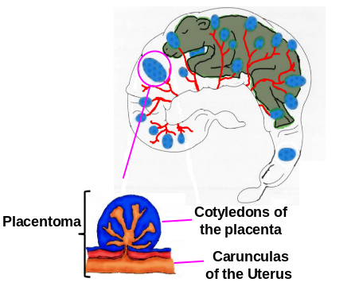
Figure 1. Placentomas

Retained placenta by itself is not a problem, however it may lead to uterine contamination. For example, when the cow lies down, the placenta hangs further out of her body and touches dirty stalls and corrals loaded with bacteria. When the cow stands and walks, the contaminated tissue is pulled back into the uterus. A cow with RP is 5 to 7 times more likely to have metritis (uterine infection), and her pregnancy rate decreases by approximately 15%. Furthermore, cows with RP are more susceptible to suffer ketosis, displaced abomasums and being culled earlier. The cost of each RP is estimated at over $300.

Overall, the incidence of RP is 8%; however, it ranges from 3 to 40% across herds. If your herd has an incidence of RP above 10%, you should be looking closely into this problem. On the other hand, if the incidence of RP is too low in your herd, you should ensure that postpartum checks and/or record keeping are being done properly.

Several factors have been associated with increased risk of RP. The most important are listed below:
- Mechanical factors: difficult birth (dystocia), twins, stillborn, abortion.
- Nutritional factors: mineral and vitamin deficiency, low levels of calcium in blood.
- Management factors: stress, obesity.

- Infectious diseases: Brucellosis, Leptospirosis, IBR, DVD.

After a normal calving, the immune system recognizes the placenta as a foreign body and attacks it. The unions between cotyledons and caruncles are destroyed and the placenta is released. However, when the immune system is weakened, it fails to degrade those unions and RP occurs. There are several very important factors for a good immune response that should be taken into consideration to prevent RP:
- Calcium blood levels: check the dietary cation-anion difference (DCAD).
- Dietary minerals and vitamins: ensure the dry cow ration is properly balanced.
- Body weight loss: during close-up of the dry period, provide easy access to fresh palatable food to stimulate appetite.
- Quality silages: mold and mycotoxins impair the immune response.
- Stress: avoid situations that stress animals close to calving such as pen movements, diet changes, and noises.

Treating cows immediately after calving with oxytocin, prostaglandin or calcium has shown poor results on RP prevention. However, once the cow has RP, there is something very important that you can do:
Prevent Metritis (Uterine Infection).
Remember, clean and comfortable bedding is critical to ensure minimal bacterial contamination of the placenta and the uterus.
Manual removal of the placenta is not advised. Postpartum, the uterine walls are thin and fragile, and manipulation of the uterus may cause harm. Trimming out the placenta may decrease the dirt caught by the placenta, however, the pulling force of the placenta’s weight will be lost. Retained placenta ends up in metritis in 25 to 50% of cases. Metritis may require antibiotic treatment and rehydration; you should seek advice from your veterinarian to establish a metritis treatment protocol.

Cows with RP normally drop the placenta within a week. The best approach in a RP case is to watch the cow closely. It is very important to remember that if she is not sick - do not treat, and if she is sick, seek advice from your veterinarian.

Estimations of Water Use for California Dairy Cows
Alejandro R. Castillo, UCCE - Merced County

Recent water use estimations in California dairy farms indicate 40 to 50% of water is used for animal cooling and consumption. Economic and regulatory constraints make it important to know the volume of water consumed and the mineral content of the water.

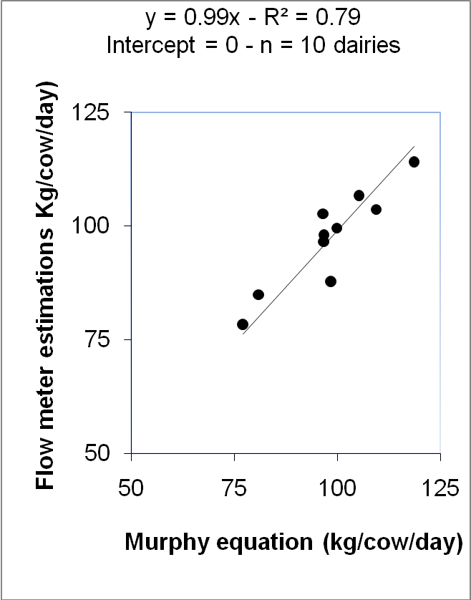
Two surveys carried out in Merced County on almost 100 dairy farms indicate that when animal drinking water has more than 500 mg per liter of Total Salts (TS), mineral content of the salts should be identified and included in the dietary mineral balance. Mineral content of drinking water is important to 1) adjust rations to meet animal requirements, 2) control, and in many cases reduce, intake of mineral supplements (feed cost), and 3) estimate mineral excretion and reduce manure production. For example, it was estimated that drinking water with a mean of 800±310 mg TS per liter provided 7% of calcium, 9% of magnesium, 25% of chloride, 25% of sodium, and 8% of sulfur that the animals required (for cows averaging 70 lb of milk per day).

The National Research Council (NRC) suggests different formulas to estimate daily water intake of lactating dairy cows. One of the most recommended formulas was developed by researchers from the Department of Dairy Science, University of Illinois (Murphy et al. 1983).

Murphy’s equation is: WI = 15.99 + 1.58 x DMI + 0 .90 MP + 0.05 x SI + 1.20 x MT.

- WI = water intake (kg/cow/day)
- DMI = dry matter intake (kg/day)
- MP = milk production (kg/day)
- SI = sodium intake (g/day)
- MT = minimum temperature (°C)
*To convert kg to lb, multiply by 2.2*
Ten dairy farms were selected in Merced County to evaluate Murphy’s equation. Electronic flow meters were installed for variable periods of time, no less than two weeks in each dairy. Water consumption of lactating animals was measured in freestall barns. The daily total volume of water used was divided by the number of cows in each barn. A high correlation (R2=0.80) was observed between Murphy’s equation and the information provided by the flow meters, indicating that Murphy’s formula can be used to estimate water intake for California dairy cows.

Water is the most important nutrient for dairy cattle (NRC, 2001). Estimations of both water intake and mineral content of drinking water are important for balancing dietary minerals (when TS are > 500mg/liter) and to control mineral excretion in manure.

Nutrient Management on a Dairy - How Much Water Does My Crop Need?
Larry Schwankl, Allan Fulton, Terry Prichard - UCCE

There are two important components of irrigation water management: (1) knowing when and how much water to apply to the crop, and (2) irrigating so that most of the applied water is available to the crop. In this article we will focus on knowing how much water to apply.

As the crop takes up water from the soil in its root zone, irrigation is required periodically to replace that water. Soil water holding capacity, influenced by soil type, and rooting depth of the crop impact how often irrigation needs to occur (irrigation frequency). Many growers have a sense of how long they can go between irrigations before the crop shows signs of stress, but often by the time the crop shows stress, it has already lost yield. Using soil moisture monitoring tools, such as soil moisture blocks, can provide valuable information on the amount of soil moisture in the crop’s root zone, allowing you to anticipate when it will be time to irrigate.

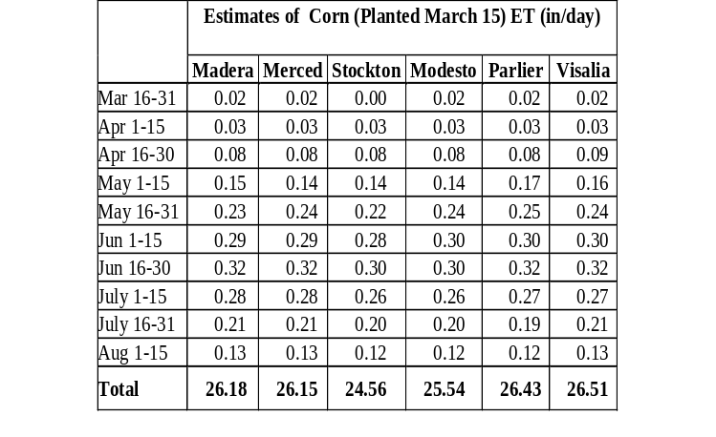
Estimating the crop water use between irrigations gives a good estimate of the amount of irrigation water needed to replenish the soil water in the crop’s root zone. Water use by a crop is often referred to as its evapotranspiration (ET). ET combines the evaporation from the soil with transpiration of the crop. ET tables are available on the web (see link below) with estimates throughout California for: corn of various planting dates, alfalfa, and wheat / barley. The ET values in these tables are in units of inches of water use per day during the calendar periods shown in the left-hand column. For example, for corn planted March 15 in Merced, CA (see table), the ET is 0.29 inches/day during the June 1-15 period. In other words, for each day during the June 1-15 period, the corn crop would be using 0.29 in/day of water. The ET estimates provided are historical averages. Actual daily crop water use may vary from these averages but over a time period of a week or more, the averages are quite accurate.

To determine the irrigation amount needed to replace the soil water used by the crop, simply add up the daily values since the last irrigation. For example, for corn planted March 15 in Merced, if the last irrigation was June 1 and the next is 10 days later, the crop ET would be 2.9 inches (10 days x 0.29 in/day = 2.9 inches). You would want to replace 2.9 inches of soil moisture with your irrigation.

Early season crop water use is low and increases to a maximum in June and July, periods of high heat and long daylight hours. Lower ET, early in the season, results from cooler weather and shorter days as well as from a crop canopy (for annual crops) that is developing. The early season, low ET would seem to indicate that you could go a long time between irrigation, but for annual crops the early season root zone is still developing and irrigations should still be relatively frequent but of a lesser amount. More information on this topic will be discussed in a subsequent newsletter article.

Table From: “Determining Crop Evapotranspiration” http://www.cdqa.org/docs/11_6_Determining_crop_ET.pdf

Be Proactive with Animal Welfare
Noelia Silva-del-Río – UCCE Tulare County

The dairy industry made the news again, but for the wrong reasons. In September, 2009 PETA charged a Pennsylvania dairy farm with animal cruelty. Isolated events related to poor animal welfare practices will gain media attention and destroy consumers’ trust. There are several initiatives led by producers and industry that can help you to meet higher standards of animal welfare:
- The California Dairy Quality Assurance Program worked with leading academic experts at the University of California to develop the Dairy Welfare Evaluation Guide. You can download this at www.cdqa.org.
- The National Milk Producers Federation is supporting a national on-farm animal well-being program accessible to all producers. More information on this initiative can be found at www.dairywellbeing.org.

We urge you to read these guides and take the appropriate steps to ensure your dairy will pass a third party audit. Remember, every person who drives past your property is a potential consumer. For any questions contact your local UCCE Dairy Advisor.


Hay Forage Seminars at the World Ag Expo:
Tuesday, February 9 at location: GS24.3

10:00 - 10:30 am Economic Trends with Hay and Forage Markets, Seth Hoyt - Hay Market Analyst

10:30 - 11:30 Producing, Sampling and Measuring High Quality Hay for Milk Production, Dan Putnam and Shannon Mueller – University of California Cooperative Extension

1:00 - 2:00 pm Principles of Producing High-Quality Silage, Limin Kung Jr - University of Delaware

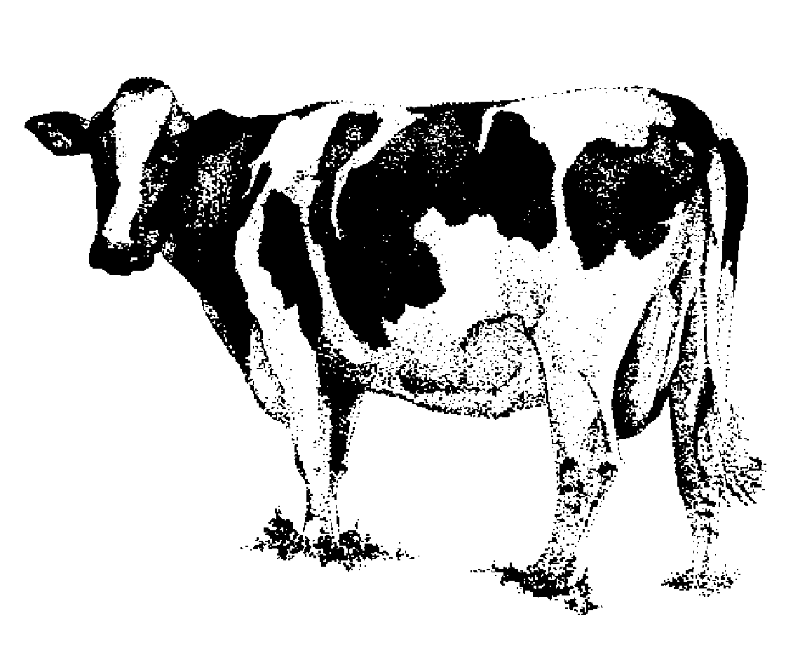


2:00 – 3:00 Silage Management : What Can Go Wrong? What Can You Do About It?, Noelia Silva-del-Río and Jennifer Heguy - University of California Cooperative Extension
Dairy Herdsman Short Course

April 27-29, 2010
Consumer Education Pavilion
University of California-Davis
Veterinary Medicine
Teaching and Research Center
18830 Rd. 112
Tulare, CA
Sponsored by:
University of California
Cooperative Extension
The purpose of the Short Course is to provide the people who do the actual work on the dairy the opportunity to receive information about the latest technology and training in all aspects of dairy management.

Registration fee is $280. Fees for companies and/or dairies with more than one participant will be $280 for the 1st participant and $260 thereafter. Students will be charged $220. No registration at the door will be accepted.

To register on-line and pay by credit card:
http://cefresno.ucdavis.edu/Dairy/Dairy_Herdsman_Short_Course.htm

For more information contact Gerald Higginbotham, UCCE Dairy Advisor at (559) 456-7558.


Attend North Valley Dairy Day to get valuable information on management
strategies that apply to all dairies – big or small.
12:00-12:30 p.m.Allied Industry Sponsored Lunch & Registration
12:30 - 1:00 Don’t Blame the Cows for Climate Change
Frank Mitloehner, UCCE Air Quality Specialist
1:30 - 2:00 The Science Behind Improving Dairy Welfare and Comfort
Cassandra Tucker, UC Davis Department of Animal Science
2:00 - 2:30 Factors Affecting the Price of Market Dairy Cows Sold at Auction
Holly Foster, Independent Contractor, California Beef Council
2:45 - 3:00 Stay Off the Residue List
Betsy Karle, UCCE Glenn & Tehama Counties
3:00 - 3:30 Impacts of Several Feed Additives on Productivity and Feed
Efficiency of Commercial California Dairy Cows
Peter Robinson, UCCE Dairy Nutrition & Management Specialist

3:30 - 4:00 Succession Planning in Uncertain Times
Rod Carter, Northern California Farm Credit Business Consulting
Hosted by: University of California Cooperative Extension Glenn County
Tuesday, February 16, 2010
12:00 - 4:00 PM
To register FREE of charge: Phone: 530-865-1107 x. 0 or E-mail: bmkarle@ucdavis.edu

Location: Glenn County Farm Bureau Office, 831 Fifth St., Orland, CA

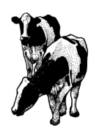
Nyles Peterson, Farm Advisor

California Dairy Newsletter
January 2010
Cooperative Extension
University of California
777 E. Rialto Ave
San Bernardino, CA 92415

