San Bernardino County
4-H Headlines
January 2008 ♥ Vol. 9 ♥ No. 1

Cooperative Extension/4-H Office
777 E. Rialto Ave., San Bernardino, CA 92415
Phone: (909) 387-2179 Fax: (909) 387-3306
E-Mail: caeggleston@ucdavis.edu
Web: http://cesanbernardino.ucdavis.edu/ and http://clubs.ca4h.org/sanbernardino/
State 4-H Web: http://www.ca4h.org/

Upcoming Events

January 11, 2005 Legacy forms for TIC, Cal Focus, and Washington Focus due to the County 4-H Office
January 11, 2005 All-Star Meeting at 5:30 pm at the County 4-H Office
January 11, 2005 Horse Advisory Meeting at 6:00 pm at the County 4-H Office
January 11, 2005 Cal Focus Meeting at 6:00 pm at the County 4-H Office
January 11, 2005 TIC Orientation/Teen Council Meeting at 6:30 pm at the County 4-H Office
January 11, 2005 County Council Meeting at 7:00 pm at the County 4-H Office
January 15, 2005 Summer Camp Staff Training Day (mandatory for all staff)
January 15, 2005 Summer Camp Committee Meeting
January 15, 2005 UC Davis Goat Day, for more information visit: http://animalscience.ucdavis.edu/events/dairygoatday/2005
January 21-23, 2005 Teen Involvement Council (TIC) Conference
January 22, 2005 Summer Camp Early Bird Registration Begins

San Bernardino County Fair Dates Have Changed
The dates for the 2005 San Bernardino County Fair will be May 7th to the 15th. The Beef weigh-in will remain on January 8th but, Sheep, Swine and Goats will move up a week to March 5th. Be sure to mark your calendars!
Attention
Fashion Revue will be combined with County Field Day this year and will be held on March 19, 2005. Get started on your outfits, as this change will put Fashion Revue three weeks earlier in the year. County Field Day packets should be out very soon!

Record Book Tips
December:
Toys for Tots Horse Show: Exhibited - P; Attended - U; High-point - W; Donated toy for Toys for Tots or worked at the show - Y; Showed in showmanship - Z
Summer Camp Staff: Youth Director - F; Staff member - J
County Teen Council Holiday Party: Attended - U
Food Fiesta: Medalist - O; Gave Demonstration - R; Planned Group Activity - T (took part in the planning and running); Attended - U; County Winner - V Project Showing Contest - Z

San Bernardino County 4-H Website

Visit and bookmark the new San Bernardino County 4-H Website at http://clubs.ca4h.org/sanbernardino/ this website is maintained by John Trammell. You can find 4-H forms, information, the county calendar, and much, much, more. The website is being updated often. Be sure to check it out!

Legacy Forms
Legacy Forms are now available on the County 4-H Website. You can download them and fill them out right on your computer or print them out and fill them out the old fashioned way, with a pen. Either way, you can download them and fill them out, then send them in to the County 4-H Office and the Legacy Committee will meet when we have several forms to be considered.

Project Leader Meeting Report Forms
Project Meeting Report Forms are now available on the County 4-H Website. These forms are for Project Leader use and should be filled out for each meeting, it is now easier, as you can do so on your computer and print them out. The directions have also been posted in case you have any questions.

Attention Community Leaders
Community Leaders please remember to check your club file whenever you are in the County 4-H Office. You may have important information or flyers for upcoming events.

Leader Cards
Leader cards have been made and sent out to the Community Leaders, contact your Community Leader to pick up your card. A big Thank You to all of our hard working volunteers!

Horse Ride-A-Thon
The Monte Vista Diamonds Horse and Pony Project held a Ride-A-Thon for the Nichole Peacock Scholarship. They collected donations and went on a two hour trail ride around Puddingstone Lake. Fun was had by all who attended and the result was over $400.00 given to the Scholarship Fund. Thank you all for helping out.

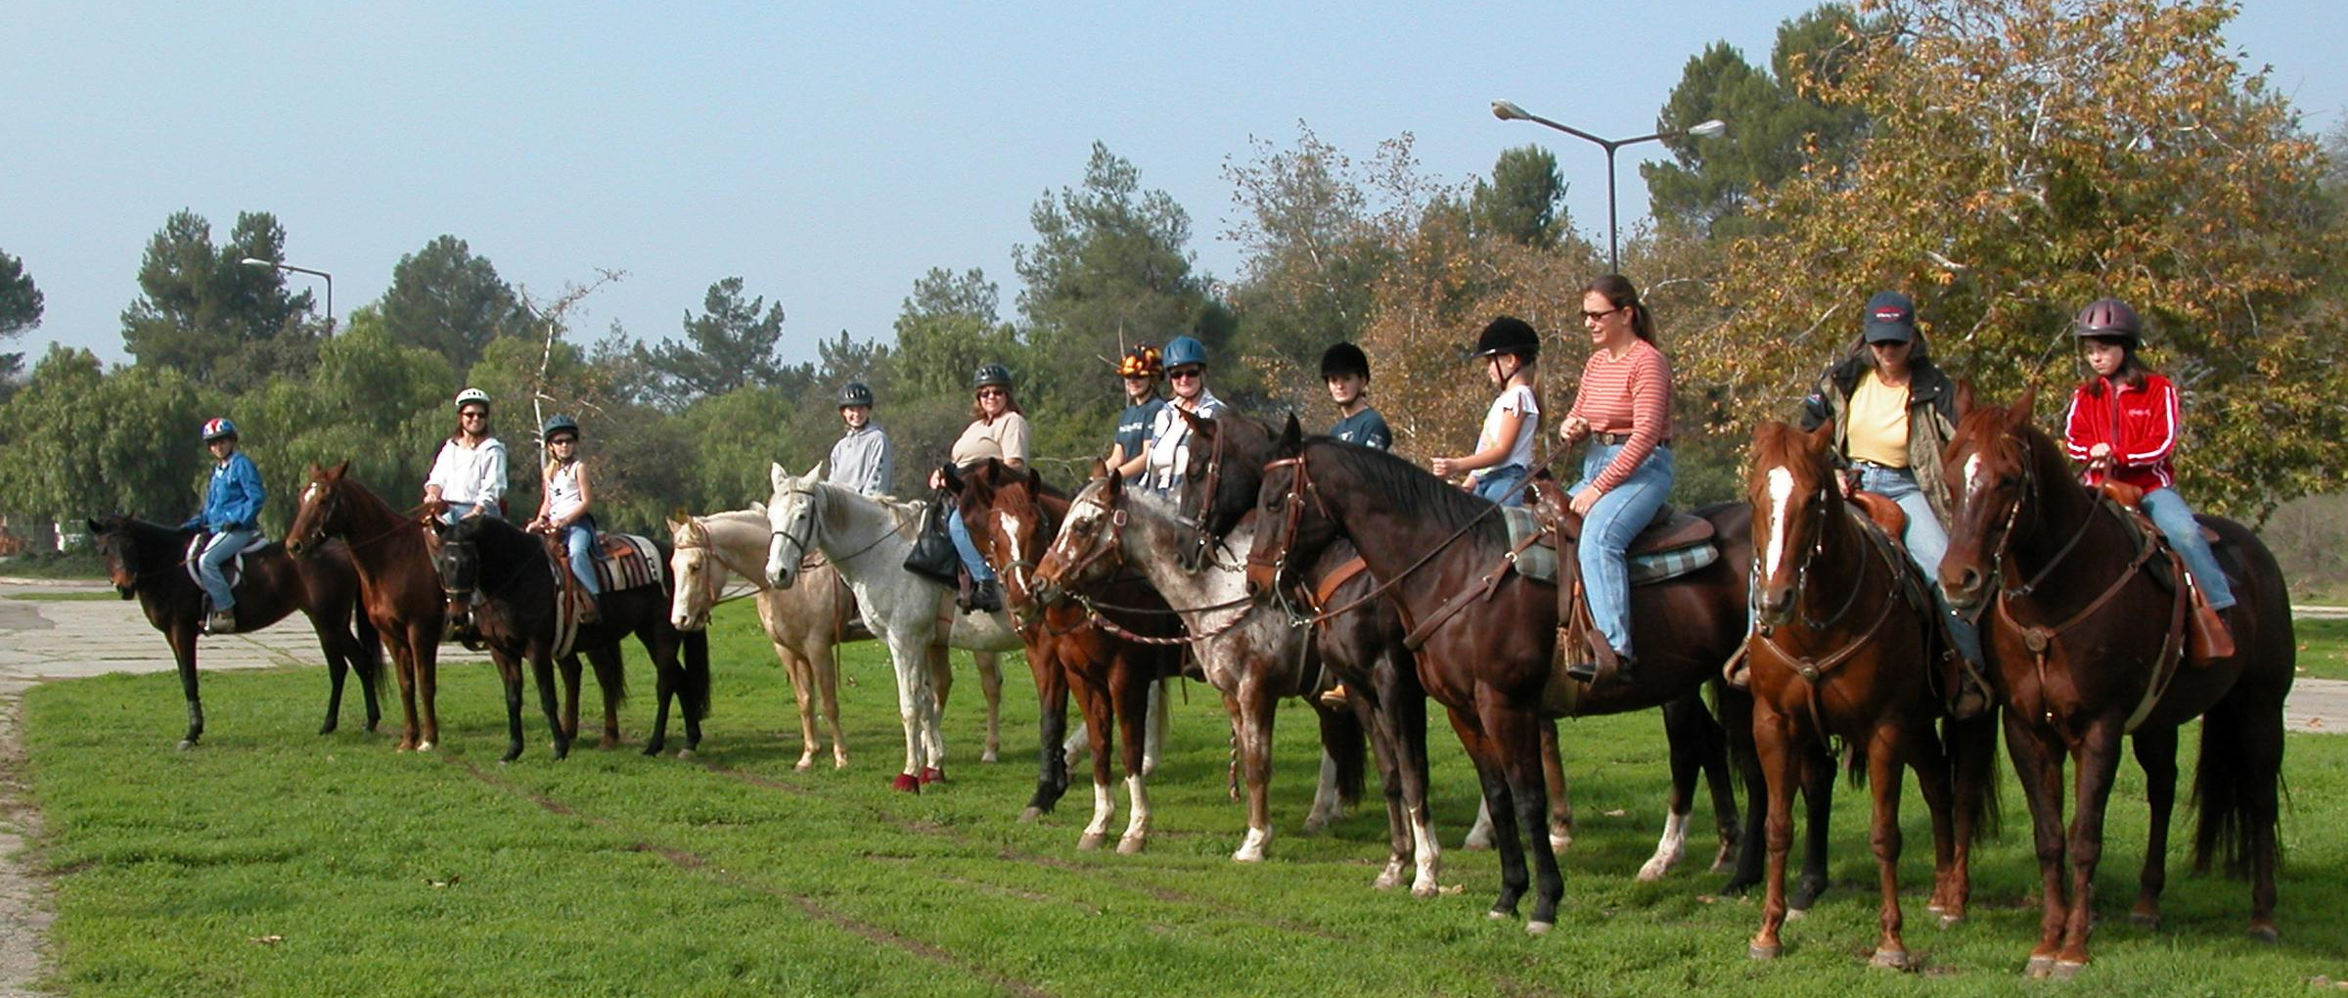

Toys for Tots Horse Show
Our County held a Toys for Tots Horse show to benefit both the Toys for
Tots and the Nichole Peacock Scholarship Fund. We had a great time and
really want to thank those people who donated awards and time to help out
at the show. A really big special thank-you to the Bloomington Boosters
Horse and Pony Project who came down just to help and ended up setting up our jump course. It would have taken our show a lot longer to finish
without their help! We hope to see the Bloomington gang joining in at our
upcoming shows.
County Teen Council Holiday Party
The County Teen Council Holiday Party was held at the Ontario Ice Skating Rink. We had a good turn out and everyone had fun. The Teen Council provided snacks and drinks. If you missed this Teen Council event and you are 13 to 19 be sure to come to the next one, they are always lots of fun!

Erin Johnson, Desert Reporter

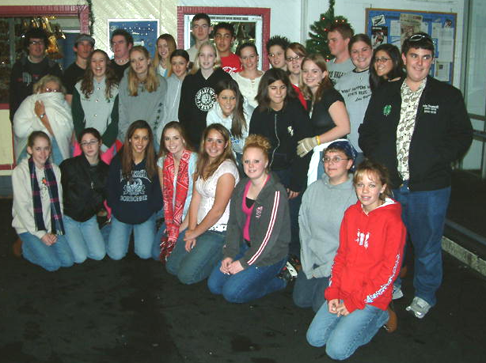

TIC 2005
The Teen Involvement Conference (TIC) this year is going to take place on January 21-23, 2005. This year’s theme is “Reaching for the Stars”. The forms for TIC can be found on the County 4-H Website, http://clubs.ca4h.org/sanbernardino/, under Teen Council or at the State 4-H Website, http://ca4h.org, under sectional conferences in the conference section to the left of the screen. Remember, TIC is first come first served so sign up today. For more information contact John Trammell at johnsphotography@msn.com.

John Trammell, TIC Planning Committee
Archery Leader Training
This training will certify leaders in the archery discipline for shooting
sports and 4-H camp programs. For more information contact Robert Claffy
at (661) 829-1658.
January 22 & 23, 2005 (8:00 a.m. - 5:00 p.m. each day)
Bakersfield, CA
Fee: $20
John Borba, 4-H Youth Development Advisor, Kern County

4-H Shooting Sports Workshop
Shotgun Discipline
This training will certify the participant who successfully completes the
course as a shooting sports volunteer leader in the shotgun
discipline. For further information contact Keith Roper at (530) 335-3917
or email: krpt@shasta.com
January 29 - 30, 2005
Redding, CA
John Borba, 4-H Youth Development Advisor, UCCE Kern County

2005 4-H Horse Leadership Conference
The 2005 4-H Horse Leadership Conference is scheduled for February 12 and 13, 2005 to be held at California State University, Fresno in the Livestock Pavilion. Registration information will be available November 1, 2004. For more information please visit http://www.cal4hhorse.com/ or contact Jazz Stables at 530-754-5809 or jstables@ucdavis.edu

2005 4-H State Leadership Conference
Present a workshop at the 2005 4-H State Leadership Conference! The conference will take place August 4-7, 2005 at UC Davis. More information is available at http://ca4h.org/conference/slc/2005/ Workshop proposals are due March 11, 2005 to the State 4-H Office.

2005 4-H Computer Corps Spring Trainings
Plan to attend the 2005 4-H Computer Corps Spring Trainings for youth and volunteers! Funded by SBC Excelerator through The California 4-H Foundation, the Spring Trainings will focus on electronic forms and web page creation. Trainings will be held from 10:00am–3:00pm on February 19 (San Benito County), March 12 (Orange County), April 9 (Kings County), and April 30 (UC Davis). Information is available at: http://ca4h.org/compcorps/server/ Registrations are due January 15, 2005.
Call for National 4-H Camp/Conference Memories
– Did you know the first National 4-H Conference was in 1927? Delegates of "National 4-H Camp" slept on cots in tents (supplied by USDA) on the National Mall in Washington, DC. In April 2005, National 4-H Headquarters will sponsor the 75th National 4-H Conference! To celebrate this historic landmark, National 4-H Headquarters is collecting stories from past National 4-H Camp/Conference participants. Share your fondest memories at http://www.4-h.org/2005conf

2005 State 4-H Presentation Day
The 2005 State 4-H Presentation Day will be held on May 29, 2005 at UC Davis. Category descriptions and evaluation rubrics are available to download at http://ca4h.org/leadership/spd/ Registration deadline is May 24, 2005.

2005 4-H State Project Competition
Information for the 2005 4-H State Project Competition is now available. The Project Competition recognizes 4-H members ages 14-19 for their leadership, citizenship, and growth in a specific project area. Record Books, due to sectional in mid-July, are judged at sectional and then at the state level. State Winners receive $500 cash and Reserve Winners receive $250 cash. More information and forms are available at: http://ca4h.org/4hresource/ir/

Citizenship Focus 2005
The 4-H Citizenship Program is searching for college-age young adults to serve in a leadership role as District Leaders at California Focus. This internship affords an opportunity for young adults to plan and deliver an educational program centered on California government and history. Application deadline is January 18, 2005. For more information, visit http://ca4h.org/citizenship/focus/districtleaderinfo.asp

Citizenship Washington Focus (CWF) is looking for bright college-age students to help facilitate the program. Program Assistant positions run May through July and include a weekly stipend of $300 with room and board provided at the National 4-H Youth Conference Center. Applications can be found at www.cwf.n4h.org/pa.html
and are due by January 28, 2005.

California Focus 2005 dates are set for June 17 – 21, 2005, adults are $535.00 and youth are $450.00. Focus will return to the Holiday Inn Capitol Plaza in downtown Sacramento. If you are interested in California Focus contact Rozie Trammell at (909) 864-2653.

Washington Focus 2005 dates are:
Washington Focus #1
Road to Democracy June 25 – July 4, 2005 $1,690.00
Heritage Trail I June 25 – July 2, 2005 $1,470.00
Washington Focus #2
Global Journey July 9 – 20, 2005 $1,985.00 Heritage Trail II July 9 – 16, 2005 $1,470.00
If you are interested in Washington Focus contact Kamie Champlin at (909) 877-0692, they will be starting fundraising for the trip.

Wanted District Leaders for California Focus
The 4-H Citizenship Program is searching for college-age young adults to serve in a leadership role as District Leaders at California Focus. This internship affords an opportunity for young adults to plan and deliver an educational program centered on California government and history. Applicants need to have graduated from high school by 2004 and have a minimum of one year of college study completed or full-time work experience. Application deadline is January 18, 2005. For more information, visit: http://ca4h.org/citizenship/focus/districtleaderinfo.asp

Strike It Rich in California at the Western Regional Leaders Forum
WRLF 2005: Exploring the 4 H’s - Head, Heart, Hands, and Health
by Mignonne Pollard, Volunteer and Staff Development
Only once every 13 years, California’s 4-H volunteer leaders host the Western Regional Leaders Forum – affectionately known as WRLF. Eureka! We’ve struck it rich in 2005! This year’s WRLF will be held in Sacramento, California, on February 23-27, 2005. The Early Bird registration price of $265.00 is available if you register on or before December 3, 2004. The price is $295.00 until January 12, 2005. Registration and detailed information can be found online at: http://www.ca4h.org/WRLF2005.

The Forum provides an opportunity for 4-H volunteer leaders and staff to share their expertise and love for the 4-H program: their ideas and resources, skills to sharpen mentoring and teaching skills, and activities to engage youth in all aspects of the 4-H program. Engage your head, heart, and hands while learning to keep the 4-H program healthy!

HEAD: Conference speakers David Henderson of National 4-H Council and Desmond Jolly, Ph.D. of the Small Farms Center will share experiences and humor while engaging our minds. Two days of workshops led by volunteers and staff will range from new skills in crafts to helping youth cope in troubling times.

HEART: Our hearts will be touched by Papa Joe, the Doctor of Common Sense. Papa Joe hails from Texas and tells tall tales to help us make it through the coming years. We will honor amazing volunteers from each state for their service to their club and communities. Make connections with fellow delegates to last throughout the years!

HANDS: A special feature planned for WRLF 2005 is a Community Action Day which will explore the ideals of youth-adult partnerships and service-learning while raising public awareness of 4-H. Participate “hands-on” in a service-oriented activity such as preparing care packages for our troops or helping to restore an urban school site with other youth and adults. Conference delegates can also view 4-H service-learning projects from around the Golden State.

HEALTH: Improve your 4-H program health with pre-conference workshops focusing on the “Marketing of 4-H” led by National 4-H Council’s David Henderson, and the “Elements of Positive Youth Development” shared by Stephen Russell of University of Arizona and Mignonne Pollard of University of California. Carole MacNeil, California State Program Leader and National Director of the 4-H Youth in Governance Initiative, will also provide training on the youth voice in decision-making.

Come to WRLF 2005 to discover Sacramento’s historic Old Town or ride the Napa Valley Wine Train on one of the many day trips offered as part of the festivities! Join enthusiastic youth and adults for dynamic presentations, great prizes, and “golden” ideas to take back home and use in your club or program. Strike It Rich in California – we’ll see you soon!

MARK YOUR CALENDAR!

March 5, 2005

MASTER SHOWMANSHIP CLINIC
At the San Bernardino County Fairgrounds

Hosted by the High Desert Challengers
4-H Club
Improve your showmanship skills in Beef, Dairy Cattle, Dairy Goats, Market Goats, Sheep, and Swine

There will also be a clinic for small animal master showmanship

Registration forms will be available in January.
For further information please contact:
Sarah Wilson (760) 868-5583 or email:
4-hleaders@verizon.net
Maloree McElvain (760) 956-1313 or email: a_vet_tech@bybluelight.com
Food will be available on grounds


Sonoma County 4-H Rabbit Raisers
present
State 4-H Rabbit Field Day

Saturday - January 22, 2005
Sonoma County 4-H Center, Rohnert Park
Check In at 8-8:30 AM  Program Begins at 9:00 AM
COMPETITIONS

Showmanship Judging
Breed Identification Display/Poster Contest

Bonus Small Animal Round Robin Clinic

----------------------------------------------------------------------------------------------

NAME______________________________________________ AGE__________

ADDRESS_________________________________________________________

CITY____________________ STATE CA ZIP _______PHONE______________

SHOWMANSHIP CLASS: □ Novice □ Primary □ Junior
(check only one) (any age) (8 & under) (9-10)
□ Intermediate □ Senior
(11-13) (14+)

UNIFORMS RECOMMENDED – LONG SLEEVES REQUIRED
Rabbits will be supplied – Please do not bring your own

COST: $5.00 Pre-Entry (postmarked by 1/12/05) - $8.00 At the Door
Make checks payable to Sonoma County Rabbits Special Account

MAIL ENTRIES TO: Sonoma County Rabbit Raisers
c/o Jeannette McClure
4101 Pierce Point Road, Inverness, CA 94937

FOR MORE INFORMATION CALL: Hanna Kubicka (707) 769-8554 or Pat Brewer, Adult Leader (707) 762-8104

