San Bernardino County
4-H Headlines
February 2005 ♥ Vol. 9 ♥ No. 2

Cooperative Extension/4-H Office
777 E. Rialto Ave., San Bernardino, CA 92415
Phone: (909) 387-2179 Fax: (909) 387-3306
E-Mail: caeggleston@ucdavis.edu
Web: http://cesanbernardino.ucdavis.edu/ and http://clubs.ca4h.org/sanbernardino/
State 4-H Web: http://www.ca4h.org/

Upcoming Events
February 8, 2005 Cal Focus Meeting at 7:00 pm
February 19-21, 2005 Sectional Horse Show
February 23-27, 2005 Western Regional Leaders Forum
February 26, 2005 San Bernardino County Fair Barn Bash Fundraiser
March 1, 2005 Entries due for County Field Day, Fashion Revue, and Expressive Arts
March 5, 2005 Master Showmanship Clinic. Entry forms are online at: http://clubs.ca4h.org/sanbernardino/
March 8, 2005 All-Star Meeting 6:00 pm
March 8, 2005 Horse Advisory Meeting 6:00 pm
March 8, 2005 County Council Meeting 7:00 pm
March 19, 2005 County Field Day, Fashion Revue, and Expressive Arts
March 19-20, 2005 San Bernardino County Fair Clean-up Day from 9:00 am to 12:00 noon each day

Record Book Tips
January:
County Teen Council Meeting: Attended - U (may only count once for the year no matter how many you attend)
County Council Meeting: Attended - U (may only count once for the year no matter how many you attend)
Teen Involvement Council (TIC) Conference: Attended - U
Sectional Teen Council Meeting: Attended - U (may only count once for the year no matter how many you attend)

San Bernardino County 4-H Website

Visit and bookmark the new San Bernardino County 4-H Website at http://clubs.ca4h.org/sanbernardino/ this website is maintained by John Trammell. You can find 4-H forms, information, the county calendar, and much, much, more. The website is being updated often. Be sure to check it out!

Legacy Forms
Legacy Forms are now available on the County 4-H Website. You can download them and fill them out right on your computer or print them out and fill them out the old fashioned way, with a pen. Either way, you can download them and fill them out, then send them in to the County 4-H Office and the Legacy Committee will meet when we have several forms to be considered.

Project Leader Meeting Report Forms
Project Meeting Report Forms are now available on the County 4-H Website. These forms are for Project Leader use and should be filled out for each meeting, it is now easier, as you can do so on your computer and print them out. The directions have also been posted in case you have any questions.

Attention Community Leaders
Community Leaders please remember to check your club file whenever you are in the County 4-H Office. You may have important information or flyers for upcoming events.

Leader Cards
Leader cards have been made and sent out to the Community Leaders, contact your Community Leader to pick up your card. A big Thank You to all of our hard working volunteers!

County Field Day
Fashion Revue and Expressive Arts
The packets for County Field Day, Fashion Revue, and Expressive Arts are now available online at http://clubs.ca4h.org/sanbernardino/ under "County Events" or from your community leader or the County 4-H Office. Start filling out your entries and sending them in now, don't wait until the last minute. We look forward to seeing you there!
Barn Bash
The 2005 Barn Bash is February 26, 2005. Tickets may be purchased from
Jacqui Cloutier, call Jacqui for other locations to purchase tickets. Please call Jacqui with auction donations. Come and join us for good food and great company. A great chance to help improve our livestock area at the San Bernardino County Fair. Jacqui (909) 877-1466

Kelly O'Brien-Secord, Bloomington Boosters

Rate of Gain Weigh-in
The Rate of Gain weigh-in and tagging for Market Lambs, Market Hogs and Market Goats will be Saturday March 5, 2005. 9:00 am to 2:00 pm only. Gates will close at 2:00 pm. To be held at San Bernardino County Fairgrounds. This is for entries into the Rate of Gain/Evaluation animals only. Any questions call Kelly (909) 877-5801.

Kelly O'Brien-Secord, Bloomington Boosters

Chino Junior Fair
The Chino Junior Fair will be held July 11 through 15, 2005. Everyone is invited to participate! Keep an eye on the upcoming Headlines for more information.

South Section Spring Technology Training Day
The California 4-H Computer Corps will be presenting the South Section Spring Technology Training Day at the Orange County UCCE Office, on Saturday, March 12, 2005. Registration deadline is February 15, 2005.
Please visit http://ca4h.org/compcorps/server/index.asp to print registration forms, and inform the members of this opportunity!
Thank you!
Christy & Kay Strothman and John Trammell, CA 4-H Computer Corps

Teen Involvement Conference
From January 21 to 23, 2005 the Teen Involvement Conference was held at Pathfinder Ranch, 10 miles south of Mountain Center, California. 112 youth from all over Southern California and statewide attended this three day conference. During the conference, youth and adults got to learn new opportunities through 4-H as well as new techniques for leadership and citizenship. San Bernardino County once again was the biggest delegation at the conference. On Sunday morning the Teen Council had their annual elections. I want to give congratulations to Sarah Roethlisberger, the new Southern Sectional Teen Council Secretary, and John Trammell, the new Southern Sectional Teen Council President. I want to thank all the youth for attending and the adults for chaperoning. Workshop proposal forms for TIC will be coming out in March 2005. See all of you next year at TIC.

John Trammell, Valley Reporter

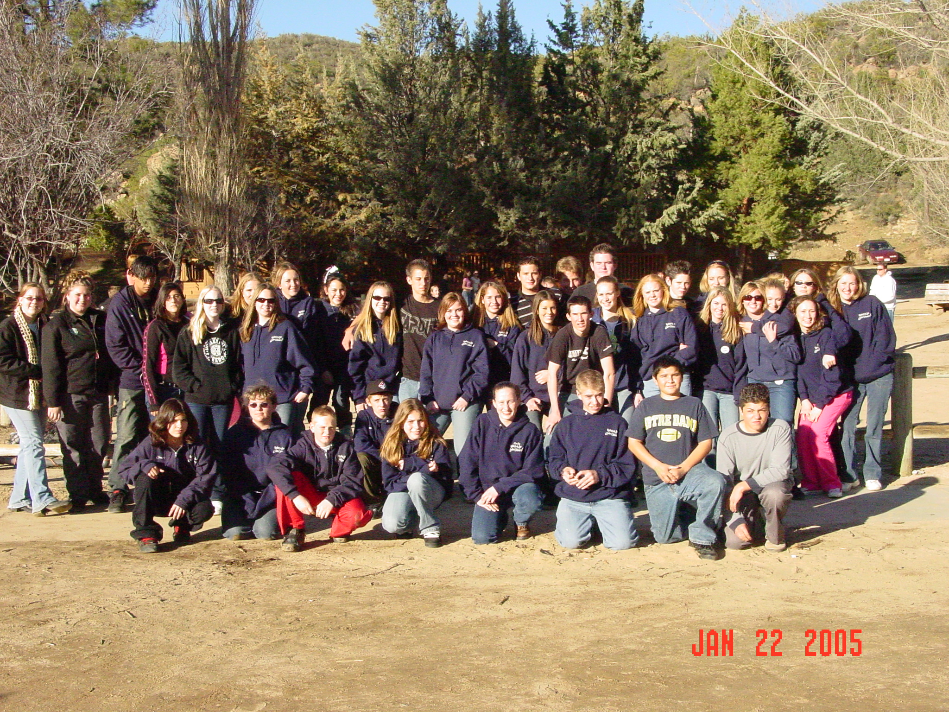
San Bernardino County’s TIC Delegation

2005 4-H State Project Competition
Information for the 2005 4-H State Project Competition is now available. The Project Competition recognizes 4-H members ages 14-19 for their leadership, citizenship, and growth in a specific project area. Record Books, due to section in mid-July, are judged at sectional and then at the state level. State Winners receive $500 cash and Reserve Winners receive $250 cash. More information and forms are available at: http://ca4h.org/4hresource/ir/

Friends of the California State Fair
Doubles Scholarship Awards for 2005
Scholarships Awarded in 2005 Will Total More than $50,000
Volunteer Organization Now Accepting Applications from Calif. Students

In a move that demonstrates their ongoing commitment to fostering youth participation in the areas of agriculture, arts, education and economics, the Friends of the California State Fair today announced that their 2005 Scholarship Program will offer more than $50,000 to California students - nearly double the scholarship amount from 2004. The group is now accepting applications for their Scholarship Program for the 2005-2006 academic year. College students and graduating high school students currently attending California institutions are eligible and must apply by March 25, 2005.

This year, as many as 42 scholarships will be awarded in the following areas: arts, general studies, agriculture, international studies, teaching credential programs, viticulture and enology, culinary, African American and Asian Pacific Islander. The number of scholarships available this year has increased more than 80 percent from 2004 when 28 scholarships were awarded totaling $26,000.

“The Friends of the California State Fair Scholarship Program is our annual pledge to the community that we will support and help sustain California’s outstanding students”, said Friends of the California State Fair President Harry Moos. “By doubling the scholarship donation to $50,000 this year, we are rewarding these students for their achievements and helping ensure that they have adequate resources to support their educational goals”.

All applicants will be evaluated on the basis of personal commitment, goals established for their chosen field, leadership potential and civic accomplishments. In addition to individual, field-based scholarships, all applicants are eligible for the Concours d’ Elegance $5,000 Outstanding Candidate Scholarship.

The Scholarship Program was initiated in 1993 and is a collaborative effort of the Friends of the California State Fair, the California Exposition & State Fair, the California State Fair Agricultural Advisory Council and the Ironstone Concours Foundation.

For more information and to download an application, please visit the California State Fair website at www.bigfun.org or call (916) 274-5969.

Shooting Sports
An online Powerpoint slide show has been put together that answers many of the questions staff and leaders often have regarding the Shooting Sports Project. To access the information, go to: http://ca4h.org/projresource/shootingsports/index.asp Once you have entered the site, click on the bar labeled "California 4-H Shooting Sports Program Orientation Slide Show". If you have questions, contact John Borba at jaborba@ucdavis.edu or (661) 868-6216.

Dairy Cattle Curriculum
To all 4-H Staff and 4-H Families: Would you like to be part of a nationwide pilot test for the new 4-H Cooperative Curriculum System’s Dairy Cattle curriculum? Activities can be downloaded at: www.n4hccs.org. Click on "2005 pilot materials" in the left column and look for the dairy cattle project. The last column, labeled "Pilot test materials”, has PDF files broken down according to levels. For more information, visit: http://ca4h.org/4hresource/updates/attach/DairyCattle.doc

2005 4-H Horse Leadership Conference
The 2005 4-H Horse Leadership Conference is scheduled for February 12 and 13, 2005 to be held at California State University, Fresno in the Livestock Pavilion. Registration information will be available November 1, 2004. For more information please visit http://www.cal4hhorse.com/ or contact Jazz Stables at 530-754-5809 or jstables@ucdavis.edu

Searching for Photos
National 4-H Council needs winning photos from your 2000-2004 state and county fairs to create the 2007 4-H Calendar. The winning thirteen photographs will go on display at the National 4-H Conference Center on September-November 2005 and also be posted on the National 4-H Council website. Photos can be submitted to: 2007 4-H Calendar, National 4-H Supply Service, 7100 Connecticut Avenue, Chevy Chase, MD 20815. More information is at: http://www.4-hmall.org/4H_Mall/PhotoContest2006.asp. Deadline for submissions is March 1, 2005.

LifeSmarts
The California Department of Consumer Affairs is sponsoring the LifeSmarts competition this year and they are looking for additional participants. The State competition will be held March 2, 2005 in Sacramento. The finalist in the State competition will be invited to a national match to be held in Sacramento in April. There is still time to register a team!
In case you haven't heard of LifeSmarts, here is a brief description.
LifeSmarts is a program sponsored by the National Coalition for Consumer
Education. The program develops the consumer and marketplace knowledge and skills of teenagers in a fun way and rewards them for what they learn. LifeSmarts is run as a game-show style competition and can be used as an activity for classes, groups, clubs, and community organizations. It is open to all students in the USA in the 9th through 12th grades. Teams of 4 to 5 students compete in local matches on-line, with the top teams being invited to a State competition.
Please consider sponsoring a team. Feel free to pass this message on to
anyone you think might be interested in participating. For more
information you can go to the Dept. of Consumer Affairs web site:
<www.dca.ca.gov> OR the LifeSmarts site: <www.lifesmarts.org>.
Thanks for considering this opportunity.

Connie Costello, Program Representative, Consumer Economics Program

National Family Volunteer Awards
Family Matters, a national program of the Points of Light Foundation & Volunteer Center National Network, is accepting nominations for National Family Volunteer Awards. The National Family Volunteer Awards recognize outstanding family volunteering activities performed at any time throughout the past year. Families, business/corporations, nonprofit agencies, and volunteer centers are all eligible to apply for the awards. See the Points of Light Foundation website for complete program information and nomination guidelines at: http://pointsoflight.org/awards/nfva/nominate.cfm. Deadline for nominations is March 4, 2005.

Agricultural and Environmental Sciences Field Day
The College of Agricultural and Environmental Sciences at UC Davis will hold the 29th Agricultural and Environmental Sciences Field Day on March 4-5, 2005. Field Day consists of 27 judging events and leadership contests. 4-H clubs and individuals are welcome to compete in all events with five contests designated as official qualifying events for 4-H’ers. 4-H clubs can register by mail. More information is available at: http://ca4h.org/projresource/aesfd/index.asp

4-H Statewide Postal Shoot
It’s time to sharpen up your shooting skills and start preparing for the 21st Annual 4-H Statewide Postal Shoot, sponsored by the Siskiyou County 4-H Council. Entries for the Statewide Postal Shoot must be postmarked by March 11, 2005. All registration materials and fees must get to your local county 4-H office in time to meet the mailing deadline. Full information is available at http://ca4h.org/projresource/shootingsports/index.asp

2005 4-H State Leadership Conference
Present a workshop at the 2005 4-H State Leadership Conference! The conference will take place August 4-7, 2005 at UC Davis. More information is available at http://ca4h.org/conference/slc/2005/ Workshop proposals are due March 11, 2005 to the State 4-H Office.

2005 You See Davis Days
Hay! Alfalfa? Grass? Dinner at the dorms? Wait a minute, just 'cause they CALL us Aggies doesn't mean we have to eat like 'em...
Come check out the other side of UC Davis. It's not just a conference venue with conveniently located classrooms and assembly halls - it's a school too!
Come join your fellow California 4-H'ers for an awesome chance to experience college - no SAT scores required!
Collegiate 4-H at UC Davis is proud to announce the 2005 You See Davis Days:
*Who*
Open to all California, high school level, 4-H members

*What*
This three day, activity-filled event offers high school 4-H members a safe
taste of college life and a valuable chance to experience the campus of the
University of California, at Davis.
While on campus, students will be given a chance to:
- Attend classes
- Tour the campus
- Meet admissions advisors
- Explore Greek life
- Experience the food, dorms, and other highlights of college life.

*When*
April 14th - April 16th
*Where*
University of California, Davis

*Register Now*
Space is limited, so get your forms in as soon as possible! Registration deadline is March 31, 2005
For more information please download the information & registration packet. http://clubs.ca4h.org/collegiate4h/ucd/ysddays.htm

Any questions? Please contact the Event Chair, Vanessa Renwick at vmrenwick@ucdavis.edu
Cindy Sperry, California 4-H Computer Corps

MARK YOUR CALENDAR!

March 5, 2005

MASTER SHOWMANSHIP CLINIC
At the San Bernardino County Fairgrounds

Hosted by the High Desert Challengers 4-H Club
Improve your showmanship skills in Beef, Dairy Cattle, Dairy Goats, Market Goats, Sheep, and Swine

There will also be a clinic for small animal master showmanship

Registration 8:30 a.m.

Clinic Begins at 9:00 a.m.–

Clinic should be through by 1:00 p.m.
For further information please contact:

Sarah Wilson (760) 868-5583 or email;

4-hleaders@verizon.net
Maloree McElvain (760) 956-1313 or email: a_vet_tech@bybluelight.com
Food will be available on grounds
Registration Form

Club: ____________________

Leader Name: _______________Phone #:_________

Members Attending Clinic
Clinic attending: ____Large animal ____ Small Animal
Please use a different form for each clinic

- __________________________________

- __________________________________

- ___________________________________

- ____________________________________

- ____________________________________

- ____________________________________

