San Bernardino County
4-H Headlines
December 2006


COOPERATIVE EXTENTION/4-H OFFICE
777 E. Rialto Ave.
San Bernardino, Ca 92415
(909)387-2179 Fax: (909)387-3306 E-mail: caeggleston@ucdavis.edu

Mark Your Calendar
~December 25- Christmas
~January 1- New Years Day
~January 9- County Council
~January 19-21- TIC
~February 13- Record Book Training
~March TBD- County Field Day/Fashion Revue/Expressive Arts

Memory Book
For this year's memory book each club has been allotted one page, if you need more space you can buy an additional page for $100.00. (Contact the 4-H office) The club page should have a photograph and the balance of the page is yours to use. Contact the 4-H office if you would like a youth representative from the committee to help you. The deadline for submitting photographs and club layouts is December 1st, so everyone needs to be working on this endeavor. Again, if you need assistance, please call, we are more than willing to help, come take photos or what ever you need.

News Letter Articles
If you have any information on events or projects that you would like to put into the newsletter you can call the County office at 909-381-2171, mail it to 777 E. Rialto Ave, San Bernardino, CA 91415, or you can e-mail it to Halli at haller@ucdavis.edu.

State 4-H Equine Field Day

When: Saturday, March 17, 2007
8:30am-4:30pm
Where: Animal Science Pavilion
CSU Fresno
Over twenty presentations are being planned. Participants will be able to attend five different one-hour workshops. Proposed workshops include gymkhana, dressage, driving, drill team, reining, equine health and much more. Pre-Registration is due March 1st. $20 per person, $15 per person for a group of 10 or more, or $25 at the door. If you would like a flyer and registration form contact Halli or Cheryl at the County office.

Charlotte's Web Tickets

For every ticket purchased for Paramount Pictures and Walden Media's production
of Charlotte's Web through
http://www.fourhcouncil.edu/>www.fourhcouncil.edu, Hollywood Movie Money
>will make a $1 donation to 4-H to support your state's 4-H program.
Submitted by Janet Champlin



and pupae are washed out. Make sure you re-fill the trough and put the stopper in the drain. Horses don’t make tasty jerky when dried on the hoof. Be sure to always double and triple check the water source for animals in this triple digit weather. Keep an eye out for standing water under potted plants, old tires, in trash piles, and in garden drains, anywhere it might be. Plants need more water during the heat but water running off of lawns and landscapes in the gutter or puddles in the yard are signs of over-watering.
Teen Involvement Conference 2007


Join us for Operation TIC January 19th - 21st for a weekend of mystery, intrigue, and excitement. This 007 weekend is for 4-H members 14 – 19 years of age as of January 1, 2007. The conference is at Pathfinder Ranch, in Mountain Center, California. This is near Idyllwild and the San Bernardino National Forest. Map, directions, and local attractions can be found on the website below.

The weekend will include interactive workshops such as archery, mock trial, cake decorating, photographing nature, news writing, or going on a trail hike.

For those who are up-to-date on the new Record Book and PDR requirements, and the new Platinum Star, it may be interesting to know several community service activities and service learning projects will be offered.

Registered delegates will be sent a list of workshops where they can rate 1 to 5 their preference of workshop for each time slot. Another reason to register early!

Registration and the most up-to-date information can be found on the Conference Website at: www.TIC007.org

For Questions, e-mail us at krazy_kitten@datahunter.com

A wealth of knowledge is available online at the California Department of Food and Agriculture (CDFA) website. Type “CDFA West Nile Virus” into a search engine and you will get there or use the URL“http://www.cdfa.ca.gov/ahfss/ah/wnv_info.htm”. The CDFA page has hotline numbers for various areas and purposes, information for veterinarians to submit blood samples for testing, places to call and report dead birds, and the latest statistics on horse disease and death.
West Nile Virus is spread by mosquitoes from birds to humans and to horses. The horse is considered a “dead end” recipient in the disease transmission cycle since mosquitoes don’t seem to be able to pick up the virus from infected horses to transmit to other animals or humans. In the wild, infected birds are the “reservoirs” and mosquitoes are the vectors spreading the disease from bird to bird and bird to humans and to horses. Dead birds are an indicator of disease prevalence in an area. Mosquito control is the key to controlling West Nile Virus. Be a good neighbor as well and don’t breed mosquitoes.
Vaccinations and follow –up boosters is the key to keeping a healthy horse. By all means keep yourself safe as well—be smart.
County Projects

Jennifer Barnes, is an Alumni formerly of Apple Valley Rattlers.
Jennifer was the teen leader for the Horse and Pony group. She is very active in the local gymkhanas. She was crowned Hesperia Rodeo queen on July 29th, 2006. Jennifer represents the City of Hesperia, at different rodeos all over the state of California. She is very involved in the community events like the Air Show, Special Ops Rodeo, and Parades.
Jennifer is seen
here carrying the 4-H
flag at the Sheriffs
Rodeo, at Glen Helen
in September 2006.
We would like to
congratulate Jennifer
on her crowning and
thank her for her
continued support of
the 4-H programs.

California Focus
June 22-26, 2007, Sacramento, California
For those who are planning to attend this years California Focus please remember that registration is due by January 29th with a $100.00 non-refundable deposit. If you would like more information on California Focus and when the next meeting will be held please contact Michele Grainger at (909) 795-8663.

Colorado River 4-H
Small Stock Show
When: Saturday and Sunday February 24 & 25, 2007
Where: La Paz County Park, Parker Arizona
If you would like registration information please contact Cheryl at the county office.
There are some projects that used to be recognized at the State level that are no longer considered a project, but we still use them at our county level. For instance, Beginning 4-H – this project introduces new members in 4-H to different projects throughout the year so they can choose a project they would be interested in. Although there are no guidelines at the state level for this project anymore, we still consider it a project at the county level and members can receive credit in their record books at the county level only.
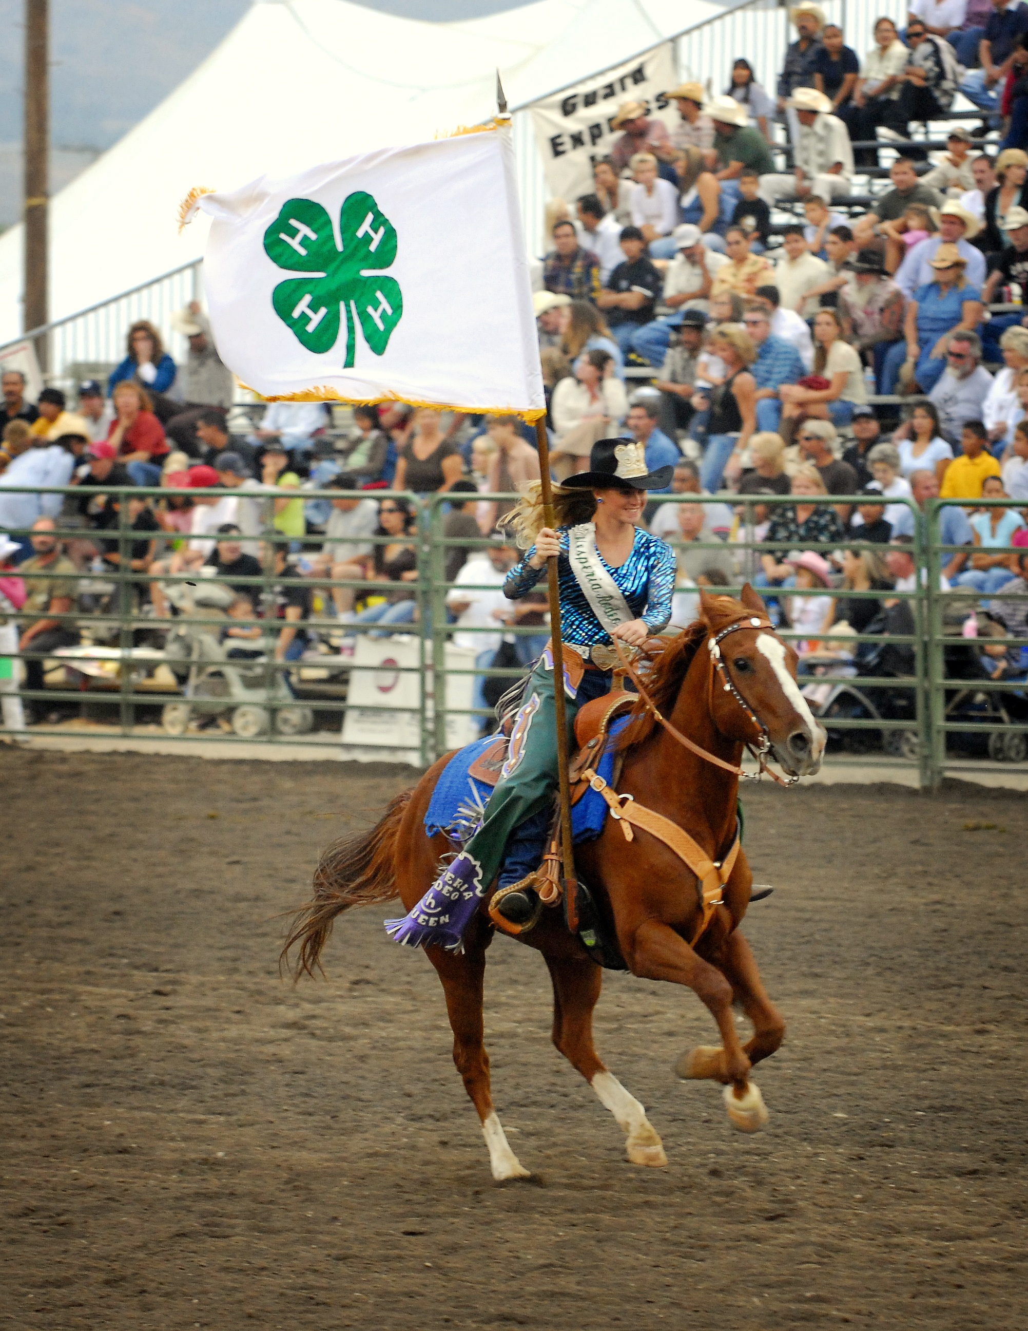
National 4-H Week
October 1 - 7. National 4-H Week is fast approaching. Now it the time to start planning what you club would like to do to celebrate National 4-H Week. Community services and educational exhibits are always great ways to get the 4-H name out in the public. If you need any assistance, please call the 4-H Office.

Congratulations!

Congratulations to
Stephanie Sornoso
a member of the
Bloomington Boosters
Club. She represented
us at the state fair and
won the wool “Lads
and Lassies” competition
at the State Fair. Doesn't
she look great!

Achievement Night
The Happy Days of 4-H
Food Fiesta

Food Fiesta was a great success thanks to the Inland Rockin Rebels and all their hard work. Everyone who came had a good time and some good eatin' at the end of the day! Here are the results:

Primary Members
Kevin Macasey Snowline Club Blue Ribbon
Trinity Williams Blue Ribbon
Tom Frye East Valley Blue Ribbon
Victoria Williams Blue Ribbon

Cookie Class
Henry Frye East Valley Red Ribbon
Tory Grainger Inland Rockin Rebels Red Ribbon
Danielle Johnson Bloomington Boosters Blue Ribbon
Erin Mackesy Snowline Club Blue Ribbon
Anthony Macasey Snowline
Megan Chiatovich Bloomington Boosters Blue Ribbon & Best of Show

Agriculture Vegetable Gardens & Crops
Danielle Johnson Bloomington Boosters Blue Ribbon
Henry Frye East Valley Blue
Sam Frye East Valley Blue & Best of Show

Favorite Dessert
Cassie Dunbar Hesperia Highlighters Blue
Stephanie Keith Apple Valley Rattlers Blue
Andrew Viloria Apple Valley Rattlers White
Rumiana Coe Snowline White
Michelle Davis Bloomington Boosters White

Cake Decorating
Michelle Davis Bloomington Boosters Blue
Rumiana Coe Snowline Blue

Food Craft
Amanda Chiatovich Bloomington Boosters Blue
Wes Chamberlain Snowline Blue
Rumiana Coe Snowline Blue & Best of Show

Candies & Confections
John Macesy Snowline Blue & Best of Show
Becky Dunbar Hesperia Highlighters Blue
Erin Mackesy Snowline Red

Come join the fun and celebration of achievement night. Good food, friends, and meet our own COUNTY MASCOT.

Where: Bloomington Christian School
9904 Bloomington Avenue
Bloomington
When: Saturday, September 23, 2006
Dinner- 5:30 P.M.
Awards- 7:30 P.M.

Leadership Day 2006

Leadership day will be held on Saturday, October 14th at 9:00 a.m. at the county 4-H office. There will be workshops on the new junior teen leader forms, how to complete your leadership records, officer training, developing leadership beyond the club level and much more. This is a great way to meet new friends, learn skills to take back to your club and participate in the county teen council meeting.
This year, we are collecting canned goods to be sent to the Ronald Mc Donald House in Loma Linda. This will count as part of your citizenship, community service project, so bring your donation to the meeting.
We will be electing new teen council officers and yes, we will be voting on the design for our TIC sweatshirt. Bring your ideas and designs. All teens are welcome to come.

Memory Book

Perserved Food
Rumiana Coe Snowline Blue
Tory Grainger Inland Rockin Rebels Blue
Erin Mackesy Snowline Red
Tory Grainger Inland Rockin Rebels Red
Cortney Guerra Inland Rockin Rebels Red
John Mackesy Snowline White
Tory Grainger Inland Rockin Rebels Blue & Best of Show

Breads & Rolls
Michelle Davis Bloomington Boosters Blue
Janet Champlin Inland Rockin Rebels Blue
Amanda Chiatovich Bloomington Boosters Blue
John Mackesy Snowline Blue & Best of Show

Primary Foods
Cole Coonce Bloomington Boosters Blue
Andriana Coonce Bloomington Boosters Blue

Foods and Home Environment
Danielle Johnson Bloomington Boosters Blue & Medalist
Megan Chiatovich Bloomington Boosters Blue
Tory Grainger Inland Rockin Rebels Blue & County Winner

Foods Preservation
Candaa Torres Inland Rockin Rebels Blue & Medal

Cake Decorating
Janet Champlin Inland Rockin Rebels Blue & Medalist
McKenna Chamberlain Snowline Blue & Best of Show

2007 California
Focus Group

Are you interested in learning about California and how it is run? Then Cal. Focus is the program for you. California Focus is a unique 4-H Citizenship educational experience that combines hands-on participation in workshops, debates, and simulations with outstanding speakers and visits to historical, cultural, and governmental sites. California's capital city, Sacramento, becomes a "living classroom" for this five-day, action packed adventure.
We are currently forming a group of teens that will represent our county this year. You must have completed the 8th grade by the time of the event in June 2007. The delegates will extend their learning as they prepare and present a "Plan of Action" to implement back home in their respective communities. Outstanding plans are showcased at the conference and an award is given each year for the one that is judged

