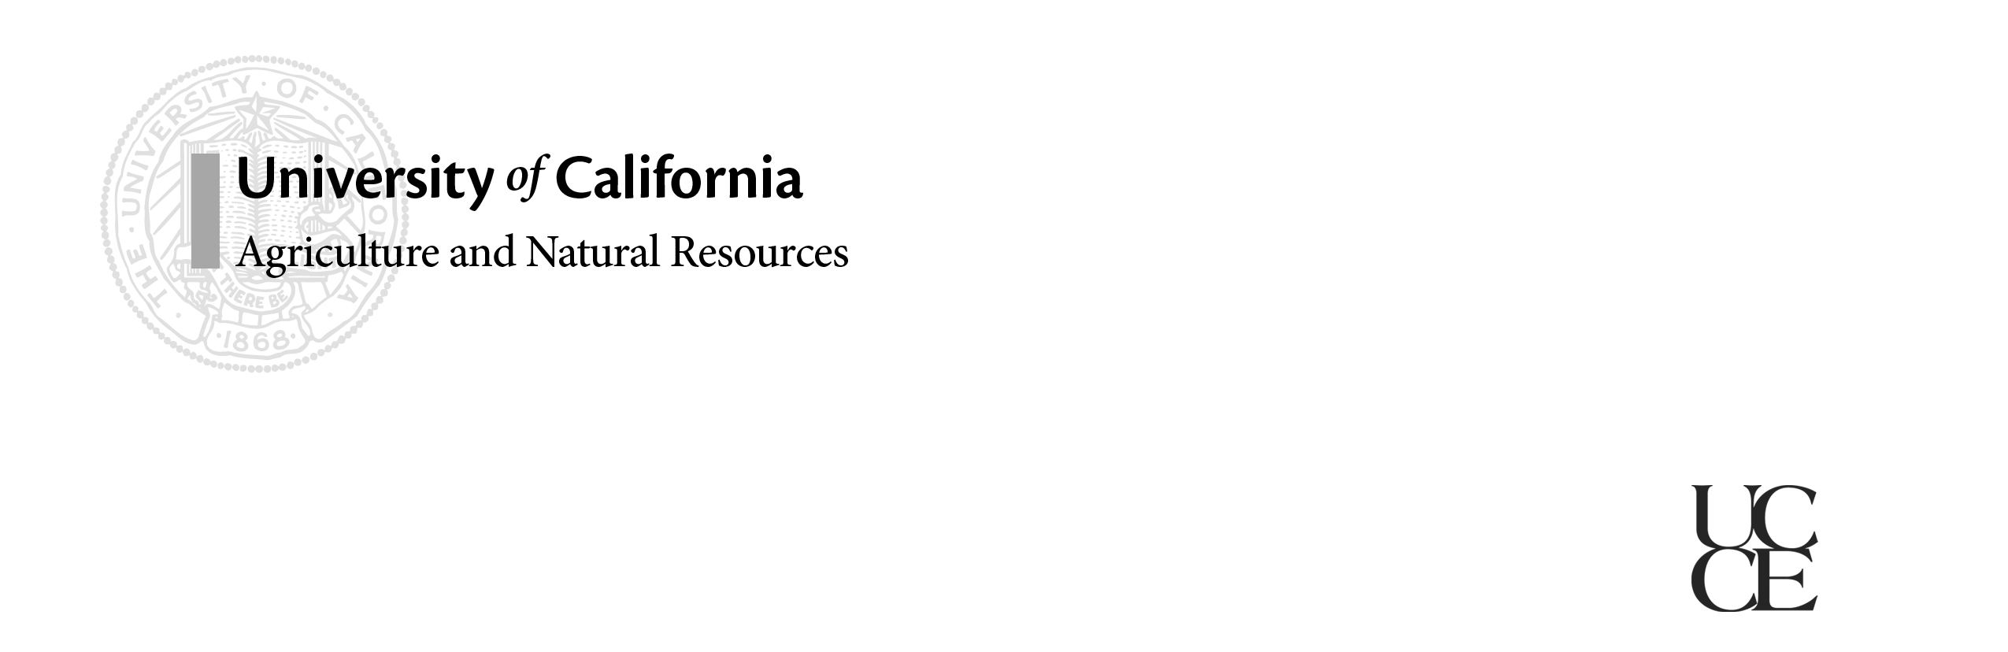

# California Dairy

# Newsletter

# Vol. 7, Issue 4 October 2015

**Preparing for El Niño**

**In this Issue…**

Preparing for El Niño **–** 1

Managing Mud **–** 2

Sharp Objects and Lame Cows **–** 4

Pneumonia in Calves – 5

CAHFS and Animal Disease – 6

C. Collar Retirement – 7

Dairy Advisor Position Recruitments – 7

**Newsletter Editors:**

**Jennifer Heguy**

UCCE Dairy Advisor

Merced/Stanislaus/San Joaquin

jmheguy@ucdavis.edu

209-525-6800

**Dr. Noelia Silva-del-Rio**

Dairy Production Medicine Specialist, VMTRC

[nsilvadelrio@ucdavis.edu](mailto:nsilvadelrio@ucdavis.edu)

559-688-1731

*Dr. Deanne Meyer, UCCE Livestock Waste Management Specialist, UC Davis*

The meteorologists tell us we have an El Niño winter ahead of us. In fact, it’s a big one from an El Niño perspective. That doesn’t mean winter will arrive early. It merely means that winter is likely to be warmer and wetter for parts of California. The 64 million dollar questions are where will it be wetter and how wet is wetter? No easy answers are available. Here’s what we know…Southern California typically gets pounded by El Niño. The Central Valley may or may not get hit and every place within the Valley may not get hit even if the Valley gets abundant rain. Where does that leave you? If you’re in California preparation is essential.

**Read through your Operation and Maintenance Plan** for your facility. This should provide a good starting point for an “it’s going to rain” check list - always a good thing to make when we haven’t seen rain in a bit.

**Clean and repair gutters:** Gutters work best when they’re free of debris and in one piece. Walk through the facility and think about heavy rainfall. Where will water flow from roofs? Does it have a way to get collected and stored? This is an especially important exercise if you’ve added any roofed or concrete surfaces in recent years (given we haven’t seen rain in what seems like forever). If you can divert clean water from storage, that’s good. If not, plan to collect all rainwater that comes in contact with feed or manure nutrients.

**Clean corrals:** removing solid manure from corrals relocates nutrients. It’ll be important to have an earthen base and repair any potholes in corrals before rains set in. Also, check the slope of corrals and be sure that water accumulating in the downslope area is able to be pumped out and transferred to storage lagoons.

**Cover stockpiled solid manure:** covering solid manure prevents rainwater from coming in contact with manure nutrients. This is important to minimize potential erosion of stockpiled piles and also helps keep the nutrients in the pile. You’ll likely need to collect the runoff and store it in a lagoon, but at least this will add very dilute water and not as many nutrients to your liquid system. Also, for those dairies in the San Joaquin Valley it’s important to keep wet things wet, and dry things dry and under cover (Air District Rule 4570 measure).

**Talk with your crop consultant NOW:** Understand your nutrient budget well enough now so that if heavy rains arrive and you need to apply nutrients to your fields, you’ll have a good understanding of your options. You’ll likely want to sample your lagoons ahead of the application events to see if nutrients are diluted (or not) given the rainy season.

Planning ahead is your best tool for El Niño! If you do end up with a discharge be sure you contact the Regional Water Quality Control Board and conduct all necessary sampling. You may also want to contact your local County dairy permitting authority.

**Managing Mud on Dairies**

*Dr. Michael Payne - Director, CDQAP*

Now is the time to manage corrals to reduce mud before El Niño is upon us. Relatively little research exists on the effects of mud on dairy cattle, but in one relevant study researchers estimated that for every inch of mud, dry matter intake (DMI) is reduced by 2.5%. This observed correlation between increasing mud and decreasing DMI should predict a concurrent decrease in milk production.  In fact, in a separate University of California (UC) study, there was a significant association between increasing precipitation and reduced test day milk, particularly for dairies where cows were housed outside without shelter.

Cows will be more reluctant to make their way to the feed alley if they have to walk through mud. When they do walk to the feed apron, depending on the depth of the mud, they can expend significantly more energy doing so. Cows also require increased energy requirements if forced to lay in wet environments and cows will spend less time laying down altogether. During research conducted by UC, cows even preferred to lie on concrete rather than in muddy areas. Reluctance to transverse muddy areas may lead to cows eating fewer and larger meals (slug feeding) which may increase incidence of rumen acidosis, laminitis and displaced abomasums. Mud and lack of cleanliness associated with wet environments has been linked to increases in [mastitis](http://www.progressivedairy.com/index.php?option=com_content&view=article&id=1380%3A0508-pd-the-effects-of-mud-on-your-dairy-cows&catid=99%3Apast-articles&Itemid=129) and metritis. Wet conditions contribute to softer hooves and an increase in lameness.

**Corral Management to Prevent Mud**

General- Most corrals can be maintained at a minimal cost using some basic practices. In particular and as described below, diversion of outside rain water and regular scraping can typically be performed with existing equipment and labor. Most mud problems can be managed simply by creating adequate slopes and drainage and regular manure removal. For many dairies, soil stabilization with wood chips, gravel, road base, fly ash, concrete etc., may only be required in high-traffic lanes, feed alleys and around watering troughs.

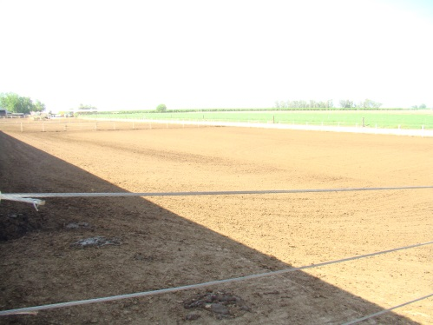Corrals can be managed to prevent mud, but *correcting* mud problems can be difficult if not impossible during the winter, after the soil has been saturated by rain. For that reason it is important to repair, resurface, re-slope and re-compact the corrals during the dry months. A useful mindset reported by some successful dry-lot producers is that corral management and grooming needs as much attention as that given to free-stall management and grooming. [Good corral management](http://gpvec.unl.edu/mud/Enviro-FeedlotMud-SDSUExt1020.pdf) includes attention to water diversion, routine grooming, corral sloping and drainage, and loafing mounds.

Routine Scraping/Grooming of Corrals – Manure greatly increases the water holding capacity (and softening) of soil; Midwest feedlot managers actually sometimes [refer to the top layer of manure and soil as “sponge”](http://gpvec.unl.edu/mud/Enviro-FeedlotMud&DustControl-Notes&Thoughts2008.pdf). For this reason, light but regular scraping throughout the year is essential. Use of a box scraper or similar implement is preferable to use of a front end loader to prevent gouging the corral surface and disrupting the slope. [One trick](http://gpvec.unl.edu/mud/Enviro-FL-PenSurface.pdf) beef feedlot managers have used to prevent employees from scraping too deeply is to use a screwdriver to measure the depth of the compacted manure and set the scraping implement accordingly.

Water Diversion – In some situations preventing outside surface water from entering the lot may be the simplest, most cost-effective action to reduce mud in a corral. Terraces or trenches can be built to direct water around animal confinement areas and gutters can be used to collect rainfall from building roofs for diversion.

Sloping Corral Surface & Drainage – In order to assure adequate drainage, California has regulations specifying slope for pens ranging from 1 ½ to 3 percent depending on the density of cattle. Beef feedlot experts suggest that more aggressive slopes are needed to provide for adequate drainage with minimum erosion, typically between 3 and 6 percent. Less slope may be needed for pens having a reduced cow density. Ideally the corral surface should be shaped to provide the shortest route for storm water to get to a drainage channel. If possible it’s optimal for each pen to have its own definite drain. Methods used to compact silage in bunkers have been reported to work well for corral surfaces. As described below, fly ash can be used to stabilize both mounds and corral surface.

Loafing Mounds – More than 60% of beef feedlots in the U.S. use mounds and Cooperative Extension literature contains [excellent guidance on managing feedlot mounds](http://gpvec.unl.edu/mud/Enviro-FeedlotMounds-ISU%2010525.pdf). In general, mounds should be orientated in the direction of the corral slope to prevent blocking drainage. In some corrals, producers may consider joining the mound to the feed apron and water trough so that cows don’t have to cross muddy areas to access them. Typically, feedlot mounds are recommended to be 5 to 8 feet high with a slope of 4:1 to 5:1 allowing cows to rest comfortably. The mound crown is typically kept only 5 to 10 feet wide; wider crowns tend to promote standing water which softens the surface. Typical recommendations for feedlot mound size are in the 45 square feet per head range. Mound stabilization is critical and fill dirt, preferably clay, should be mechanically compacted during the summer. Methods used to compact silage in bunkers have been reported to work well for mounds.

**Fly Ash to Stabilize High Traffic Areas**

One method of preventing mud is to use fly ash (or more typically a blend of fly ash and bottom ash) to stabilize the corral surface or lanes of high animal traffic.  Fly ash (or flue ash) is a combustion product of industrial incinerators consisting of the fine particles that rise with the flue gases. When collected for use, fly ash has the consistency of talcum powder, making it difficult to transport or apply in its pure form. In contrast, the “bottom ash” which is typically removed from the bottom of the broiler, will have consistency more like fine gravel or course sand. A unique feature of fly ash is its “pozzolanic reaction” with calcium in soil, setting up a mixture that is similar to concrete, greatly stabilizing the surface and minimizing mud. Unlike fly ash however, much of the pozzolanic activity in bottom ash has been lost during its transport in water to storage ponds. Bottom ash then has little benefit as a soil-stabilizing amendment by itself, but it is frequently mixed with fly ash. Such Bottom Ash Blend (BAB) products have soil-like characteristics, are easy to work with and still maintain the ability to bind and stabilize soil. For ease of use, ideally the supplier provides producers with a 70% bottom ash and 30% fly ash mixture, based on volume. If you intend to use fly ash to stabilize high traffic areas, it’s critical that it be sourced from companies using only organic material such as tree trimming and unpainted lumber. Fly ash using other source material (such as tires or treated lumber) potentially contains contaminants which you don’t want on your dairy.

*This article is excerpted from “CDQAP Ruminations.” For more information on mud management and other topics related to animal care and improving your bottom line profit visit CDQAP Ruminations at* [*http://cdrf.org/home/checkoff-investments/cdqap/animal-care-the-cdqap/*](http://cdrf.org/home/checkoff-investments/cdqap/animal-care-the-c#dqap/)

**Lame – Are Your Cows Stepping on Sharp Objects?**

*Dr. Marc Pineda, VMTRC Researcher & Dr. Noelia Silva del Rio, UCCE Dairy Health Specialist*

Lameness is an important issue on dairy cattle operations with implications on animal welfare and herd production level. Economic losses associated with a lameness case range from $18 to $95. Our research team has recently interviewed 22 hoof trimmers in California (13 in-house and 9 outside service providers) to learn about their perception of the most common reasons for lameness. Surprisingly, most hoof trimmers (82%) indicated that stepping on sharp objects or stones was one of the major problems found on lame cows.

**Figure 1**. Foreign objects found stuck on hooves.

***What are cows stepping on?***

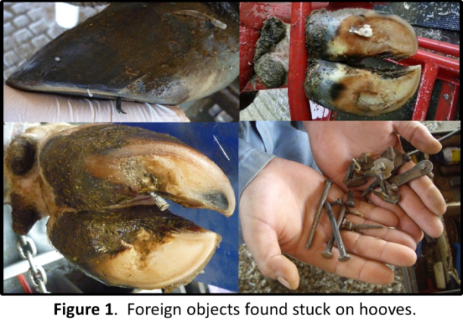Metal pieces from stall separators, headlockers, worn rubber mats or heavy equipment (mixer box, harvester, bedding) are routinely found on cow's hooves (Figure 1). Other objects found on hooves included needles, teeth and stones.

***How can I know if this is a problem on my dairy?***

Ask your hoof trimmer about the frequency and type of sharp objects stuck on your cow's hooves. Even when no foreign objects are found on the hoof, evaluate if abscess and bruises are present. Abscesses are formed after sharp objects introduce bacteria in the hoof, while bruises result from traumatic force to the sole when stepping on rough objects.

Note that some hoof trimmers are not skilled at lesion identification. Bruises were often mistaken for sole ulcers and white line diseases. Reviewing lesion classification with your hoof trimmer is advisable (<http://www.vetmed.wisc.edu/dms/fapm/fapmtools/6lame/Hooflesionscoresheet.pdf>).

***How can I reduce hoof lesions due to sharp objects?***

**Figure 2**. Magnents used to remove metal objects from walkways and pens.

Reduce the presence of sharp objects on walkways and pens by:

- Removing nails and screws with a magnet. *(Figure 2)*

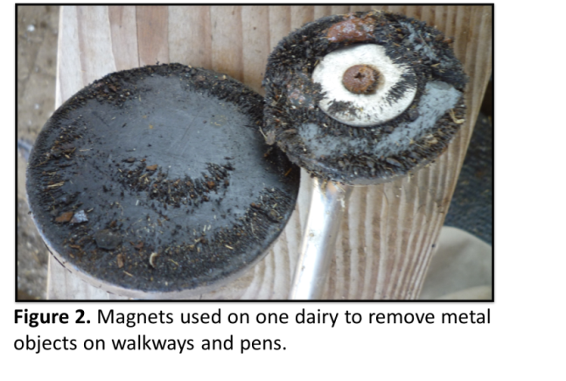- Disposing needles properly

- Repairing worn rubber mats. We have found nails sticking out of worn rubber mats that can puncture hooves.

- Maintaining facilities. Broken concrete can be a source of sharp stones.

Ensure your cows have a desirable sole thickness and horn hardness:

- During trimming, avoid unnecessary reduction of sole thickness.

- Consider the installation of rubber mats on walkways.

- Reduce humidity at the claw level to avoid soft horn.

**Pneumonia Prevalence in Pre-weaned Dairy Calves**

*Betsy Karle, UCCE Dairy Advisor, Northern Sacramento Valley*

During the summer and early fall of 2014, we visited 31 dairies in three regions of Northern California (Humboldt, Del Norte- Region 1; Sonoma, Marin, Mendocino- Region 2; Glenn, Tehama, Yuba- Region 3). We completed a survey focusing on calf management practices and scored calves on the dairy using the California Bovine Respiratory Disease (BRD) scoring system (**Figure 1**). The scoring system was developed to be accurate, rapid, cheap, reliable and simple and correctly identified 72.2% of calves with BRD and 89.9% of healthy calves in a validation study. Calves were considered positive for BRD if their score was equal to or greater than five.

**Figure 1**: BRD scoring system chart, available at: <http://www.vmtrc.ucdavis.edu/>.

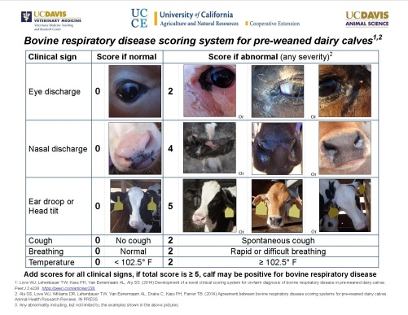

A total of 1,438 calves were evaluated in this study. The average BRD prevalence was 10.2% and ranged from zero to 37%. The difference in prevalence across the regions was not statistically significant. The observed prevalence of BRD in Holstein calves was 7.2%, compared to 15.9% and 12.1% for Jerseys and all other breeds, respectively. Jersey calves were 2.2 times more likely to be positive for BRD in this study. More than half (54.8%) of the dairies visited were certified organic and were located exclusively in Regions 1 and 2 on the North Coast. Overall BRD prevalence was 10.5% on organic dairies and 10.8% on conventional dairies, which was not statistically different.

**Figure 2.** Group housing and BRD prevalence.

About 70% of the dairies surveyed used some degree of group housing for pre-weaned calves, with pens containing between 2 to 40 calves (**Figure 2**). Group housing was correlated with increased odds of BRD compared to calves that were housed individually. Each additional calf in a pen was associated with a 7% increase in BRD.

Our initial analysis of the data underscores that no single management practice is responsible for pneumonia in pre-weaned calves and there is a need to further examine risk factors. We would like to collect additional data from the San Joaquin Valley and analyze further management practices that affect prevalence of pneumonia in pre-weaned dairy calves. For training on the California BRD Scoring System or to participate in this study, please contact Betsy Karle ([bmkarle@ucanr.edu](mailto:bmkarle@ucanr.edu), 530-865-1156) or Dr. Sharif Aly ([saly@ucdavis.edu](mailto:saly@ucdavis.edu), 559-688-1731).

**CAHFS’ Core Mission and How it Supports the Dairy Industry**

*Dr. Patricia Blanchard, Associate Director, CAHFS*

The primary mission of the California Animal Health and Food Safety Laboratory System (CAHFS) – a public service program of the UC Davis School of Veterinary Medicine - is to detect and diagnose incursions of foreign and emerging animal diseases, diseases of high consequence and toxic events involving animals. However, to accomplish this mission, CAHFS must have a robust laboratory system in place so that experienced personnel and appropriate test methods required to detect and respond to a foreign animal outbreak or toxic event are immediately available. This ongoing competency and laboratory infrastructure is ensured by the day-to-day performance of routine necropsies and a wide range of tests for common diseases and health screening for nutritional status and proof of freedom from disease for movement. In performing our daily work, CAHFS may identify evidence that suggests a foreign disease or toxic event through an animal’s clinical history or necropsy.

Many endemic diseases can cause oral lesions in cattle which can appear like foreign animal diseases. For example, the most commonly investigated potential Foot and Mouth disease (FMD) cases in dairy cattle are usually Bovine Papular Stomatitis (BPS), a parapox virus. However BPS can cause ulcers instead of raised pox lesions which could look like FMD. The American form of Malignant catarrhal fever, a rare disease seen sporadically in dairy and beef cattle, is caused by an ovine herpesvirus-2, but the disease looks identical to the African form of MCF carried by wildebeests. In 2008, a beef sale in Texas resulted in several purchased heifers that were moved to other states becoming ill and dying from the African form of MCF. A state and federal investigation revealed a group of 135 bred heifers had been housed adjacent to a pasture with a long established herd of wildebeests. For reasons like this incidence, when a disease which can look like a foreign animal disease is detected, a trained foreign animal disease diagnostician from the California Department of Food and Agriculture (CDFA) or the United States Department of Agriculture (USDA) performs a farm investigation and the necropsy samples and samples collected from live animals on the farm are tested at both a USDA and CAHFS laboratories. CAHFS is able to perform official screening tests within six hours for 11 viral diseases which include nine endemic “look-alike diseases” including BPS and Bovine viral diarrhea (BVD), Bluetongue virus, American MCF, as well as, FMD and Vesicular Stomatitis. The importance of these types of investigations involving CDFA and USDA, the veterinarian and animal owner, is for California and the nation to demonstrate to our global trading partners that we are performing due diligence to investigate potential foreign animal disease incursions. This work helps guarantee our export markets remain open and that a foreign animal disease is identified as early as possible.

On occasion, CAHFS receives animals from premises where numerous animals have died or become ill in a very short period of time without evidence of an infectious cause. A thorough clinical history combined with necropsy findings can often narrow the likely cause to a toxin exposure. CAHFS toxicology laboratory has one of the most extensive menus of test methods available nationally and provides confirmatory testing of toxins in animal samples and feed. When needed, the toxicology section can also test for the toxin in milk or meat. By regulation pursuant to section 9101 of CDFA code, “..any toxicology condition likely to contaminate animals or animal products (meat, milk or eggs)” is reportable to CDFA. This reporting allows CDFA to investigate in order to ensure no toxins enter the human food supply and, when necessary, to trace the source of the toxin and sales of the tainted product if it was a commercially available animal feed.

CAHFS’ critical partnership with producers, veterinarians, CDFA and USDA will continue to allow us to detect foreign and emerging diseases and toxic events early so that intervention and control efforts can be initiated. This is a valuable resource for animal owners, veterinarians and the general public ensuring safe animal feed and human food and ensuring our export markets remain open.

*For information on services offered by CAHFS visit* [*http://cahfs.ucdavis.edu/*](http://cahfs.ucdavis.edu/)

**Dairy Advisor, Carol Collar, Retired After 31 Years of Service with UCCE**

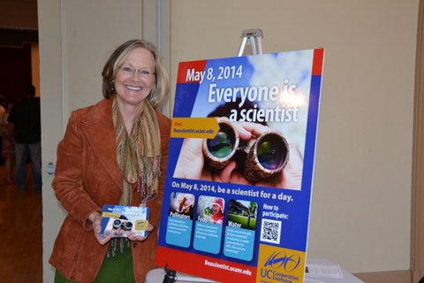Carol Collar retired in July, after 31 years serving as a farm advisor for University of California (UC) Cooperative Extension. She began her career as an intern in Madera County, later was hired as dairy advisor for Fresno and Madera Counties, and subsequently transferred to Kings County where her focus has been dairy and forages since 1986. Throughout her career, Collar collaborated with growers and dairymen to address a wide range of current issues. “This job was never boring”, said Collar. Corn, wheat, sorghum and sometimes unconventional forages like sunflowers were evaluated in countless forage trials to assess agronomic traits and nutritional value for dairy cows. She conducted on-farm studies to provide practical information about unusual but promising dairy feeds, additives or other new products and technologies to conserve water and energy. She organized farm demonstrations to showcase ideas for implementing alternative crops or management practices. Results from her surveys and reports provided benchmarks for comparison to other farms, dairies or regions. To facilitate these efforts, Collar gathered teams of expertise from within UC, allied industry and other universities. She took great pleasure in working together with others to solve diverse and interesting problems. “It was tremendously rewarding to serve as a bridge between the local agricultural community and the University – I learned greatly from many amazing people on both sides,” Collar said.

The UC dairy team would like to thank Carol for her dedication to the University of California, the producers of Kings County, and the California dairy industry.

**Recruitment Underway for Two New Dairy Advisors in the San Joaquin Valley**

The University of California, Division of Agriculture and Natural Resources is seeking UC Cooperative Extension (CE) academic advisors to conduct multi-county-based extension and applied research programs focused on Dairy Science. These positions will provide programs across a spectrum of industry issues as they relate to dairy production systems. Successful programs will address production issues and sustainability in an integrated approach that will consider economic viability and conservation of natural resources including land use, air, water, and energy.

A minimum of a Master's Degree is required, though other advanced degrees are encouraged, in disciplines such as Dairy or Animal Science, or a closely related field.  Excellent written, oral and interpersonal communication skills are required.  Demonstrated ability in applied animal science research and extension experience are desirable.

Positions will be located in **Tulare** (Tulare/Kings/Kern Counties) and **Fresno** (Fresno/Madera Counties).

For more information, or to apply, please visit: <http://ucanr.edu/Jobs/Jobs_990/>

Look Inside:

California Dairy News

October 2015

an02473_

The University of California prohibits discrimination against or harassment of any person employed by or seeking employment with the University on the basis of race, color, national origin, religion, sex, gender identity, pregnancy (which includes pregnancy, childbirth, and medical conditions related to pregnancy or childbirth), physical or mental disability, medical condition (cancer-related or genetic characteristics), genetic information (including family medical history), ancestry, marital status, age, sexual orientation, citizenship, or service in the uniformed services (as defined by the Uniformed Services Employment and Reemployment Rights Act of 1994: service in the uniformed services includes membership, application for membership, performance of service, application for service, or obligation for service in the uniformed services) or any person in any of its programs activities. University policy also prohibits retaliation against any employee or person seeking employment or any person participating in any of its programs or activities for bringing a complaint of discrimination or harassment pursuant to this policy. This policy is intended to be consistent with the provisions of applicable State and Federal laws. Inquiries regarding the University's equal employment opportunity policies may be directed to Linda Marie Manton, Affirmative Action Contact, University of California, Davis, Agriculture and Natural Resources, One Shields Avenue, Davis, CA 95616, (530) 752-0495.

Jennifer Heguy, Dairy Advisor

Merced, Stanislaus & San Joaquin Counties

NONPROFIT ORG.

US POSTAGE PAID

MODESTO, CA

PERMIT NO. 400

**Cooperative Extension**

**University of California**

**3800 Cornucopia Way, Suite A**

**Modesto, CA 95358**