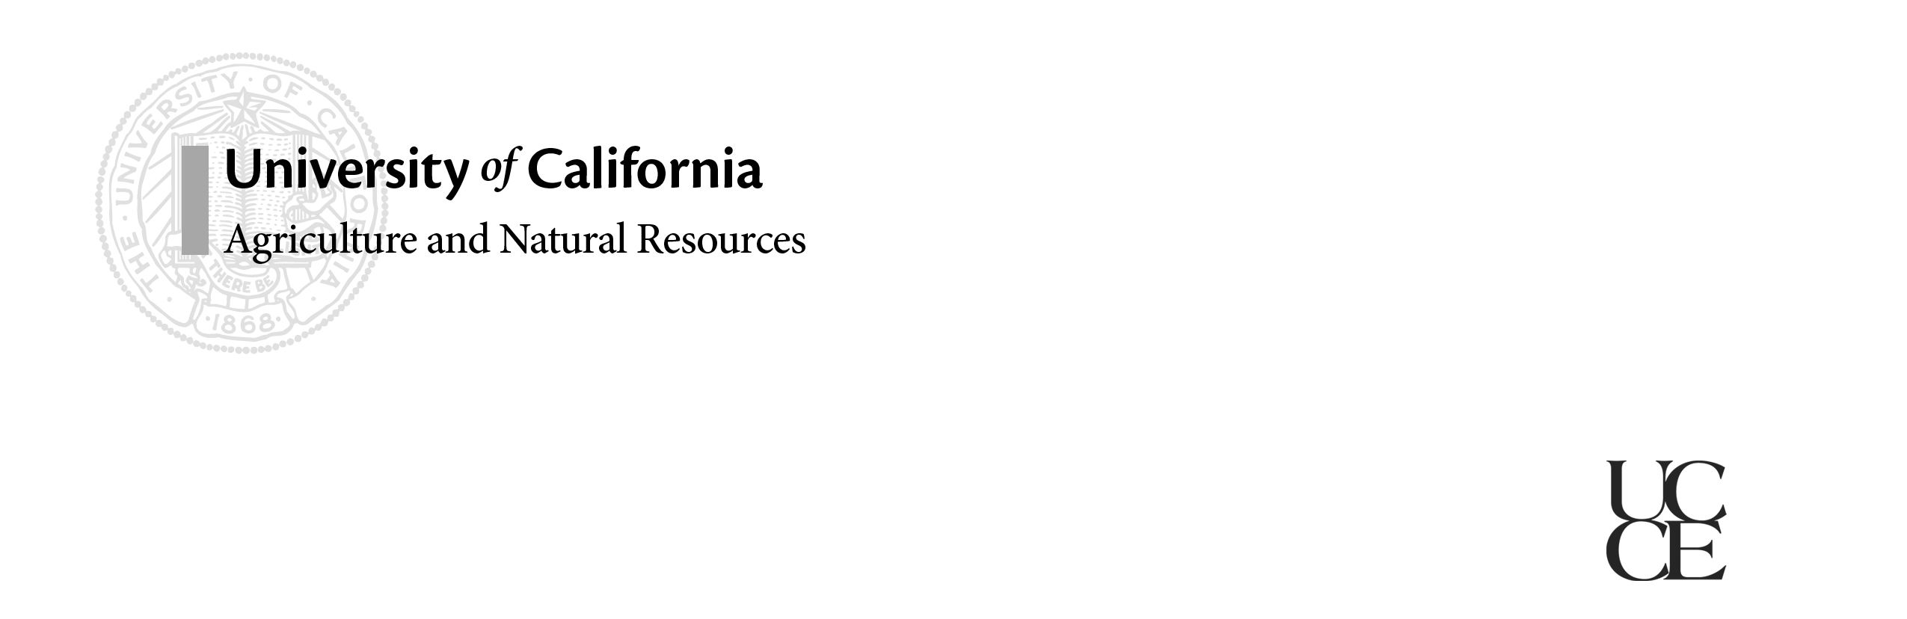

# California Dairy

# Newsletter

# Vol. 7, Issue 1 January 2015

***In Vitro* Embryo Production: Technology that Came to Stay**

**In this Issue…**

What is IVF? **–** 1

Winter “To Do” List for Compliance **–** 2

Western Dairy Management Conference **–** 3

Meeting- Cow Comfort in Hot Weather – 4

Meeting – California Dairy Management Seminars, Focus on Feeding – 5

**Newsletter Editors:**

**Jennifer Heguy**

UCCE Dairy Advisor

Merced/Stanislaus/San Joaquin

[jmheguy@ucdavis.edu](mailto:jmheguy@ucdavis.edu)

209-525-6800

**Dr. Noelia Silva-del-Rio**

Dairy Production Medicine Specialist, VMTRC

[nsilvadelrio@ucdavis.edu](mailto:nsilvadelrio@ucdavis.edu)

559-688-1731

*Dr. Alex Souza, UCCE Tulare & Kern Counties*

*In vitro* fertilization (IVF), the process of fertilizing and growing cattle embryos in the lab, is not a new technology.

Briefly, eggs (or oocytes) are harvested from cows: 1) through the use of a transvaginal ultrasound-guided needle (mostly used in cows with high genetic value – more expensive method); or 2) straight from the ovaries of cows sent to the slaughterhouse (a much cheaper method). Once harvested, these oocytes are brought to the lab and placed in solutions that mimic the uterine environment. This allows sperm to fertilize the eggs and the formed embryos to grow until transferred to recipient cows, roughly one week after oocytes were harvested from the ovaries.

Although IVF technology is routinely used as an integral part of other countries’ breeding programs, the commercial use of IVF in US dairy herds is still uncommon, but forecasted to increase in the future. In fact, in some areas of South America, more embryos are produced through IVF than through the more traditional method of super-ovulating cows and later flushing the uterus; I’ve personally been to dairy herds in which artificial insemination is no longer used and instead is totally replaced by IVF embryo transfer – obviously an extreme case. It is also true that one of the reasons why IVF became so popular in some countries is due to the fact that their cattle breeds (i.e. Nellore) can produce far more oocytes per collection than Holstein cows, making lab-production of embryos very efficient. However, in the case of breeds that produce less oocytes, efficiency of IVF can be significantly increased by pre-selecting donor cows with a greater population of ovarian follicles. These cows can be detected by either a single ultrasound exam or by measuring anti-Mullerian hormone (Souza et al., 2014).

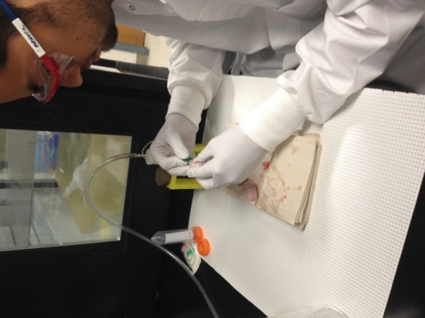In practical terms, the more expensive ultrasound-guided IVF method could be used to spread genetics from heifers and cows of high genomic value to heifers with poor genomic tests. Alternatively, producers could also explore a cheaper method of producing high genomic value embryos by utilizing ovaries from a subset of their own cull cows on a weekly basis and, for example, fertilizing the oocytes from these cows with an outstanding sire – one straw of semen can fertilize as many as 500 oocytes or more.

Photo: Technician at UC-Davis harvesting oocytes from slaughterhouse ovaries for *in vitro* embryo production.

*

**The Winter Monitoring “To Do” List for Water Quality Compliance**

*Dr. Deanne Meyer, UCCE Livestock Waste Management Specialist*

Each dairy in California needs to keep manure or other nutrients from leaving the property and especially from getting into surface waters.

**Don’t forget to check field valves BEFORE irrigations.** It’s been so long since we had winter rains that it’s easy to forget about winterizing a facility and dusting off the winter monitoring ‘to do’ list. It’s nice that we actually had rain in November. If your standard procedure is to open valves or gates for tail water to leave the property, PLEASE do your due diligence before any irrigations occur and **BE SURE those end of field valves are securely closed**. You’ll want to be sure nothing got stuck in the valve allowing water to leave (discharge) when you don’t want it to. Keep in mind, it’s important to document the “before irrigation” conditions of the land application area. The Central Valley Dairy General Order requires inspections: “Inspect the land application area and note the condition of land application berms including rodent holes, piping, and bank erosion. Verify that any field valves are correctly set to preclude off-property or accidental discharges of wastewater.**” (**MRP Table 1 page 2 of MRP). Don’t forget, when liquid manure is applied you’ll need to document conditions daily: “Inspect the land application area and note the condition of land application berms including rodent holes, piping, and bank erosion; the presence (or lack) of field saturation, ponding, erosion, runoff (including tailwater discharges from the end of fields, pipes, or other conveyances), and nuisance conditions; and the conditions of any vegetated buffers or alternative conservation practices.” If you need a template for your record keeping needs, one is available through the Reference Binder created by the California Dairy Quality Assurance Program. You can find it at <http://www.cdrf.org>. Clink on CDQAP and then on the WDR Reference Binder. It’s the second template in section 6 of the Binder. The Order is available at <http://www.waterboards.ca.gov/centralvalley/water_issues/dairies/dairy_program_regs_requirements/index.shtml> - click on the first link for Order R5-2013-0122.

**Different sampling is required for various types of discharges.** Table 3 of the MRP identifies the various types of discharges (some on property many off property) that require sampling and documentation. Samples must be taken and submitted to an ELAP certified lab in field of testing 108 for wastewater. Additionally, the dairy operator is obligated to notify the Regional Water Quality Control Board for some of these discharges. For those situations, interim reporting (before the next Annual Report) is also required.

**Discharges (Including Off-Property Discharges) of Manure or Process Wastewater, from the Production Area or Land Application Area.** This discharge includes application of wastewater from the lagoon to crop land that is not indicated in the nutrient budget (non-compliance event). Notify the Regional Water Quality Control Board staff of discharge as soon as possible. Sample the discharge. Forward copies of results to the Regional Board and include them in your Annual Report.

**Storm Water Discharges to Surface Water from the Production Area.** Daily during each discharge to surface water, sampling must occur at the discharge point, upstream and downstream of the discharge. Notify the Regional Water Quality Control Board about this discharge. Sample the discharge. Forward copies of results to the Regional Board and include them in your Annual Report.

**Storm Water Discharges to Surface Water from Each Land Application Area**. Sample locations must be chosen such that the samples are representative of the quality and quantity of storm water. Samples are required from the “first storm event of the wet season and during peak storm season (typically February) each year from one third of the land application areas with the land application areas sampled rotated each year”. Samples should be taken from the first event that generates continuous runoff for one hour or intermittent runoff for three hours in twelve. Analyze and include results in your Annual Report.

**Sampling required for tailwater.**

Tailwater Discharges to Surface Water from Land Application Areas. Tailwater samples shall be collected at the point of discharge to surface water from each land application area where irrigation has occurred less than 60 days after application of manure. Information on discharge monitoring is included in the Annual Report.

**Summary:** An ounce of prevention is worth a pound of cure. Be sure field valves are closed so no unwanted discharges will happen. Sample and quantify the various types of on and off site discharge. For some, notify the Regional Board immediately and follow-up with written report. Lastly, include all discharge information in the Annual Report.

**Western Dairy Management Conference Meets March 3-5, 2015**

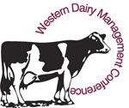Mark your calendars for the next Western Dairy Management Conference.  It will be held March 3-5, at John Ascuaga’s Nugget in Sparks, NV. Registration is available on-line at: <http://www.wdmc.org>. Please note the change in format for this year’s meeting: **THE TALKS START ON TUESDAY, MARCH 3RD AT 1:30 PM AND THE PROGRAM WILL FINISH ON THURSDAY, MARCH 5THAT 5:40 PM.** As always, there will be multiple hospitality suites available throughout the conference.

The program promises to have the top researchers share new information on nutrition, reproduction, calf management, employees, genetics and more. This is the most comprehensive dairy conference in the United States providing “news you can use,” and it’s right in our back yard. A full list of topics and speakers, including a number of speakers from California, is available at the conference website:  <http://www.wdmc.org>. Let’s have a great showing of California producers - the Nugget is a great place to get away in March!

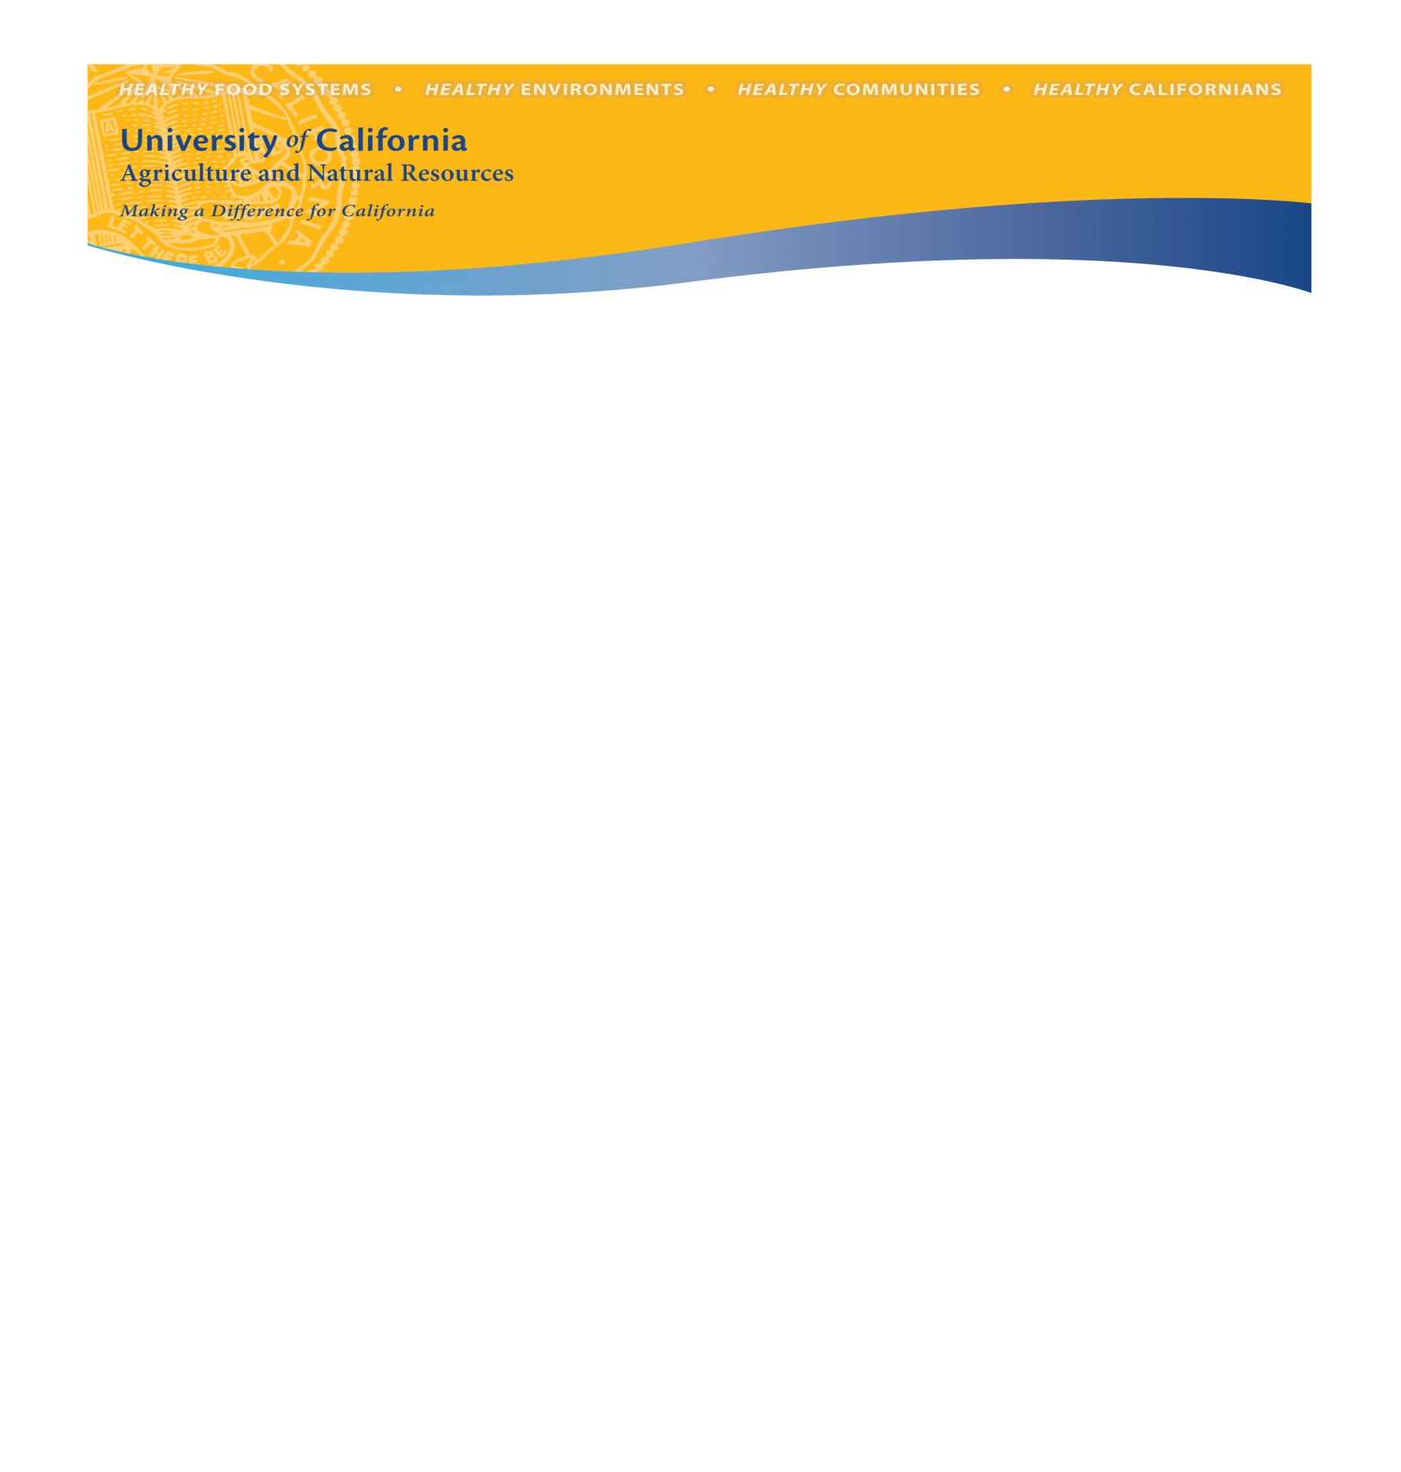**Managing Cow Comfort in Hot Weather**

*Thursday, January 29, 2015*

Tulare County Agricultural Building, 4437 So. Laspina St., Tulare CA

It is cold and foggy now, but oppressive summer heat is just around the corner. Be ready for it this year by arming yourself with the most current information regarding cow comfort during hot weather. A terrific line up of UC and industry experts will share brief updates. Attendance is free. If you will be joining us, please RSVP to the Tulare UC Cooperative Extension office (559-684-3300) so that we can plan for lunch. Details about time, location and topics can be found in the following program agenda:

8:30 a.m. **Registration**

9:00 **Welcome**

*Carol Collar, Farm Advisor, UCCE Kings County*

9:05 **NOAA/NWS Western Region Heat Impact Level (HIL) Project**

*Paul Iniguez, Meteorologist, National Oceanic and Atmospheric Administration, National Weather Service, Hanford*

9:30**Assessing and Improving Animal Welfare on Your Farm**

*Cassandra Tucker, Professor, Department of Animal Science, UC Davis*

9:55 **Soakers to Cool Cows: Can We Reduce Water Use?**

*Jennifer Chen, PhD student, Department of Animal Science, UC Davis*

10:20 **Break**

10:30 **Applied Strategies to Reduce Heat Stress in Dairy Herds**

*Luis Rodriguez, Account Manager, Zinpro Performance Minerals*

10:55 **Heat Stress Management on California Dairies**

*Noelia Silva del Rio, Dairy Specialist, UC Davis Veterinary Medicine Teaching and Research Center*

11:20 **Interactions Between Milk Production, Heat Stress and Fertility**

*Alex Souza, Farm Advisor, UCCE Tulare & Kern Counties*

11:45 **Round Table**

*All speakers and invited industry specialists*

12:10 **Lunch provided by Zinpro Performance Minerals, *to be guaranteed lunch, please call the Tulare County office to RSVP at 559-684-3300.***

For more information regarding the meeting, contact Alex Souza (559) 805-2639 or at [souza@ucanr.edu](mailto:souza@ucanr.edu)

The University of California Division of Agriculture & Natural Resources (ANR) prohibits discrimination or harassment of any person in any of its programs or activities (Complete nondiscrimination policy statement can be found at http://ucanr.org/sites/anrstaff/files/107778.doc ) Inquiries regarding ANR’s equal employment opportunity policies may be directed to Linda Marie Manton, Affirmative Action Contact, University of California, Davis, Agriculture and Natural Resources, One Shields Avenue, Davis, CA 95616, (530) 752-0495.promulgated. Inquiries regarding the University’s nondiscrimination policies may be directed to Linda Marie Manton, Affirmative Action Contact, University of California, Agriculture and Natural Resources, 2801 Second Street, Davis, CA 95618, (530) 750-1318.

California Dairy Management Seminars

**Seminars will be delivered in English and Spanish.**

The goal of the California Dairy Management Seminars is to provide science-based information and

discussion on topics contributing to the success and profitability of dairy operations in California.

February’s seminars sponsored by:



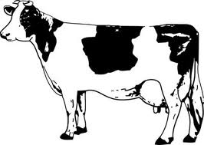

|  |  |  |
| --- | --- | --- |
| **February 24, 2015 – Orland, CA**  UCCE Glenn County  Farm Advisors’ Office  821 E. South Street – Orland, CA  Local Contact: Betsy Karle  (530)865-1156  bmkarle@ucanr.edu | **February 25, 2015 – Modesto, CA**  UCCE Stanislaus  Harvest Hall  3800 Cornucopia Way – Modesto, CA  Local Contact: Jennifer Heguy  (209)525-6800  jmheguy@ucdavis.edu | **February 26, 2015 – Tulare, CA**  UC Davis VMTRC  Consumer Education Pavilion  18830 Rd. 112 – Tulare, CA  Local Contact: Noelia Silva-del-Rio  (559)688-1731  nsilvadelrio@ucdavis.edu |

**English Session:** 10:30 AM—12:00 PM

**Lunch:** 12:00 PM (for both sessions)

**Spanish Session:** 12:30 PM—2:00 PM

**Seminars are offered free of charge.**

**Pre-registration is appreciated to guarantee your handouts and meal.**

Pre-register by **phone** (209-525-6800) or **email** (jmheguy@ucdavis.edu). Please specify location attending (Tulare, Modesto, Orland) and language (English or Spanish).

**SEMINAR PRESENTATIONS**

**Variation in TMR Preparation and Delivery on California Dairies**

*Discussion of how the formulated and fed rations differ on farm, with suggestions of practices to improve the feeding process and reduce variability in fed rations.*

Presented by: **Noelia Silva-del-Rio**, DVM, PhD—UCCE Vet Med Extension Dairy Specialist

**Understanding the Importance of Dry Matter and On-Farm Analysis Options**

*Basic discussion of the concept of dry matter for feeders: why it’s important when mixing rations, and demonstration of different on-farm analysis methods.*

Presented by: **Jennifer Heguy**, UCCE Farm Advisor - Merced, Stanislaus & San Joaquin Counties

**\*Presentations will be given separately in English and Spanish\***