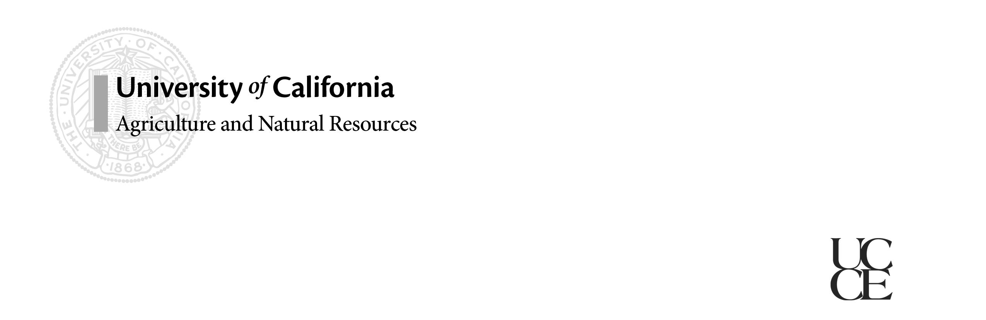

# California Dairy

# Newsletter

# Vol. 6, Issue 1 January 2014

**In this issue…**

Preventing Milk Fever **–** 1

Promote Your Product **–** 2

Heat Stress Meeting – 2

Voluntary Waiting Period **–** 3

In Memoriam: Don Bath **–** 4

Hoof Health Meetings – 5

**Newsletter Editors:**

**Jennifer Heguy**

UCCE Dairy Advisor

Stanislaus/San Joaquin Counties

[jmheguy@ucdavis.edu](mailto:jmheguy@ucdavis.edu)

209-525-6800

**Noelia Silva-del-Rio**

Dairy Production Medicine Specialist, VMTRC

[nsilvadelrio@ucdavis.edu](mailto:nsilvadelrio@ucdavis.edu)

559-688-1731

**Preventing Milk Fever with Anionic Salts.**

*Noelia Silva-del-Rio, UCCE Vet Medicine Specialist*

Cows transitioning from the dry cow pen to the fresh pen are subject to a large calcium demand in order to synthesize and secrete colostrum and milk. If calcium demand exceeds the calcium available in plasma, cows may end up suffering milk fever, also known as hypocalcemia. Results from the 2002 National Animal Health Monitoring System (NAHMS) survey indicated that clinical hypocalcemia incidence in US herds was 5%, and subclinical hypocalcemia was 25% for primiparous cows, and between 41% to 54% for multiparous cows. There are important physiological consequences of hypocalcemia, as calciumis essential for muscle contraction as well as immune function. Clinical hypocalcemia has been associated with dystocia, uterine prolapse, retained placenta, endometritis, compromised fertility, mastitis, and reduced rumen and abomasum motility. Similarly, cows with subclinical hypocalcemia have a greater risk for metritis, displaced abomasum, and culling.

In order to reduce the incidence of clinical and subclinical hypocalcemia, some dairies may benefit from feeding anionic salts during the close-up period. The principle behind feeding anionic salts is to acidify the dry cow diet to modify the electrical charge of the blood. Under metabolic alkalois (positively charged blood) the conformation of the parathyroid hormone (PTH) receptors changes rendering them non-functional. As a result, the cow is unable to mobilize calcium from bone to meet the demands of lactation. The most common cations (positively charged electrolytes) found in feed are sodium (Na+), potassium (K+), calcium (Ca2+) and magnesium (Mg2+), while the most common anions (electrolytes negatively charged) are chloride (Cl-), sulfate (SO42-), and phosphate (PO43-). A typical dry cow ration formulated with forages and concentrates will always have a positive DCAD. Adding anionic salts are the only means of achieving a negative DCAD. However, anionic salts are expensive, unpalatable, and represent an environmental concern. Their inclusion in the ration should be kept to a minimum.

**Considerations when feeding anionic salts:**

1. Determine the DCAD of the dry cow diet before adding anionic salts.

The level of anionic salts necessary to sufficiently acidify the diet is going to be determined by the DCAD of the dry cow diet. Most nutritionists adjust the level of anionic salts to reach a DCAD of about –50 to –150 meq/kg. A sample of the close-up ration, before adding anionic salts, should be sent to a lab for macrominerals analysis to determine the DCAD. For better results, it is recommended to use a lab that offers wet chemistry techniques.

1. Reduce DCAD of the dry cow diet through formulation before adding anionic salts.

Alfalfa included in close-up diets should be low potassium alfalfa or “DCAD alfalfa”. This alfalfa is grown under restricted potassium soil amendments to avoid extra uptake of potassium by the plant. Also, the combination of low potassium alfalfa and corn silage should be considered as the forage base for the dry cow ration. This approach will minimize the dose of anionic salts necessary to acidify the diet.

1. Evaluate the DCAD program.

The success of a DCAD program can be easily evaluated by monitoring urinary pH. In Holstein cows, urinary pH values should be between 6.2 and 6.8, and for Jerseys, between 5.8 to 6.3. If the urine fails to be acidified, evaluate if the inclusion rate of anionic salts in the diet is adequate, and if the preparation and delivery of the ration is done properly.

**Promote your Product**

*Betsy Karle, UCCE Glenn & Tehama*

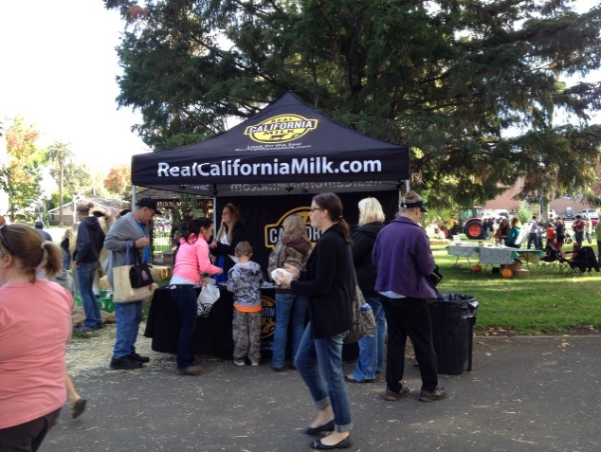The dairy industry is fortunate to have outstanding checkoff partners who create great advertising and promotional materials, but consumers continue to express the desire to hear from real dairy farmers. It’s amazing how significant your impact can be, as consumers really have few opportunities to identify with farmers. For example, consider the exponential growth of Farmers’ Markets and “Farm to Fork” events over the past several years. This trend clearly indicates that consumers are interested in learning more about how their food is produced and where it comes from. Questions like “Are there antibiotics in milk?” and “How can a cow possibly have four stomachs?” are common and usually followed up with the question, “Do you have a dairy?” It is evident that consumers are hungry for information about dairy and there is no better source than the folks on the ground. Consider participating in community festivals and farm days or help plan an activity for Dairy Month in June. Your impact on the people who are purchasing your product is likely much greater than you think!

*Participating in community festivals is a great way to educate consumers about dairy products. If you can provide products to sample or offer hands-on activities, your booth will be a popular stop!*

**Dairy Heat Stress Road Show**

April 4, 2014

University of California Veterinary Medicine Teaching and Research Center - 18830 Rd. 112, Tulare, CA

**Meeting Topics:**

* Managing Heat Stress in California Dairies
* Nutritional Additives and Facility Modifications to Reduce Heat Stress
* Tools and Technologies to Assess Heat Stress on Commercial Dairies
* Should We Cool Dry Cows?
* Current and Future Opportunities to Reduce the Impact of Heat Stress

For more information, contact Dr. Noelia Silva-del-Rio at 559-786-9729 or [nsilvadelrio@ucdavis.edu](mailto:nsilvadelrio@ucdavis.edu)

**What’s the ideal voluntary waiting period (VWP) for your dairy herd?**

*Alex Souza, UCCE Tulare & Kern*

Voluntary waiting period (VWP) can be defined as the interval during the postpartum period in which producers decide not to breed cows even if estrus occurs. It usually lasts about 50 days, but may vary a lot from herd to herd according to the breeding strategy in place. For example, VWP tends to be longer for herds relying more on synchronization programs, or may vary across cows with parity number, breed, and even calving season! In general, dairy cows should not be inseminated before 40 to 50 days in milk because their uterine tract is not fully recovered from previous calving and conception results are normally poor. On the other hand, for healthy cows, one should not wait more than 100 days after calving to breed cows for the 1st time and risk having extended inter-calving intervals or an excessive number of non-pregnant cows that are over 150 days in milk. Thus, the ideal VWP is a fine balance between breeding as soon as possible after calving and uterine involution, and waiting long enough to ensure good conception results.

Therefore, based on the herd performance in the 1st breeding cycle after the end of the VWP, the two main variables that will dictate the most ideal VWP are:

* Estrus detection efficiency also known as service rate.
* Conception rate in the 1st breeding cycle after the end of the VWP

With the same conception rate levels, herds that have very high service rates in the 1st breeding cycle (i.e. efficient tail chalk service, well-designed synchronization programs, etc.) may be able to have longer VWP as compared to herds with poor service rate results. Similarly, herds having very high conception results may afford delaying time to 1st AI even until 90-100 DIM without losing on overall reproductive efficiency (days open). But be careful with conception rates to 1st AI; for every 10 days of delay in time to 1st AI, dairy producers need to capture 6-8% points in conception, otherwise it is better to keep VWP shorter!

Alternatively, producers might want to change the VWP across seasons to capitalize on variations of conception and estrus detection efficiency throughout the year. For instance, it is fairly common to see producers anticipating breeding or being more aggressive with timed AI programs particularly just before peak summer to take advantage of the last few weeks of good conception results before heat stress hits. Same producers might want to keep well designed timed AI programs running all summer to compensate for lower behavioral estrus. In the heat of summer, best management approaches need to be discussed with consultants to both lower the impact of heat stress as well as to decide on best VWP and find opportunities for profitability.

**Table 1**. Ideal VWP based on service and conception rates in the 1st breeding cycle.



**Table 1** uses information on service rate and conception rate in the 1st breeding cycle after the end of the VWP to ***suggest*** the ideal VWP for your herd. Obviously, this table does not apply to all situations in all dairy herds! In addition, if your conception and/or service rate results for 1st AI are low, or even fall outside of these ranges during any season of the year, you have bigger management issues to deal with than worrying too much about your VWP!

**In Memoriam: Donald Bath**

Donald L. Bath, UCCE specialist emeritus, passed away on Oct. 26. He was 81.

He earned his B.S. and M.S. in animal husbandry and his Ph.D. in nutrition, all from UC Davis, where he also quarterbacked the Aggie football team and served as president of the Sigma Alpha Epsilon fraternity. In 1963, Bath became a UC Cooperative Extension dairy nutrition specialist based at UC Davis.

“Don had a significant impact on my career and my philosophy toward the dairy industry,” said Ed DePeters, professor in the Department of Animal Science at UC Davis. “I first met Don when I came to UC Davis in October 1979, as a green Ph.D. from Penn State. It was a meaningful experience for me, because as an undergraduate at Cornell University I used his book, “Dairy Cattle: Principles, Practices, Problems, Profits” by Foley, Bath, Dickinson, and Tucker in my dairy production class.”

During his 30-year career, Bath authored 350 publications, including the widely used textbook. He and his colleagues developed and marketed PC Dairy, one of the first linear programming ration-balancing computer programs. Bath and his UC Davis colleague Vern Marble developed a method for determining total digestible nutrients in alfalfa hay. In 1980, he co-authored “By-products and Unusual Feedstuffs in Livestock Rations,” which summarized the scientific literature on the chemical composition of more than 200 by-product feeds, and which remains a reference guide. In the 1980s, when cottonseed meal was commonly used in feed, Bath and DePeters conducted research that demonstrated that canola meal was equivalent to cottonseed meal and opened the California market to canola meal. Canola meal is a common feed ingredient in commodity barns and is widely used in dairy rations on California dairy farms. Bath retired in 1993.

“The facts that PC Dairy and the Alfalfa Hay Testing Program each still plays a role in the dairy industry and that canola meal is a primary protein supplement in California demonstrate the significance of Don’s science to the dairy industry,” said DePeters.

Bath is survived by his wife Gloria, their sons Robert and Daniel, five granddaughters and his sister Darlyn. Gifts in Bath’s memory may be made to the “Donald Bath Animal Science Student Award,” payable to the UC Davis Foundation, c/o Martha Ozonoff, UC Davis, CAES Dean’s Office, One Shields Ave., Davis, CA 95616.

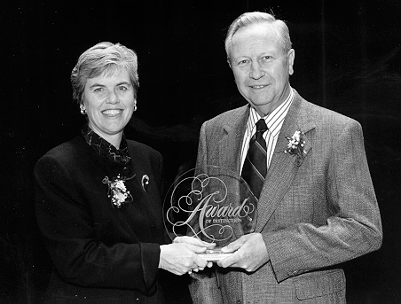

Dr. Donald L. Bath was presented with the College of Agricultural and Environmental Sciences Award of Distinction in 1996.



**The same program will be offered in two locations.**

**March 4, 2014 – Tulare**  
UC Davis Veterinary Medicine Teaching and Research Center

18830 Rd. 112 - Tulare, CA 93274  
Contact: Alex Souza (559) 805-2639 [souza@ucanr.edu](mailto:souza@ucanr.edu)

**March 6, 2014 - Merced**UC Cooperative Extension Merced  
2222 M Street, Merced, CA 95340  
Contact: Alejandro Castillo (209) 385-7434 arcastillo@ucanr.edu

**Program presented by:** Alfonso Lago, DVM, PhD, DairyExperts

**Hosted by:** University of California Cooperative Extension

**Sponsored by:**

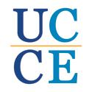

Hoof Health Management Workshop  
**Workshops will be delivered in English with simultaneous translation to Spanish.**

**Agenda**

**8:30 am - 9:00 am** Registration

**9:00 am - 12:00 pm** Bovine lower leg anatomy, biomechanics, lesion identification and classification, functional and therapeutic hoof trimming practices, blocking and wrapping will be covered during classroom instruction.

**12:00 pm – 1:00 pm Lunch**

**1:00** **pm – 5:00 pm**Participants will have the opportunity to work with Dr. Lago and others to develop their skills trimming, blocking and wrapping real, postmortem hooves. Proper care and sharpening of hoof trimming tools will also be practiced.

**5:00 Adjourn**

**PRE-REGISTER BY FEBRUARY 26 TO GUARANTEE YOUR HANDOUTS AND LUNCH, $10 REGISTRATION FEE.**Please choose one of the following pre-registration methods:

1. Pay at the door and preregister by **phone** (559-684-3300) or **email** (souza@ucanr.edu) OR  
2. Register by sending a **check** for $10.00/person payable to **UC Regents**   
  
Name:____________________________________________________   
  
Telephone number:____________________________  
  
Number attending:____________________________   
  
Location (please circle): Tulare / Merced

Language (please circle): English / Spanish

If registering by mail, send this form and your check to:

Alex Souza – Dairy Advisor

UC Cooperative Extension

4437-B S. Laspina Street

Tulare, CA 93274

The University of California Division of Agriculture & Natural Resources (ANR) prohibits discrimination or harassment of any person in any of its programs or activities. Complete nondiscrimination policy statement can be found at [http://ucanr.org/sites/anrstaff/files/107778.doc](http://ucanr.org/sites/anrstaff/files/107734.doc)). Inquiries regarding ANR’s equal employment opportunity policies may be directed to Linda Marie Manton, Affirmative Action Contact, University of California, Davis, Agriculture and Natural Resources, One Shields Avenue, Davis, CA 95616, (530) 752-0495.

