# California Dairy

# Newsletter

# Vol. 5, Issue 2 August 2013



**Evaluating Kernel Processing During Harvest**

**In this issue…**

Harvest Reminder, Kernel Processing **–** 1

New AVMA Euthanasia Guidelines – 2

Central Valley Regional Water Quality Control Board, General Order Reminders **–** 3

Employee Heat Safety Reminders **–** 4

Neonatal Calf Diarrhea **–** 5

Sugar Beets as a Potential Starch Substitute – 6

Dairy Surveys Underway **–** 7

**Newsletter Editors:**

**Jennifer Heguy**

UCCE Dairy Advisor

Stanislaus/San Joaquin Counties

[jmheguy@ucdavis.edu](mailto:jmheguy@ucdavis.edu)

209-525-6800

**Noelia Silva-del-Rio**

Dairy Production Medicine Specialist, VMTRC

[nsilvadelrio@ucdavis.edu](mailto:nsilvadelrio@ucdavis.edu)

559-688-1731

*Jennifer Heguy, UCCE Stanislaus & San Joaquin Counties*

Since starch content is a major parameter used to decide which corn variety to plant, I’ll describe a fast, yet effective way to evaluate kernel processing during harvest. Kernel processing breaks up corn kernels, allowing the starch to be digested. If whole kernels pass through the animal, the starch is lost in feces rather than used as energy for milk production. By evaluating kernel processing at the time of harvest, adjustments can be made to ensure kernel processing is effective. Following are 6 easy steps to evaluate kernel processing:

**2**

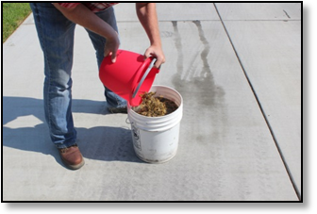

**1**

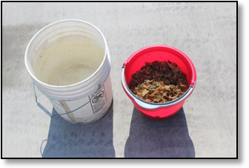

**4**

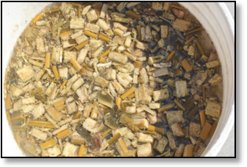

**3**

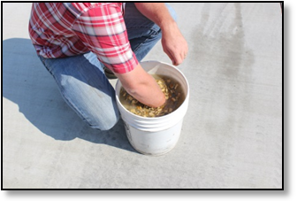

**5**

**6**

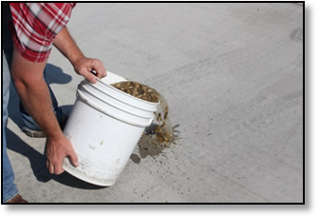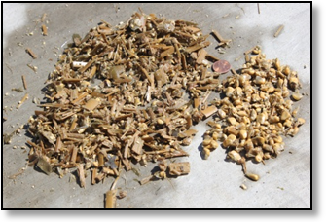

**1)** All you need is a 5-gallon bucket filled with water and your silage sample.

**2)** Add silage sample to the water bucket.

**3)** Mix for several seconds.

**4)** Let the contents of the bucket settle.

**5)** Carefully pour off the water and floating material.

**6)** Kernels (and other dense material) sink to the bottom of the bucket; examine the kernels to ensure the majority are broken or crushed.

**Are you Implementing AVMA’s New Euthanasia Guidelines?**

*Michael Karle, DVM- Mid-Valley Veterinary Hospital and Synergy Cattle Group, Inc.   
and Betsy Karle- UCCE Glenn and Tehama Counties*

Earlier this year, the American Veterinary Medical Association (AVMA) updated guidelines for the euthanasia of animals. While the familiar “not between the eyes” rule is still applicable, AVMA suggests that the bullet or captive bolt entry point should be a bit higher than previously suggested in order to ensure enough brain destruction for immediate death. This site can be found by drawing two imaginary lines from the ***outside*** corner of the eye to the opposite horn (or horn position). The bullet or captive bolt should enter at the intersection of the two lines.

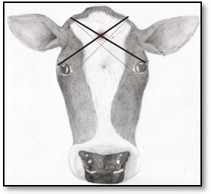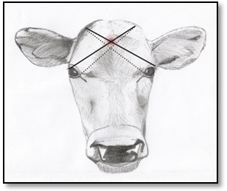

Figure 2

Figure 1

*Anatomical site for gunshot or captive bolt entry in calves (Figure 1) and adult cattle (Figure 2). Note that the new guidelines (solid line) place the entry point slightly higher than previous guidelines (dashed line). Artwork courtesy Erin Martin.*

Also consider what tools you are using on your dairy for euthanasia. If a handgun is being used, .32 to .45 are acceptable calibers. A .22 caliber pistol does not create enough muzzle energy to consistently penetrate the skull in an adult animal, regardless of the bullet used. Rifles generate much more muzzle energy, so .22 to .308 are appropriate calibers. However, if a .22 caliber rifle is the gun of choice, solid point bullets at close range (1-3 feet) should be used in addition to ensuring the bullet enters the skull at the proper anatomical position. Twelve, 16 or 20 gauge shotguns with number 6 or larger birdshot or slugs may be used. Be sure to carefully consider gun power when euthanizing bulls or large cows- higher power is likely necessary. No firearm should ever be held directly against the animal’s head for operator safety. Be sure to watch out for what is beyond the animal to ensure that exit bullets do not create unintentional damage. A penetrating captive bolt may also be used, but must be followed by exsanguination or IV injection of KCl. Manual, blunt force is never an acceptable euthanasia method, even in calves, because the skull is too thick to achieve immediate destruction of brain tissue.

While you’re revisiting your euthanasia method, take the time to update your protocols with your veterinarian. They should include who is responsible for making the decision to euthanize and carry out the action, the appropriate euthanasia method, and contact information for veterinary and rendering services. An easy to use template can be found at <http://cdrf.org/home/checkoff-investments/cdqap/animal-care-the-cdqap/animal-care-farm-resource-binder/> under “Tab 10.4.”

As always, safety is of paramount concern. Proper training and handling of euthanasia devices must be well enforced.

* The entire AVMA guidance document can be found at: <https://www.avma.org/KB/Policies/Documents/euthanasia.pdf>.
* “Not Between the Eyes” posters, brochures, etc.:

<http://vetmed.iastate.edu/humaneeuthanasia/en/euthanasia-downloads>

**Keeping up with the Central Valley Regional Water Quality Control Board General Order**

*Dr. Deanne Meyer, Livestock Waste Management Specialist, UC Davis*

It’s been 6 years since the adoption of the Dairy General Order. Inspectors from the Regional Board have now set boots on each and every dairy covered under the Order. Inspectors will continue inspecting large numbers of dairies as they strive to reach every facility once in three years. For those people who were inspected during the early years of the Order’s implementation, things are very different now that the staged implementation process should be completed.

The base premise for the **PRODUCTION** area (where the feed, cows, and manure reside) is to be sure nutrients don’t leave this area uncontrolled. No off-site discharge. No-standing water 72 hours after rain events. Manure storage needs to be sufficient so liquid manure is applied when nutrients are needed for crop production and not because the pond is full. Also, the regular pond photos should include the pond marker. The standard visual observations and associated record keeping from the production area should be maintained on the farm and available for inspectors.

The Nutrient Management Plan is the large umbrella which covers land application areas. Key in this Plan is the Nutrient Budget. The Budget identifies expected crop yields for each field and each crop and identifies nitrogen application rates (quantity and frequency) during the crop growing season. This counts nitrogen in irrigation water, solid and liquid manure, as well as fertilizer. Nutrient Budgets should be available for inspectors at the time of inspections. Many individuals have modified their budgets since the original ones were developed in 2008.

The monitoring and reporting program has detailed requirements for record keeping for each field. Imagine a field with a very tall wall and a door that is opened to allow nutrients or irrigation water to enter or exit. Everything that enters the field and exits the field must have documentation. It’s important to keep current records of all applications (quantity and nutrient content) of solid and liquid manure, irrigation water, and fertilizer. Regional Board inspectors will most probably look for updated computations indicating a cumulative record of nutrients applied to each current crop in each field and potentially compare these values to anticipated harvests.

There’s plenty of record keeping associated with the General Order. You should have received a packet of record keeping templates from the California Dairy Quality Assurance Program in late May/early June. These were sent to each facility to remind operators of the need to maintain records. If you would like to download any of the documents, they are available in section 6 (templates) of the WDR Reference Binder (<http://cdrf.org/home/checkoff-investments/cdqap/about-the-environmental-stewardship-program/wdr-general-order-reference-binder-materials/> or go to [www.cdqap.org](http://www.cdqap.org) and be redirected to the CDRF website).

Successful inspections are enjoyed by those individuals current on their compliance record keeping.

**Stay Safe and Keep Your Employees Safe**

*Nyles Peterson, UCCE San Bernardino*

In 1977 a tropical storm that combined heat with high humidity hit southern California killing hundreds of dairy cows. The combination of high temperature and high humidity can be deadly to cattle, but it can also be deadly to humans. For this reason, you need to remind your employees (at least once a year) about the dangers of on-the-job heat risks.

You have probably seen Heat Index (heat – relative humidity) charts that show the areas of *Caution*, *Extreme Caution*, *Danger* and *Extreme Danger*. I want to remind you that conditions as low as 85 degrees with 60 percent relative humidity require extreme caution.

**Heat Index**

Temperature (°F) versus Relative Humidity (%)

|  |  |  |  |  |  |  |
| --- | --- | --- | --- | --- | --- | --- |
| Temp | 90% | 80% | 70% | 60% | 50% | 40% |
| 80 | 85° | 84° | 82° | 81° | 80° | 79° |
| 85 | 101° | 96° | 92° | 90° | 86° | 84° |
| 90 | 121° | 113° | 105° | 99° | 94° | 90° |
| 95 |  | 133° | 122° | 113° | 105° | 98° |
| 100 |  |  | 142° | 129° | 118° | 109° |
| 105 |  |  |  | 148° | 133° | 121° |
| 110 |  |  |  |  |  | 135° |

|  |  |
| --- | --- |
| Heat Index | Warning and Possible Related Heat Disorder |
| 80 – 90° F | **Caution**: Fatigue possible with prolonged exposure and physical activity |
| 90 – 105° F | **Extreme Caution**: Sunstroke, heat cramps and heat exhaustion possible |
| 105-130° F | **Danger**: Sunstroke, heat cramps, and heat exhaustion likely, and heat stroke possible |
| 130° F & greater | **Extreme Danger**: Heat stroke highly likely with continued exposure |

The important things to remember when it’s hot outside are drink lots of water, take breaks every 15 minutes, and seek shade often. If you start to experience muscle cramps or start to feel light headed or nausea or profuse sweating, don’t ignore these warning signs. You are experiencing heat exhaustion and the next stage, heat stroke, can be fatal or cause permanent disability. The signs of heat stroke are vomiting, high body temperature, confusion, and hallucination. If someone is experiencing these, call 911 immediately.

First aid for both heat exhaustion and heat stroke should be provided immediately upon recognizing the signs. The affected person should be moved to a cool, shady area or to an air conditioned building or vehicle, if possible. Taking a cool bath or shower can provide some relief. If you can’t get the person to a tub or shower, then sprinkling their clothes with water can also be helpful. It is also recommended that the person starts SLOWLY drinking cold water.

In 2005, California was the first state in the nation to adopt heat illness regulations. The regulation was strengthened in 2010 to include high heat provisions for five industries including agriculture. So, being aware of heat illness is not only wise it is the law.

**Neonatal Calf Diarrhea**

*Dr. Patricia C. Blanchard, California Animal Health and Food Safety Laboratory*

Calf diarrhea is a multifactorial disease caused by interaction of calf (immunity status, age), environment and organism factors. The most common organisms found in ­<35 day old calves with diarrhea are cryptosporidia, rotavirus, coronavirus, *Salmonella*, attaching and effacing *E. coli* and K99 *E. coli.* At CAHFS, some organisms, such as attaching and effacing *E. coli* are only detectable by examination of the intestine of calves so fecal only testing of live calves does not detect them. Increased illness and deaths in calves is often due to the presence of more than one organism.

The age of onset and type of diarrhea can provide clues to the likely causes. K99 *E. coli* causes watery diarrhea, severe dehydration and electrolyte loss but can only attach and cause diarrhea in calves <6 days of age, and most cases occur in 1-3 day old calves. The best prevention is the use of dry cow K99 vaccines so the colostrum contains antibodies that protect the newborn calf. In the face of an outbreak, use of commercial K99 antibody fed to calves at birth is also effective. Parasitic diseases like cryptosporidia take several days to cause diarrhea and are not found in the feces until after 3 days of age. When blood is seen in the feces this usually indicates the presence of one of three organisms, *Salmonella*, coronavirus or attaching and effacing *E. coli.* Rarely blood can be seen with severe cryptosporidia infections and is also seen with *Clostridium perfringens* type C infection but the latter is a rare cause of diarrhea in calves. In the fall of 2012 and winter of 2013, CAHFS saw a marked increase in the occurrence of attaching and effacing *E. coli*, a disease CAHFS can only diagnose by examination of the intestine (ileum and colon) of dead calves. Owners often reported seeing bloody diarrhea or flecks of blood in the feces. Review of cases from 14 premises revealed age at the time of death ranged from 4-21 days with an average of 11 days. Calves were reportedly sick for 1-3 days before death.

The source of milk may be a factor if unpasteurized hospital milk with antibiotics or bacteria like *Salmonella* is fed to calves. Extensive use of oral antibiotics can suppress the normal healthy bacterial flora in the intestine which makes calves more susceptible to infection with *Salmonella*, yeast and other fungi. If the pasteurizer is not working properly it might overheat milk degrading its quality or not have sufficient time and temperature levels to kill organisms. *Salmonella* Newport (group C2) and *S*. Typhimurium (group B) will also cause diarrhea in postpartum cows and can be found in hospital milk from diarrheic cows. *Salmonella* Dublin is the most common *Salmonella* seen in 1-3 month old calves but is also seen in younger calves and can be shed in the milk of carrier cows even without diarrhea. *S*. Dublin often causes septicemia with fever and respiratory signs in calves while the other types of *Salmonella* are usually limited to intestinal infections causing diarrhea.

Determining the causes of calf diarrhea can assist in identifying weaknesses in calf management programs and implementing changes to prevent future problems.

**Replacing Part of the Corn Grain by Sugar Beets in Feedlot Diets**

*Alejandro R. Castillo, UCCE Merced and Richard A. Zinn, UC Davis*

Of all the carbohydrates present in a normal dairy diet, starch is the main "energy fuel" for feeding rumen bacteria and dairy cows. Starch is very difficult to replace in high-yielding animal diets without affecting animal performance. The main sources of starch in dairy cow diets in California are corn grain, corn silage, and, in a smaller proportion, barley grain and some byproducts. Corn grain is a base ingredient in dairy diets. Information from more than 90 dairy farms in Merced County indicates that corn grain is used in almost 100% of the dairies. Corn grain starch content is about 70% on a dry basis. Lactating cows consume a mean of 10 lbs. of corn per day, from less than one lb. in the low string cows to 18 lbs. per day or more in high milk-yield-cow groups. Can we replace part of the corn in dairy diets with other energy sources?

In a previous newsletter, we analyzed all the byproducts that are being used for feeding dairy cows in California (CA Dairy Newsletter, August 2012). Some of them might be considered to replace part of the corn grain in dairy diets. But, due to possible seasonal variability, amounts available, quality consistency over time, and some other concerns discussed in the mentioned newsletter, it is important to consider or analyze other possibilities.

A study was conducted in California (*) on high concentrate diets for finishing feedlot cattle. The study evaluated the comparative feeding value of Dried Shredded Sugar Beets (**DSSB**) as a replacement for Steam-Flaked Corn (**SFC**). Very little research has been reported comparing feed value of DSSB to conventional grain for cattle. DSSB has great potential as a reduced cost energy alternative. Dry matter yields of beet pulp greatly exceed yield of corn grain in the Imperial Valley where the study was conducted. For example, with an average dry matter (DM) content of 23%, clean beet DM yields in the Imperial Valley of California averaged 10.2 tons/acre, which is 277% more than the 2010 average DM yield for corn grain, 3.7 tons/acre (USDA, 2011; National Agricultural Statistics Service).

The DSSB was prepared as follows: 1) freshly harvested beet tubers (not cleaned or washed) were shredded in a single pass through a forage chopper (New Holland model 33 flail chopper); 2) shredded beets were then spread on a concrete pad to a depth of roughly 2 inches; 3) material was turned twice daily until air-dry (3 days). Three inclusion rates of DSSB (0, 20, and 40%) substituted for SFC (DM basis) were evaluated.

The results of this research indicated that DSSB may replace SFC in finishing diets at inclusions of up to 40% without having detrimental effects on diet acceptability, daily body weight gain, and carcass characteristics. The DSSB have 82% the Net Energy value of SFC (dry basis).

No scientific information was found using DSSB in high production dairy cow diets. However, because of the results obtained with finishing feedlot animals, feeding lactating cows with DSSB might be an opportunity for dairy farms to lower ration costs by replacing part of the corn grain. Another consideration to take into account about sugar beets is its high fertilizer demand (nitrogen and minerals) which may be important for some dairies to help with Nutrient Management Plans.

(*) *Journal of Animal Science* 2012, 90:1892-1897.

**Dairy Calf Bovine Respiratory Disease (BRD) Survey Underway**

A few weeks ago, dairy producers in California received a survey titled “Survey of Calf Raising Practices in California”. This survey is the first step in an extensive research project to identify practices associated with reduced incidence of Bovine Respiratory Disease (BRD). Respiratory disease is the primary cause of natural death in US cattle, and a major source of economic loss in calves due to reduced growth in infected calves. The information collected from this study will be combined with future research to develop a risk assessment tool for BRD. This tool will allow herdsmen to identify suboptimal management practices and reduce their losses caused by clinical and subclinical respiratory disease in the calves.

At the end of the questionnaire, participants will have the opportunity to volunteer to be included in the next phase of our research, which may include an on-site visit by our researchers. All responses to the survey will be handled anonymously.

If you have already completed the survey, we thank you for participating in this important research. Questions may be directed to [brdsurvey@vmtrc.ucdavis.edu](mailto:brdsurvey@vmtrc.ucdavis.edu).

**Survey of dairy producers regarding genomics**

*Joe Dalton, University of Idaho & Dale Moore, Washington State University*

Genomic testing of dairy cattle is a new technology that may be used for herd improvement. Our multi-state dairy research and extension group (Washington State University, University of Idaho, and University of Florida) is investigating new fertility traits for which genomic technology might be used. We are interested in what dairy producers have heard or thought about genomic testing. We invite you to share your thoughts by completing a short survey at: <https://www.surveymonkey.com/s/6G8L8WS>

The survey will take approximately 5 minutes to complete. All responses will be anonymous. Thanks for helping us understand dairy producer opinions and educational needs related to genomics.

**California Dairy Newsletter**

**August 2013**



Nyles Peterson, Farm Advisor

UCCE San Bernardino County

The University of California prohibits discrimination against or harassment of any person employed by or seeking employment with the University on the basis of race, color, national origin, religion, sex, gender identity, pregnancy (which includes pregnancy, childbirth, and medical conditions related to pregnancy or childbirth), physical or mental disability, medical condition (cancer-related or genetic characteristics), genetic information (including family medical history), ancestry, marital status, age, sexual orientation, citizenship, or service in the uniformed services (as defined by the Uniformed Services Employment and Reemployment Rights Act of 1994: *service in the uniformed services* includes membership, application for membership, performance of service, application for service, or obligation for service in the uniformed services) or any person in any of its programs activities. University policy also prohibits retaliation against any employee or person seeking employment or any person participating in any of its programs or activities for bringing a complaint of discrimination or harassment pursuant to this policy. This policy is intended to be consistent with the provisions of applicable State and Federal laws. Inquiries regarding the University's equal employment opportunity policies may be directed to Linda Marie Manton, Affirmative Action Contact, University of California, Davis, Agriculture and Natural Resources, One Shields Avenue, Davis, CA 95616, (530) 752-0495.

**Cooperative Extension**

**University of California**

**3800 Cornucopia Way, Suite A**

**Modesto, CA 95358**

**Nonprofit Org**

**US Postage Paid**

**Modesto, CA 95358**

**Permit No. 400**



**California Dairy Newsletter**

**February 2012**

NON PROFIT ORG.

US POSTAGE PAID

MODESTO, CA

PERMIT NO. 400

University of California

Cooperative Extension

3800 Cornucopia Way, Suite A

Modesto, CA 95358

Current Resident or: