

# California Dairy

# Newsletter

# Vol. 5, Issue 1 April 2013

**Dairy Worker Turnover Rates**

**In this issue…**

Labor Turnover **–** 1

Feeding calves – 1

Forage NDF digestibility **–** 3

Surviving in Agriculture **–** 6

**are on the Decrease**

*Gregorio Billikopf, Labor Management Farm Advisor*

*& Gustavo González*

Excessive employee turnover in dairies can be expensive and upset routines—which in turn can affect animal health and dairy productivity. While a replacement is being hired, a substitute has to do the work. Employee turnover may also be a symptom of other labor management challenges at the dairy.

Data collected in 2009 indicated the average length of employment (LOE) for 209 dairy workers (interviewed in San Joaquin, Stanislaus and Merced counties) was 6.6 years (ranged from 2 weeks to 40 years). On the average, these subjects had held three dairy positions, that is, their present job plus two more. In 1984 the LOE was about 4 years and in 1953, about 1 year (Fuller and Viles).

Most workers had a single, prominent reason for leaving their dairy jobs. In order of importance, the reasons for leaving were compensation and benefits, dairy economic problems, personal or family reasons, working schedules and time off, housing and transportation, relations with management, job duties, laid off or discharged, relations with other employees, job injuries, and started their own dairy.

In recent years employees have reported improved relations with management and supervisors. Perhaps this is due to better management practices as well as employment laws that protect workers from more arbitrary treatment. There is, however, a substantially greater turnover among Hispanic than non-Hispanic employees.

For the complete report, please visit <http://www.cnr.berkeley.edu/ucce50/ag-labor/7research/7rsearch.htm>

**Feeding calves on a higher plane of nutrition**

*Betsy Karle- UCCE Glenn & Tehama Counties*

As we find ourselves shivering in the early morning temperatures and craving a warm cup of soup, it’s a good time to think about the nutritional needs of calves. Calves expend significantly more energy to maintain body weight as the mercury dips and will need even greater nutrition for optimal growth. Should you consider increasing the quality and/or quantity of milk for your pre-weaned calves?

**Biological Need**

Too often, we feed “a pound a day” of milk replacer because that’s the way it’s always been and the calves seem to be turning out OK. However, when we stop to think about the biological need of a pre-weaned calf, it quickly becomes clear that we may be limiting calves’ potential. Whole milk is 27-30% protein and a suckling calf will nurse an average of 5 times per day. A gallon of 20% milk replacer in two feedings isn’t going to come close to what nature intended. Furthermore, when ambient temperatures reach 32 degrees F, calves need 30% more dry matter intake, just to *maintain* body weight.

**Better Health**

A well fed calf is a healthier calf who is better equipped to fight off the inevitable challenges that come with an immature immune system. Calves will be less susceptible to typical health challenges when fed on a higher plane of nutrition and, when scours or respiratory issues do occur, they will use fewer energy reserves, recover more quickly, and avoid major setbacks on growth rate. Less sickness reduces antibiotic usage and its associated issues as well.

**Long-term Payoff**

Studies out of Cornell and University of Georgia found a more than $200 economic advantage during the first lactation as a result of enhanced nutrition in the pre-weaning period. The upfront cost of feeding more milk to calves can seem difficult to justify, but more vigorous calves today means more milk down the road.

**Making it Work**

While the benefits of feeding calves on a higher plane of nutrition are well-documented, putting a plan into action has its own set of challenges. Fortunately, there are many ways to implement an enhanced feeding plan.

* Try 3X- The most labor-intensive option, but many producers have had great success by adding a third feeding each day.
* Use bigger bottles- Provide a larger volume at each feeding without additional labor or extra bottles to wash.
* Try an “accelerated” milk replacer formula- Powders formulated to more closely mimic whole milk are widely available and effective. Be sure to feed an adequate volume.
* Or whole milk- It may be worth taking milk from the tank to match calves’ natural nutritional needs. Pasteurized waste milk also works, but can be variable in quality and poses additional challenges that must be considered. Be sure to feed an adequate volume.

Focusing on the future of your dairy by giving calves a nutritional boost has long-term benefits that will pay dividends in future lactations. Especially during the cold months, calves need the extra attention and nutrition of an enhanced feeding program to develop into profitable and durable milk cows.

**UC Needs your Help for BRD Survey**

A UC Davis team of Veterinarians, Specialists and Farm Advisors are tackling the complexities of bovine respiratory disease (a.k.a. pneumonia) in a multi-year research project funded by the University of California Division of Agriculture and Natural Resources. One of the first steps in this project is to conduct a survey of calf management practices in place on California dairies. Dairy producers will receive a survey in the mail this Spring and your input will be incredibly valuable. In order to focus and proceed with more detailed research and analysis we need the most comprehensive survey response possible. When the survey hits your mailbox, please participate and don’t hesitate to contact your local Farm Advisor for guidance or questions.

**The ABC’s of Forage Analysis – Fiber & Digestibility**

*Ed DePeters, Department of Animal Science and Jennifer Heguy, UCCE Stanislaus and San Joaquin Counties*

High quality forages in dairy cow diets provide energy and nutrients that support milk yield. As we discussed in our first ABC’s article on forage analyses, forages are typically variable in chemical composition. The primary reason for this variability is that forages are harvested at various stages of physiological maturity, but many other factors including harvest methods, plant variety, soil fertility, storage conditions, and weather conditions also play important roles. Because of this variability in chemical composition, it is important to analyze forages for chemical composition prior to formulating diets. It is important to obtain a representative sample of the forage so take many samples to create your composite sample since sampling error is often large. A future article will discuss sampling methods. In this article we’ll take a closer look at the fiber component of your forage analyses, specifically fiber digestibility.

**Measures of fiber: NDF and ADF**

Fiber is an important component of forages that impacts the digestibility of plant organic matter. Organic matter includes everything except the water and inorganic minerals in the plant; it includes, for example, the proteins, carbohydrates, and lipids that are used by the cow for energy.

*Terminology:*

Neutral Detergent Fiber (NDF) – hemicellulose, cellulose, and lignin.

Acid Detergent Fiber (ADF) – cellulose and lignin.

For most forages, as plant maturity increases the amount of fiber (cell wall constituents) increases. Cell wall is often measured as **NDF**. Hemicellulose and cellulose are both structural carbohydrates that can be digested to some extent by rumen bacteria to provide energy to the lactating cow. These structural carbohydrates are digested by rumen bacteria more slowly than nonstructural carbohydrates (e.g. sugars and starches). **Lignin** is not a carbohydrate but an essentially indigestible compound. Lignin in the cell wall of plants reduces the digestibility of cellulose and hemicellulose by rumen microbes. Wood from trees is highly lignified and not very digestible. **Acid detergent fiber** is also a measure of plant fiber content, but ADF does not measure hemicellulose.

**Predicting forage quality from fiber**

As the alfalfa plant matures, the amount of fiber increases and digestibility of the organic matter decreases. If digestibility decreases, the energy content is also decreased because if the cow cannot digest the fiber, energy cannot be obtained. As the alfalfa becomes more mature or is harvested during the hot summer months, the ADF and NDF contents increases. Since lignin is essentially indigestible, and because it reduces fiber digestion by the rumen microbes, energy content (%TDN) decreases with increasing %ADF and % NDF. Energy content is not measured in the lab, but is predicted from ADF and NDF measurements. High quality alfalfa hay is low in ADF and NDF content.

Because of the relationship between fiber digestibility and energy content of forages, researchers began to study the digestibility of the fiber (NDF) fraction using *In vitro* and *In situ* methods.

*More Terminology:*

*In vitro:* often means using test tubes with rumen fluid to digest plant material.

*In situ:* often refers to using animals with rumen fistulas (openings into the rumen) to digest plant material.

*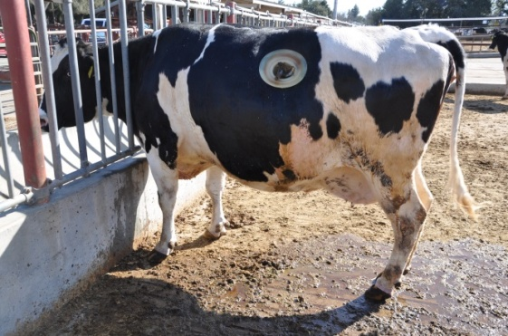Why use NDF and not ADF?* There are many reasons. First, NDF is a better measure of total fiber because it includes hemicellulose. Second, legumes (example: alfalfa hay) and grasses differ; grasses contain more hemicellulose than legumes, making NDF a better fiber method to compare grasses with legumes.

**What is NDFd and how is it measured?**

While sugars, starches, and proteins are highly digestible in most plants, it is the range in fiber digestibility that sets forages apart. Neutral detergent fiber digestibility (NDFd) is a measure used to improve the predicted energy value of forages. Digestibility of NDF can be measured by either *In vitro* or *In situ* methodology. Incubation times vary, although 24, 30, or 48 hours are typical times used by commercial labs. Using the amount of NDF present at the beginning of the incubation and the amount of NDF remaining at the end of the incubation, NDF digestibility is calculated (often this is called **NDFd**).

*Helpful Hint: NDFd values will vary across laboratories, as there will be differences in either rumen fluid (In vitro) or rumen environment (In situ). For this reason, it is important to compare forage reports from a single lab.*

*Let’s look at an example.*

A summary of corn silages, both conventional and BMR (brown midrib), from a commercial lab is shown in Table 1. The BMR gene in corn plants results in lower lignin content, which is important since lignin is indigestible and reduces plant fiber digestibility.

The conventional corn silage varieties contained 3.34% lignin (Table 1), while the BMR corn silage varieties contained 2.43% lignin. The average 30 hour NDF digestibility for the conventional corn silages was 59.9%, which results in a predicted energy value of 0.65 Mcal NEL/lb of silage dry matter. For the BMR corn silages, the 30 hour NDF digestibility was 68.5%, which results in a predicted energy value of 0.68 Mcal NEL/lb.

**Table 1.** Summary of Conventional and BMR Corn Silage

|  |  |  |  |  |  |
| --- | --- | --- | --- | --- | --- |
|  | DM | NDF | Lignin | 30-hr NDF** | Predicted Energy*  **30-hr NDF digestibility; *In vitro* methodology  *Mcal NEL/lb, calculated using the summative equations of W.P. Weiss, The Ohio State University, using 30-hr NDF digestibility |
| Conv. Corn | 34.5% | 43.5% | 3.34% | 59.9% | 0.65 |
| BMR Corn | 35.3% | 44.9% | 2.43% | 68.5% | 0.68 |

**Why is NDFd important?**

Yes, there is only a small difference in the predicted energy value between the two types of silages, but small differences are important when you consider (1) the amount of corn silage cows are consuming in the TMR and (2) energy intake is a limiting factor for high milk production. Fiber (NDF) is slowly digested and because it is only about 40 to 60% digested in the rumen, it has a fill effect in the rumen that can restrict feed intake. The dairy cow needs rumen fiber fill to create a mat to retain feed particles for digestion and maintain normal rumen function and pH. But that fiber mat must also be digested to provide energy to the cow and to allow the cow to consume more energy (TMR). Nutritionists use the information on NDFd in a variety of ways to best create a TMR for high milk production while maintaining normal rumen function, feed intake, and milk fat test.

To put some numbers (and potentially dollars) to the importance of NDFd, let’s look to the results of a study reported in the Journal of Dairy Science. The study found that a one-unit increase in NDFd was associated with a 0.37 pound increase in dry matter intake and a 0.55 pound increase in 4% fat corrected milk. These responses are why nutritionists are paying closer attention to NDFd.

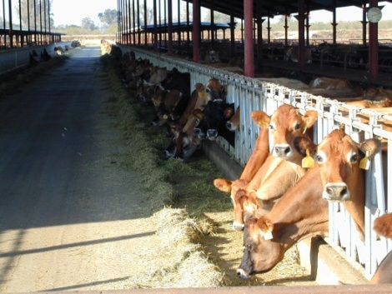**Take Home Message**

The composition of your forages provides valuable information to feed your cows. It also provides information that aids in determining forage pricing. Forage carbohydrates can be thought about in terms of structural carbohydrates that are measured by NDF and ADF. The structural carbohydrates are limited in digestibility by lignin and for that reason NDF digestibility (NDFd) is often measured. Your nutritionist uses NDFd information to formulate diets that support high milk production.

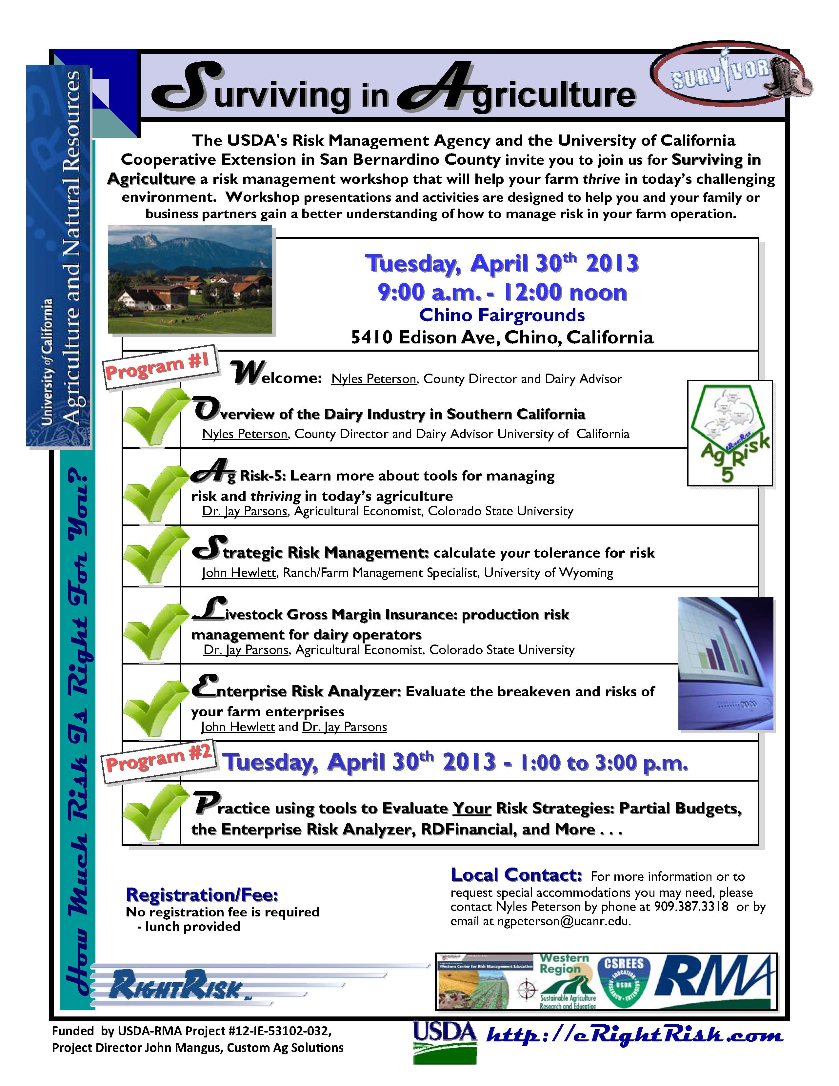

**California Dairy Newsletter**

**March 2013**

Nyles Peterson, Farm Advisor

UCCE San Bernardino County

The University of California prohibits discrimination against or harassment of any person employed by or seeking employment with the University on the basis of race, color, national origin, religion, sex, gender identity, pregnancy (which includes pregnancy, childbirth, and medical conditions related to pregnancy or childbirth), physical or mental disability, medical condition (cancer-related or genetic characteristics), genetic information (including family medical history), ancestry, marital status, age, sexual orientation, citizenship, or service in the uniformed services (as defined by the Uniformed Services Employment and Reemployment Rights Act of 1994: *service in the uniformed services* includes membership, application for membership, performance of service, application for service, or obligation for service in the uniformed services) or any person in any of its programs activities. University policy also prohibits retaliation against any employee or person seeking employment or any person participating in any of its programs or activities for bringing a complaint of discrimination or harassment pursuant to this policy. This policy is intended to be consistent with the provisions of applicable State and Federal laws. Inquiries regarding the University's equal employment opportunity policies may be directed to Linda Marie Manton, Affirmative Action Contact, University of California, Davis, Agriculture and Natural Resources, One Shields Avenue, Davis, CA 95616, (530) 752-0495.