Managing for More Milk

In this issue…

Management Considerations – 1
Plant Tissue Sampling – 2
Diagnosing Downer Cows – 3
Supply Well Sampling – 4
Utilizing Checklists – 4
NRCS Announcement – 5

Jennifer Heguy, UCCE Stanislaus & San Joaquin and
Jed Asmus, Independent Nutritionist

You cannot simply take one dairy’s diet, feed it to another herd, and expect the same production results. The reason - there are many variables that impact a cow’s ability to make milk. While nutrition is extremely important, and the largest cost of producing milk, it is only one of a number of factors that needs to be routinely evaluated. Table 1 is the typical time budget for a lactating cow (housed in freestalls). Cows spend almost half the day lying down, followed by eating/drinking, standing in the stall or alley, and milking. Within each of these areas is an opportunity to improve management. Let’s take a look at a few areas where small improvements in management may find you more milk.

Table 1. Dairy cow time budget (USDA, 2007)
Activity | Hours/Day | Percent of Day
Lying | 11.3 | 47%
Eating | 4.4 | 18%
Drinking | 0.4 | 2%
Standing – Stall | 2.9 | 12%
Standing – Alley | 2.4 | 10%
Milking | 2.6 | 11%

Feeding Management
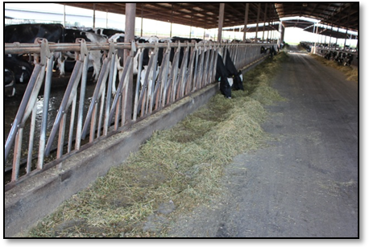
Just as important as what you’re feeding is how you feed. In a study published in the Journal of Dairy Science, three of the most influential milk production variables (outside of the ration) were related to feeding: stocking density, feeding for refusals, and pushing-up feed. These may seem like common sense practices, but all three are often overlooked on dairies. Keeping an accurate pen count and allowing for adequate feeding space are imperative to ensuring adequate dry matter intake. When animals are overstocked (more cows than feeding space), there is greater potential for sorting to affect subordinate cows in the pen. Dominant cows eat first, leaving subordinate cows to eat the sorted feed rather than the formulated ration, thus compromising milk production and animal health.

In times of high feed costs, the natural (but not necessarily correct) response is to cheapen rations. One way to accomplish this is to reduce the amount of feed offered to limit refusals. In a 2009 California feeding management survey, 58% of producers reported not feeding for refusals. Unless pen counts are spot-on and your feeder has turned weighing ingredients into a fine art, you may be underfeeding animals when not feeding for refusals. In that case, the cost of limiting feed intake (thus limiting production and affecting health) outweighs the savings in feed.

Keeping feed in front of cows is another important factor when managing for more milk. This is accomplished by feeding multiple times per day, keeping feed pushed up, and/or a combination of the two. Lack of feed, or feed not within cows’ reach should not be a limiting factor for milk production.

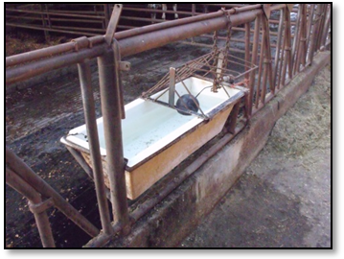
Milk is about 87% water, making water an important (and oftentimes overlooked) nutrient. If you see cows waiting to drink, you need to install more watering space. The majority of free water intake is consumed shortly after milking, so ensure that animals have abundant access to clean, cool water. Both water quantity and quality are important! Water troughs should be cleaned at least weekly, a practice only 40% of producers reported in the 2009 survey.

Resting Area
We’ve already covered stocking density as related to feeding management, but it is also important for “cow comfort” and adequate lying time. Cows need a clean, dry environment, with adequate “cushion” regardless of bedding type. Studies have shown that lying time increases with increased bedding depth. Cows standing in stalls rather than lying down can be an indication that improvements are needed. Neck rail placement in freestalls is another area where improvements may be beneficial. Table 2 provides recommendations for neck rail placement based on the size of the animals being housed. When neck rails are placed too far forward or too high in the freestalls, animals will stand and urinate/defecate in the beds, creating a hygiene problem. Neck rails placed too far back or too low can prevent animals from utilizing freestalls.

Table 2. Recommendations for neck rail placement by size of animal
Stall Dimension (inches) | Body Weight Estimate (lbs)
Stall Dimension (inches) | 1200 | 1400 | 1600 | 1800
Height below neck rail | 46 | 48 | 50 | 52
Horizontal distance between rear edge of neck rail and inside of rear curb | 60 | 62 | 64 | 66

Adapted from: Dimensions and Design Tips for Free stalls 10.21.05. Nigel B. Cook MRCVS, University of Wisconsin-Madison

Take Home Message
The objectives of any dairy are to make milk, and make money. Cows searching for adequate resting areas, eating a sorted ration, standing in holding pens for an extended period of time, etc., do not make more milk. The cheapest milk increases are not found by decreasing the cost of your diet, instead they fall into eliminating management bottle necks that decrease productivity on your dairy.

Summer Silage Sampling Reminders
Betsy Karle, UCCE Glenn & Tehama

By now, all dairy producers in the Central Valley are well aware that samples of each harvest are required for compliance with the General Order of Waste Discharge Requirements. But, are you certain you are taking samples properly to get the most accurate data thereby ensuring that your Nutrient Budget is a functional working document? Your sampling and analysis plan lays out exactly how you will take your samples. As you progress through corn silage harvest, here are some points to remember:

- Your Sampling and Analysis Plan is a document that lays out how you will be gathering the information to fine tune your nutrient applications- use it!
- Percent moisture is required for all forage samples. If percent moisture is incorrect because representative samples were not taken, the total dry matter harvested will be wrong, and the total nutrients harvested will reflect this error. Moisture varies greatly within a single field. Use sub-sampling as explained in the forage sampling protocol to obtain a representative sample.
- Monitoring requirements have changed since last year. Harvests need to be quantified in tons; cubic yards are no longer acceptable. Required lab analyses now include fixed solids (ash), total phosphorus, and total potassium (total nitrogen analysis remains the same). Be sure your lab is analyzing for the right elements.

To get the best crop and avoid unwanted regulatory attention, it is in your best interest to get good, representative samples now to fine tune your nutrient application timing and quantity. Using good information to grow a quality crop and avoid regulatory penalties is money in your pocket.

Diagnosing Downer Cow Electrolyte Imbalance
Dr. Pat Blanchard, California Animal Health and Food Safety Laboratory

The diagnosis of electrolyte imbalances (calcium, phosphorous, potassium and magnesium) in downer dairy cows often presents challenges. Treatment with electrolyte solutions such as calcium-phosphorous, calcium-magnesium-phosphorous-potassium (CMPK) or others increases the level of one or more of these electrolytes which masks deficiencies. Also blood samples collected for diagnostic purposes must be handled appropriately. A delay in separating the serum (clear portion of blood) from the red blood cells allows potassium and phosphorous (which are high in red blood cells) to leak into the serum and prevent a diagnosis of deficiency of these two electrolytes. CAHFS recommends taking a blood sample in a red stopper blood collection tube or red and gray stopper separator (gel layer) tube before the animal is treated. The serum (clear portion) that separates off from the red cells should be removed from contact with the red cells within an hour or at most two hours after collection to ensure an accurate result for potassium and phosphorous. Blood should never be frozen with the red cells still in the tube as this causes red cells to rupture and large amounts of potassium and phosphorous and lesser amounts of calcium and magnesium are released into the serum making electrolyte testing inaccurate.

CAHFS - Davis Laboratory
Phone: 530-752-8700
Fax: 530-752-6253
cahfsdavis@cahfs.ucdavis.edu

CAHFS - San Bernardino Laboratory
Phone: (909) 383-4287
Fax: (909) 884-5980
cahfssanbernardino@cahfs.ucdavis.edu

CAHFS - Tulare Laboratory
Phone: (559) 688-7543
Fax: (559) 686-4231
cahfstulare@cahfs.ucdavis.edu

CAHFS - Turlock Laboratory (poultry)
Phone: (209) 634-5837
Fax: (209) 667-4261
cahfsturlock@cahfs.ucdavis.edu

Web Site:
www.cahfs.ucdavis.edu
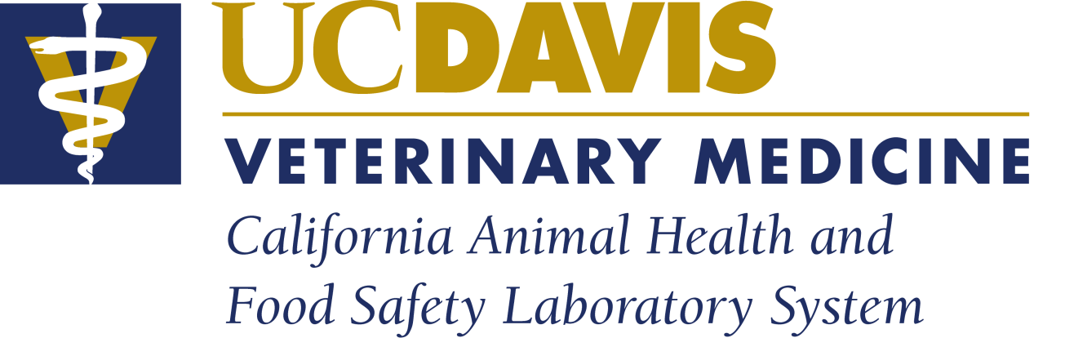

In recent months, CAHFS has worked with dairies that had a high down cow rate due to low phosphorous which caused alert downer cows that were not responding well to treatment. The initial blood samples tested were taken before electrolyte treatment, refrigerated with the serum left on the clot (red blood cells), and sent to the lab 1 to 3 days after collection. Electrolyte values were normal on these samples. Other blood samples that were submitted within an hour of collection had significantly low phosphorous values. Changes in treatment to include more phosphorous resulted in improved response to treatment and changes in the diet to increase phosphorous resolved the problem. This real example underscores the importance of submitting good samples to improve diagnostic capabilities.

Testing for electrolytes is performed at our toxicology laboratory in Davis but blood samples can be submitted to any of the four CAHFS laboratory and will be sent to the Davis laboratory.

Remember to Test Supply Well and Tile Drain Samples
for Ammonium Nitrogen
Deanne Meyer, Livestock Waste Management Specialist, Department of Animal Science, Davis, CA

Just a reminder. The Monitoring and Reporting Program for Existing Milk Cow Dairies (Central Valley) was modified in February. Modifications in Table 4 (Page 7) require field measurement of ammonium nitrogen for all supply well and tile drain samples. This is an EASY analysis to do. The Central Valley Regional Water Quality Control Board has a document available on their website
(http://www.waterboards.ca.gov/centralvalley/water_issues/dairies/general_order_guidance/sampling_analysis/field_testing_ammonia.pdf ) for field testing for ammonium.

A simple test strip is used for this field test. Total ammonia/ammonium nitrogen test strips are available and can be purchased at major aquarium supply stores or online. The Regional Board Staff tested several brands of strips and they identified the Hach brand strips were easiest to use. It is very important that strips be new and uncontaminated. Unused strips must be kept in their container until used. Do not use strips exceeding the expiration date on the bottle.

Each company provides specific instructions for use of the strips. Use freshly retrieved water for the analysis. Total ammonium nitrogen is what needs to be measured for supply well and tile drain samples. Therefore, you do not need to record temperature and pH of your sample. These additional pieces of information are only needed if unionized ammonia must be determined.

If any of your samples test positive for ammonium, then the original sample needs to be preserved appropriately for laboratory analysis of ammonium nitrogen.

The revisions are available at
http://www.waterboards.ca.gov/centralvalley/board_decisions/adopted_orders/general_orders/r5-2007-0035_mrp_rev.pdf

Something to Think About
Nyles G Peterson, UCCE San Bernardino

Would you fly with a pilot who did not use a checklist? Aviation history tells us that the pilot checklist concept was inspired by a tragic accident on October 30, 1935, when a prototype for the Boeing B-17 crashed during takeoff at Wright Field in Dayton, Ohio. At first everyone thought that the plane had crashed because it was just too much plane for any single pilot to fly, but upon further investigation the cause of the crash was identified as “pilot error” -- the pilot had neglected one important step before take off. He had forgotten to release the elevator lock. The accident happened not because the tasks were too hard for one man to do; it was rather because the number of tasks was too great for the average person to be expected to remember. After the mishap, a group of pilots got together and worked on a way to prevent future "pilot errors." They came up with checklists. With the help of checklists, pilots flew B-17s over 1.8 million miles without a serious “pilot error” mishap.

That is all well and good, but what does this have to do with running a dairy? Since that first recorded checklist, the checklist idea has been used by many professional and private fields of endeavor. You might be thinking, “My employees don’t need a checklist to remind them what to do.” That might be true, but you could be wrong. You might want to go into the milking barn and just see how well the following Milking Procedure Checklist is being followed. Your milkers might be skipping one or more important steps.

Milking Procedures Checklist:
- Cows are provided a clean stress free environment
- Milkers wear latex/rubber gloves while milking
- All teats are clean, dry, and sanitized before the milking unit is applied
- Only one cow is dried per towel
- Foremilk is checked for abnormalities
- Animals known to be secreting abnormal milk are milked last or with separate equipment, and the milk is discarded
- Milking units are attached within two minutes after the start of stimulation
- Liner slippage is minimized
- Vacuum is shut off before milking units are removed
- Immediately after unit removal, every teat is disinfected with an effective product

First Aid Checklist:
- Emergency phone numbers are posted in prominent places (by telephones and in main work areas)
- A first aid kit is readily available, and all workers know where it is located
- Someone on the dairy should be trained in First Aid and CPR

I would suggest that you use the Milking Procedure and First Aid Checklists as examples to develop similar checklists for other important functions on your dairy: feed mixing and distribution, newborn calf procedures, dry cow treatment, dairy safety, etc. Your dairy operation will run more smoothly if you use these checklists when training employees and when the procedures are reviewed on a regular basis.

NRCS Feed Management Program
Bob Fry, State Conservation Agronomist & Gerald Higginbotham, UCCE Fresno & Madera

The Natural Resources Conservation Service (NRCS) has adopted a practice standard called Feed Management (592) and is defined as “managing the quantity of available nutrients fed to livestock and poultry for their intended purpose”. Protein is typically the most expensive purchased component in dairy rations. The goal in feeding dairy cattle is to develop feeding programs and management systems that maximize the efficiency of nitrogen use and decrease nitrogen excretion to the environment. Current regulations in the Central Valley now require careful management of manure as a crop nutrient specifically as it applies to nitrogen content.

Reducing the N content of the manure will lessen the chance of groundwater contamination from excess nitrogen applications on crop ground. NRCS is offering a cost share opportunity for dairy producers interested in evaluating and possibly improving feeding practices to limit nitrogen levels in manure while also optimizing animal nutrition and production. Producers should be aware of the following if they wish to participate in this program:

- An American Registry of Professional Animal Scientist (ARPAS) dairy nutritionist certified in Feed Management will need to prepare the feed management plan and help implement it. Contact your NRCS office for help in finding a certified nutritionist.
- Feedstuff and TMR analysis, monitoring of milk N levels, and other measuring and recordkeeping is necessary.
- Nitrogen Use Efficiency (NUE) provides a method to assess the efficiency of feed N use in the dairy herd. Higher NUE values indicate better efficiency in converting feed N into milk N. For dairy producers to receive payment in the second and third year, 30% of the total N fed to the lactating cows needs to end up in the milk. (This is a 30% NUE). An NUE of 28% is adequate for the first year if new practices are being used that should lead to 30% efficiency in year two. Records must show these requirements are met. NRCS provides a recordkeeping and reporting Excel Spreadsheet, “NUE Calculator” that can be used to meet this requirement.
- To be eligible producers must not already have a 30% NUE feed efficiency. To estimate if your NUE is above or below 30% using the “Eligibility Tool”, or review the “NUE Calculator”, go to
http://www.ca.nrcs.usda.gov/technical/cnmp/feed_mgt_guidelines.html

For further information contact your local NRCS office or UC Cooperative Extension Dairy Advisor.

Cooperative Extension
University of California
777 E. Rialto Ave
San Bernardino, CA 92415

California Dairy Newsletter
September 2011

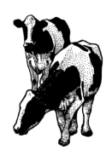
Nyles Peterson, Farm Advisor

University of California prohibits discrimination or harassment of any person on the basis of race, color, national origin, religion, sex, gender identity, pregnancy (including childbirth, and The medical conditions related to pregnancy or childbirth), physical or mental disability, medical condition (cancer-related or genetic characteristics), ancestry, marital status, age, sexual orientation, citizenship, or service in the uniformed services (as defined by the Uniformed Services Employment and Reemployment Rights Act of 1994; service in the uniform services includes membership, applications for membership, performance of service, application for service, or obligation for service in the uniformed services) in any of its programs or activities. University policy also prohibits reprisal or retaliation against any person in any of its programs or activities for making a complaint of discrimination or sexual harassment or for using or participating in the investigation or resolution process of any such complaint. University policy is intended to be consistent with the provisions of applicable State and Federal laws. Inquiries regarding the University’s nondiscrimination policies may be directed o the Affirmative Action/Equal Opportunity Director, University of California, Agriculture and Natural Resources, 1111 Franklin Street, 6th Floor, Oakland, CA 94607, (510) 987-0096.

