Antibiotic Residues in Dairies
In this issue…

Antibiotic Residues – 1
Identifying Sick Cows – 2
Monitoring Mastitis – 4
Water Board Updates – 5
Corn Silage Field Day – 7

Michael Payne, DVM, PhD. Program Director, CDQAP

According to the current USDA data available in 2008, cull dairy cows accounted for just over 7% of all cattle slaughtered in the US, but were responsible for approximately 90% of carcasses in which drug residues were detected. At Western United Dairyman’s annual conference held in Visalia in March, Dr. Michael Payne, a veterinarian from the University of California at Davis, covered some of the more common reasons leading to having a carcass condemned for drug residues.

#1 Changing the dose or route for Procaine Penicillin G: The label dose for PPG is only 1cc per 100 pounds, or about 15 cc total. When a cow is given higher doses or treated subcutaneously (under the skin), the slaughter withdraw time can increase from the label 4-10 days up to several weeks.

#2 Marketing cows treated for mastitis before completing their slaughter withdrawal: Dairy employees usually do a great job holding out milk from cows treated for mastitis, but sometimes forget that mastitis tubes also have slaughter withdrawal times ranging from 4 to 28 days.

#3 Marketing dry-treated cows before completing their slaughter withdrawal: While it’s tempting to cull a cow who has aborted, she’ll still have residues in her tissues from her dry treatment and a slaughter withdrawal of 14 to 60 days from the day she was dried off.

#4 Calves marketed for veal that have consumed colostrum or medicated milk replacer: Calves slaughtered shortly after birth (as bob veal) may have consumed enough antibiotic from the dry-treatment to trigger a positive carcass test. Tissue residues are also frequently caused by calves consuming milk replacer medicated with tetracycline and neomycin. Calves fed medicated milk replacer should never be marketed as veal.

#5 Giving pain relievers in the muscle or under the skin: The only pain relievers approved for cattle contain flunixin (Banamine, Flu-Nix), a drug which was only designed to be administered in the vein. Giving flunixin-containing products in the muscle or under the skin, rather than intravenously, can increase the withdrawal time from the label 4 days to more than a month.

#6 Marketing cows treated with intra-uterine boluses or infusions: Tetracycline can cross the uterine wall and be detected in the milk and at slaughter for variable periods. Some veterinary publications recommend slaughter withdrawal of up to four weeks following intrauterine treatment.

#7 Thinking there is a “zero meat, zero milk withdrawal” antibiotic: While products containing ceftiofur (Naxcel, Ceftiflex, Excenel, Excede) are attractive because they have no milk withdrawal, all ceftiofur-containing products have slaughter withdrawals ranging from 3 to 13 days when used according to label. There is no such thing as a “zero meat, zero milk withdrawal” antibiotic.

#8 Using any sulfa-drug off label: The sulfonamide (“sulfa”) drugs may only be legally used exactly according to label instructions. Recent FDA investigations of residues suggest that over-dosing sulfa boluses (Albon) or giving intravenous sulfa products (Di-methox) off-label in the muscle or under the skin has led to tissue residues.

While the situations above are some of the more common causes of tissue residues, virtually any drug can cause residues if it is used off label or if the drug is used on label but the label withdrawal isn’t followed. With USDA stepping up enforcement on tissue residues and the potential for FDA testing of bulk tank milk in the future, now is an excellent time for dairy managers to review their treatment programs. As always, your veterinarian is your most valuable resource for information and advice about avoiding tissue and milk residues.

Identifying Sick Cows that Need to Be Examined
Noelia Silva-del-Rio, UCCE Tulare

Fresh cows have the greatest production potential in a dairy. However, fresh cows are very susceptible to diseases. The most frequent disorders observed in fresh cows are: mastitis, metritis, injury or lameness, milk fever, ketosis, displaced abomasum, pneumonia and enteritis. Losses associated with those diseases are estimated from $200 to $400 per case per lactation. Furthermore, 15% to 25% of all cullings take place during the first 60 DIM. Early identification and treatment of sick animals may reduce the overall cost of the disease (drugs and milk production), increase the chances for a full recovery, improve animal welfare, and reduce culling, especially of fresh cows. These benefits should motivate dairy producers to work with their herd veterinarians to implement a herd health program that will successfully identify, examine and treat sick cows in the herd.

While some dairies find it valuable to routinely check all fresh cows, others, due to time and labor, may limit physical exams to cows showing signs of disease or with abnormal attitude. The objective of this article is to describe a comprehensive way that may help dairy workers to identify sick cows requiring a thorough physical examination.

Some reasons that justify the need for a detailed cow exam are: 1) difficult calving, 2) twins, 3) retained fetal membranes, 4) foul smelling vaginal discharge, 5) abnormal udder, 6) deviation in milk production, 7) reluctant to lock, 8) poor appetite, 9) abnormal rumen fill, 10) diarrhea, 11) lame or walking with difficulty, 12) down cows, 13) fever, 14) extremely fat cows at calving, and 15) cows listed as recheck. All cows presenting any of these conditions should be included in the “list of cows to examine”. In most operations, these cows will be added to the list the day prior to the exam or the morning of the exam.

In order to ensure that the “list of cows to be examined” is complete, a systematic approach to observation and recording is necessary. The identification of sick animals in the fresh pen can be accomplished by teaming up two people who walk simultaneously through the front and the back of the cows.

The person walking in front of the cows should take notes and check:
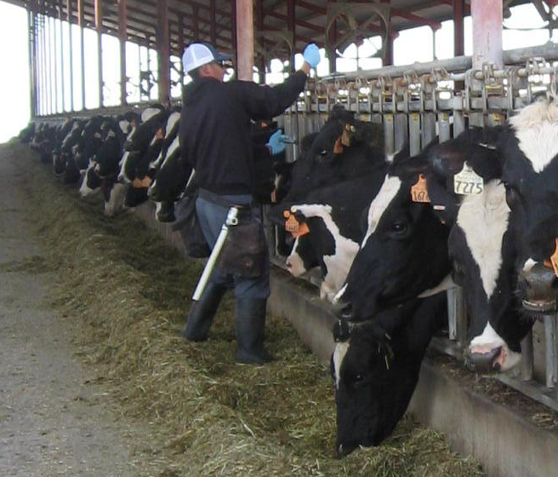
  - Appetite. Note if cows are eating, sorting or are not interested in feed at all. Check for undisturbed feed sitting in front of the cow at lock up. Before releasing the cows from the lock-ups, check for cows that consumed feed at a lower level than their neighbors.
  - Attitude. Healthy animals are curious about their surroundings. Their ears are waggling and if you approach them, they will try to smell or lick you. Sick animals tend to have their head down, dropped ears, dull eyes and are too tired to groom their noses.
  - Ears. Compare among cows the attitude and temperature of the ears. In healthy animals, ears are positioned above the point of attachment to the head, whereas sick animals have ears that are below. Droopy ears suggest a sick cow that is depressed, in pain or with fever. Cold ears will indicate decreased blood flow to the periphery which could be related to milk fever, acidosis or severe toxic states.
  - Eyes. Cows with sunken, dull and crusty eyes may be dehydrated and/or in pain. Note if there are visible eye lesions (pink eye, trauma).
  - Nose. Check for abnormal nasal discharge (white, green, yellow, or bloody) that may indicate pneumonia or acidosis. Sick cows are too depressed to maintain their noses (licked clean) and feed particles and nasal discharge will stick on their noses. It is also important to check if the nostrils appear dry, as it suggests fever.
  - Cough. Cows that are coughing two or three times should be noted for observation.

The person walking behind the cows should check:
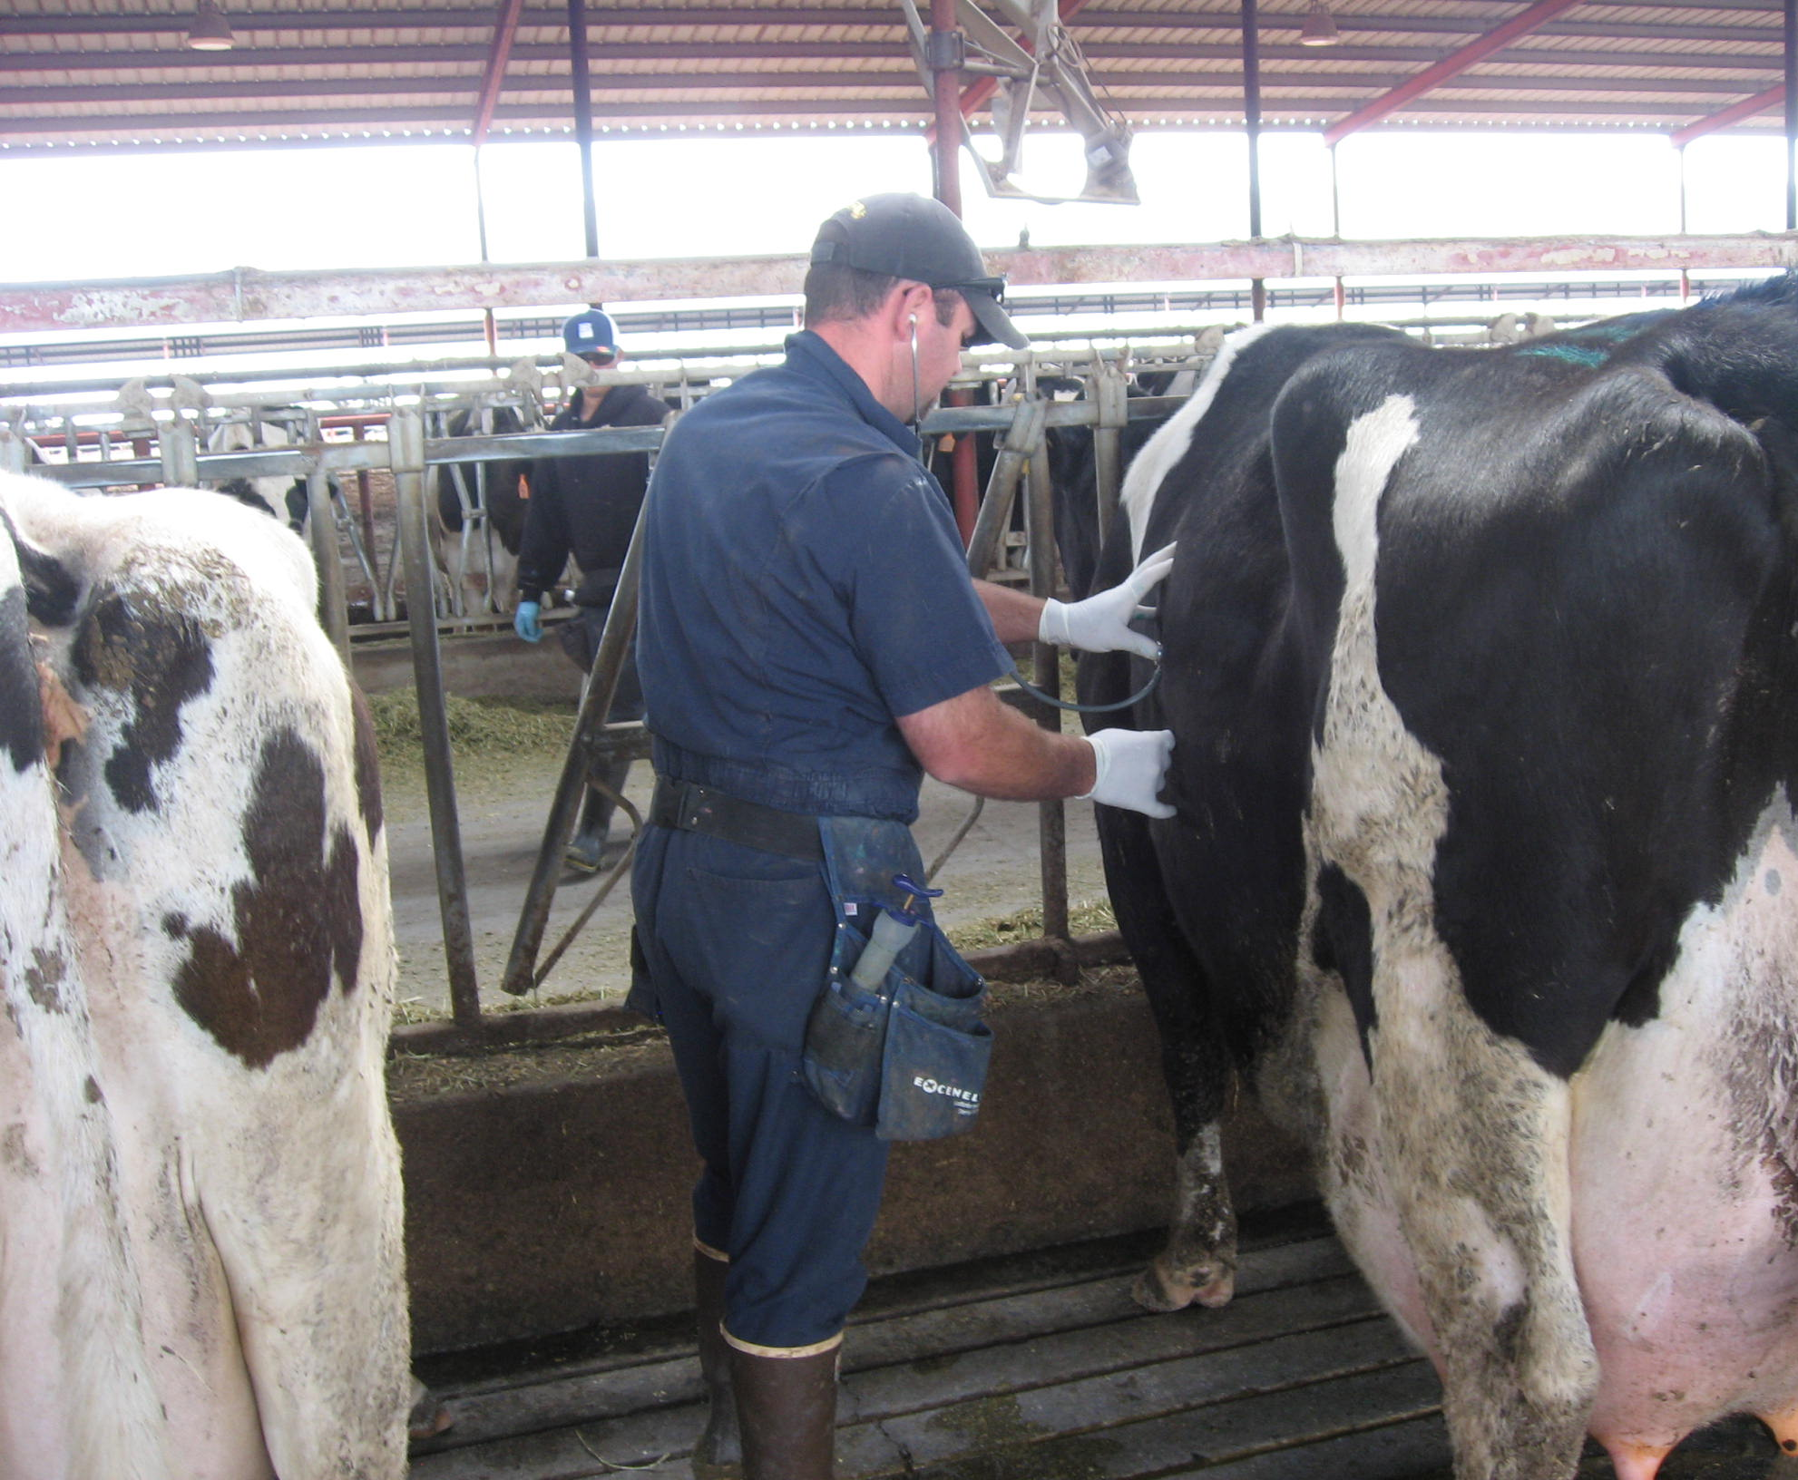
  - Manure. Check the floor, vulva and tail for manure with abnormal consistency (too loose to form a pile), color (almost black) and/or foul smelling. Abnormal manure can be found in cows suffering from acidosis, digestive upsets, toxic diseases, or enteritis.
  - Retained Fetal Membranes. Retained fetal membranes are not a health problem per se, but increase the risk for metritis. If you find retained fetal membranes, you should also look for abnormal vaginal discharge.
  - Vaginal discharge. It is normal to find vaginal discharge for up to two weeks after calving. However, dark red and foul smelling vaginal discharges are found in cases of uterine infection.
  - Abnormal abdomen. Cows with their left flank tucked in have poor rumen fill because of anorexia. If the abdomen is distended, cows may be bloated due to rumen gas accumulation.
  - Breathing rate. The basal respiration rate is 12 to 36 breaths/min. Note if the animal has an abnormal respiration rate or if inspiration and/or expiration require additional efforts. Pneumonia, bloat and toxic diseases may cause difficult breathing.
  - Abnormal udder. Note udders that are unbalanced, swollen, with abnormal color (reddish or bluish), or with damage in their suspensory ligaments. Check udder fullness; poor appetite will result in poor udder fill.
  - Cows that did not lock up after feed was delivered. Sick cows are reluctant to lock up as they lack the drive to eat.
  - Cows’ posture that indicate pain.
    - Tail away from the body: irritation in the perineal region, vagina or rectum, or severe metritis.
    - Elbows pointing out: pain in the rib cage.
    - Arched back: peritonitis, severe lameness.

Some large dairies use colored chalk on the back of the fresh cows to write relevant information (calving date, calving difficulties, disease findings, and so on), and easily identify cows needing examination.

Sick cows can be found elsewhere in addition to the fresh cow pen. Therefore, all dairy workers, but especially those involved in feeding, breeding, moving cattle and milking should be trained to identify sick cows. They all should carry a little notebook and contribute with their observations to complete the “list of cows to examine”. Feeders should look for cows reluctant to move when fresh feed is delivered. Workers moving cattle have an excellent opportunity to observe cow’s gait and posture. They should look for cows that are depressed (react slowly to stimulus), with heads down, droopy ears, arching their backs, with the elbows pointing out, walking slowly and favoring one limb, or that have difficulty standing up and moving. Breeders will walk behind cows and should look for any cow with abnormal attitude, manure, vaginal discharge or abnormal udder. During rectal exploration, they can gather information on the uterus status and the temperature of the cow. In the milking parlor, milkers can easily note swollen quarters and discolored udders. Udder fullness prior to milking (too baggy) or after milking (swollen) should always be evaluated. By stripping udders, clinical mastitis cases can be identified in the milking parlor. Dairies recording individual milk weights should look for cows deviating from the expected production.

Recommended Reading:
Terra, R. 2001. Ruminant history, physical examination and records. In: Large Animal Internal Medicine by Bradford Smith, Chapter 1: pg 3-14
McGuirk, S. Examination of Fresh Cows: http://www.vetmed.wisc.edu/dms/fapm/fapmtools/transition_cow.htm

The Evolution of New Tools for Old Problems - Mastitis
Carol Collar, UCCE Kings County

Mastitis is a universal problem that all dairy producers struggle with to varying degrees at one time or another. Management strategies to reduce the risk of mastitis usually focus on decreasing exposure of cows to the bacteria that infect the mammary gland. These strategies include practicing proper milking protocols, paying close attention to hygiene, maintaining clean free stall beds and corrals, and limiting introduction of infected animals to the herd. Tools have been developed to help dairy producers detect mastitis, and these have evolved over many decades from simple cow side tests to specialized DNA analyses. If you can’t measure it, you can’t manage it.

Few tools were available to monitor mastitis in the early days of dairy production. For individual cows, one relied on observation to find cows with abnormal milk or swollen quarters. By the time these clinical signs were obvious, infection was already well established. Early detection is valuable to identify infected animals so that effective treatment decisions can be made. The Standard Plate Count (SPC) was one of the first milk quality tests applied to measure total bacteria in milk. The SPC of commingled milk reflects hygienic conditions of milk harvest and storage, and also gives an indication of udder health status. In 1915, the SPC upper limit in California for raw milk was 200,000 cells/cc. This was reduced in the 1920’s and 30’s, and finally dropped to the current SPC limit of 50,000 cells/cc in 1970 (1).

In the late 1950’s, a simple and inexpensive cow-side test called the California Mastitis Test (CMT) was developed by veterinarians at UC Davis (2). The CMT indirectly measures immune cells that travel to the mammary gland in response to an infection. With this test, dairymen could find cows with subclinical mastitis before visual signs developed. DHIA laboratories used the test to provide members with milk quality information in addition to monthly milk weights. The CMT ushered in a whole new era of milk quality management, and it continues to be widely used around the world.

In the 1970’s, technology for directly counting immune cells (also known as somatic cells) in milk became available. DHIA and other milk testing laboratories embraced this technology and replaced CMT reporting with more precise SCC information. In California, a regulatory threshold of 750,000 cell/ml SCC in bulk tank milk was adopted in 1970 (this was later reduced to 600,000 in 1990). In recent years, other on-farm tests for measuring SCC in milk have become available, including the Porta-SCC and the Delaval Cell Counter. Both the CMT and the SCC are measures of the cow’s own cells in milk that are present to fight an infection. Other tests are needed to determine the types of bacteria causing the infection.

Bacteriological culturing of milk samples from individual cows or from bulk tanks is a way to distinguish specific mastitis pathogens. A small amount of milk is spread onto a plate of culture medium – usually bovine blood agar (BBA). The plate is incubated for 48 hours allowing bacterial colonies to grow on the plate if bacteria are present in the milk sample. Different bacteria can be distinguished by trained technicians based on the appearance of the colonies that grow – Strep ag, Staph aureus or Coliform for example. Knowledge about the type of bacteria that are present helps to focus mastitis control efforts. In California, routine programs for monitoring mastitis pathogens in bulk tank milk were initiated by UC Cooperative Extension Farm Advisors. One of the pioneers was Richard N. Eide, who worked with Danish Creamery, Fresno County DHIA and Sunnyside Veterinary Clinic to organize a monthly testing and reporting system for dairy producers. This was no small feat in the 1970’s, before personal computers and cell phones. Tracking monthly SCC and mastitis pathogens helped dairymen, farm advisors, veterinarians and field staff to implement programs to improve milk quality.

Routine culturing of bulk tank milk has been common for over 30 years. Culturing milk from individual cows is also common and is another way to keep tabs on infectious bacteria in the herd. Some dairies culture milk samples from cows when they freshen, or before dry treating. Others culture milk samples from cows with high SCC or clinical signs of mastitis to help guide treatment decisions. Several commercial laboratories offer bacteriological culturing services. The UC Veterinary Medicine Teaching and Research Center in Tulare has a world-renowned Milk Quality Laboratory. A few dairies have even established on-farm milk culturing capabilities.

Development of molecular-based testing for identification of pathogens in milk is the most recent innovative management tool. The analysis is based on a genetic “fingerprint” contained in the DNA of every living organism. A process called PCR (polymerase chain reaction) amplifies unique sections of DNA, and these are used to identify the presence of specific mastitis pathogens. PCR was developed in the 1990’s, and it has seen extensive use for clinical diagnostics in many fields. Commercial applications of automated PCR tests recently became available for milk (3). Lancaster DHIA in Pennsylvania was the first milk-testing laboratory in the US to introduce it in 2010. Benefits of PCR compared to conventional culturing include speed, accuracy and convenience. Identification of all major mastitis-causing bacteria is possible in only four hours. Samples collected on DHIA test day can be used. On the down side, cost and interpretation of the results are barriers to widespread use. At about $20 per sample compared to about $5 for culture, only those with an urgent need for immediate results are likely to use the PCR option. Questions remain about what the results mean and how they should be applied to dairy management strategies. UC Cooperative Extension field studies will address these questions. I am excited to participate in the evolution of this incredible new tool for mastitis control on dairies!

From SPC, CMT, SCC, and BBA to PCR - what is next? I recently visited with molecular biologists in the Animal Science Department at UC Davis. They described novel DNA based tests that are useful in human medicine, and these will make even the new PCR test for mastitis pathogens obsolete! Scientific advances will continue to provide new tools for use in dairy production. Application of these tools can enable us to efficiently produce safe and nutritious food for a hungry world.

References:
- Dr. Stephen Beam, Chief, Milk and Dairy Food Safety Branch, California Dept. of Food and Agriculture. Personal communication, Feb. 23, 2011.
- Schalm O.W. and Noorlander D.O. 1957. Experiments and observations leading to development of the California mastitis test. J. Am. Vet. Med Assoc. 130:199.
- Koskinen, M.T., G. Wellenberg, O.Sampimon, J. Holopainen, A. Rothkamp, L. Salmikivi, W. VanHaeringen, T. Lam and S. Pyorala. 2010. Field comparison of real-time polymerase chain reaction and bacterial culture for identification of bovine mastitis bacteria. J. Dairy Sci. 93:5707-5715.

Modifications to the Monitoring and Reporting Program of the General Order
for Existing Milk Cow Dairies
Deanne Meyer, Ph.D., UCCE Livestock Waste Management Specialist

It’s hard to believe that four years have passed since the General Order was adopted. Most producers are familiar with the basics of the Order. The Monitoring and Reporting Program (MRP) establishes the type(s) and frequencies of sampling and reporting. The MRP was opened for modifications in the fall of 2010. A draft revised document was available for public comment in October, November and a bit of December. The final revised document was posted February 23, 2011. Numerous documents for the CDQAP WDR Reference Binder have been modified and will be available at the CDQAP website http://www.cdqa.org/binder.asp : Tab1 Doc 4; Tab 5; Tab 6 Docs 1, 12, and 13; and Tab 8 Docs 2 and 3.

Why modify the MRP? The primary reason to modify the MRP was to provide language for the representative groundwater monitoring program. In the process, changes were also made to Tables 1 through 4, record-keeping requirements, and the general section of the annual report. All of these changes should be implemented immediately.

Net Effect of Changes in Sampling Requirements
The major changes are outlined here after taking into account clarifications provided by Regional Board staff. Changes from potassium or phosphorus to total potassium or total phosphorus are not included in this list, but are in the protocols and the summary document (Binder Tab 1, Doc 4).

Table 1. The rainy season is defined from October 1 through April 30. Include the pond depth marker in the photo when taking monthly photos of ponds. Document conditions of fields before beginning irrigations with liquid manure.

Table 2. Process wastewater: include analysis of total dissolved solids for quarterly samples. Every two years, conduct general mineral analysis of process wastewater. An annual pH may be requested by Regional Board staff. Solid manure: include sulfur and fixed solids analysis every two years. Track manure application and manifests by weight and moisture content (no longer allowed to use volume and bulk density). Plant tissue: Track yields for each crop from each field by weight and moisture content (no longer allowed to use volume and bulk density). Include fixed solids analysis. Soil: may distribute sampling over a 5-year period (20% of fields each year). Irrigation water: include total dissolved solids in lab analysis.

Table 3. A few modifications were made to off-site discharge sampling requirements. See Doc 8.2 and 8.3 from the CDQAP reference binder for those details should you need to collect samples.

Table 4. Supply well samples: include field test of ammonium nitrogen. If ammonium nitrogen is present, then obtain laboratory analysis of ammonium nitrogen. Run general minerals every 5 years (may be done on 20% of wells per year). The Regional Board has information on the field test kit for ammonium nitrogen.
http://www.waterboards.ca.gov/centralvalley/water_issues/dairies/general_order_guidance/sampling_analysis/field_testing_ammonia.pdf

Changes in Record-keeping Requirements. For rented or leased facilities, both the dischargers and the owners shall maintain copies of the records for 5 years. A modification was made regarding recording of weather conditions at time of manure or process wastewater applications: Record if precipitation occurred, or standing water was present, at the time of manure and process wastewater applications and for 24 hours prior to and following applications.

Changes in Annual Reporting Requirements (this is an overview of the more important items). One of the key changes is that total dissolved solids and fixed solids will be used to estimate salts generated, applied to fields, or manifested off-site. Additionally, the ratio of total nitrogen applied to land application areas and total nitrogen removed by crops harvested must be determined. Modifications were made so operators will no longer need to submit a modified dairy facility assessment. Additionally, the annual report maximum and average number of animals will need to be reported.

Groundwater monitoring. The revised MRP reminds us that each Discharger shall comply with additional groundwater monitoring requirements … either through individual groundwater monitoring or by participation in a Representative Monitoring Program. If you’ve not signed up for a representative monitoring program, you will receive a directive at some point to install groundwater monitoring wells. Between 100 and 200 individuals may be directed per year. If you’re interested in more information on the representative monitoring program, it is available at www.dairycares.com .

The modified MRP is available at
http://www.waterboards.ca.gov/centralvalley/board_decisions/adopted_orders/general_orders/r5-2007-0035_mrp_rev.pdf

Cooperative Extension
University of California
777 E. Rialto Ave
San Bernardino, CA 92715

California Dairy Newsletter
June 2011

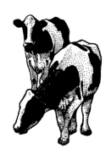
Nyles Peterson, Farm Advisor

University of California prohibits discrimination or harassment of any person on the basis of race, color, national origin, religion, sex, gender identity, pregnancy (including childbirth, and The medical conditions related to pregnancy or childbirth), physical or mental disability, medical condition (cancer-related or genetic characteristics), ancestry, marital status, age, sexual orientation, citizenship, or service in the uniformed services (as defined by the Uniformed Services Employment and Reemployment Rights Act of 1994; service in the uniform services includes membership, applications for membership, performance of service, application for service, or obligation for service in the uniformed services) in any of its programs or activities. University policy also prohibits reprisal or retaliation against any person in any of its programs or activities for making a complaint of discrimination or sexual harassment or for using or participating in the investigation or resolution process of any such complaint. University policy is intended to be consistent with the provisions of applicable State and Federal laws. Inquiries regarding the University’s nondiscrimination policies may be directed o the Affirmative Action/Equal Opportunity Director, University of California, Agriculture and Natural Resources, 1111 Franklin Street, 6th Floor, Oakland, CA 94607, (510) 987-0096.

