UCCE/4-H Office
777 E. Rialto Ave.
San Bernardino, CA 92415

San Bernardino County
4-H Headlines
April 2008

All-Star Orientation

Are you interested in becoming a San Bernardino County All-Star? Come to the All-Star Orientation and find out what being an All-Star is all about. We will have applications available for you to take home and fill out and our All-Star Advisor, Gayle Champlin, will be able to answer any questions you may have. This orientation will be held on Tuesday night, April 8th at 6:00 p.m. at the 4-H Office. (Please note the date change from last month's calendar) Please call Gayle Champlin at 909 877-0037 or the 4-H Office for more information.

County Calendaring Meeting

County Calendaring meeting will be Tuesday April 8th at 6:00 pm at the 4-H Office. Anyone who has dates they would like to have put on the county calendar can email them to the 4-H Office or come to the meeting. We need everyone’s input to get our 2008-2009 calendar done!




COOPERATIVE EXTENTION/4-H OFFICE
777 E. Rialto Ave. • San Bernardino, Ca 92415
(909)387-2179 • Fax: (909)387-3306
E-mail: caeggleston@ucdavis.edu
County Website: sbc4h.org

See Calendar inside for upcoming events!

Horse Mastership

The new dates have been set for the San Bernardino County Horse Mastership Program. It is going to be held on Saturday, May 3rd at the Chino Jr. Fairgrounds. If you have any questions contact the 4-H office or Laura Aldrich @ (626)332-7233.

First Annual San Bernardino County
Leaders Retreat

Date Change: We have changed the date of the SBC Leaders Retreat. It will be held on May 31st. Since the county 4-H staff appreciates our SBC Leaders so much, we are hosting our First Annual Leaders Retreat. This will be a day dedicated to our leaders. This event is going to be held at the Pilgrim Pines camp and conference center, located in Oak Glen near Yucaipa, on May 31st from 9:30am to 4pm. It is designed as a day for the county staff to express their appreciation for every thing the leaders do for our county.

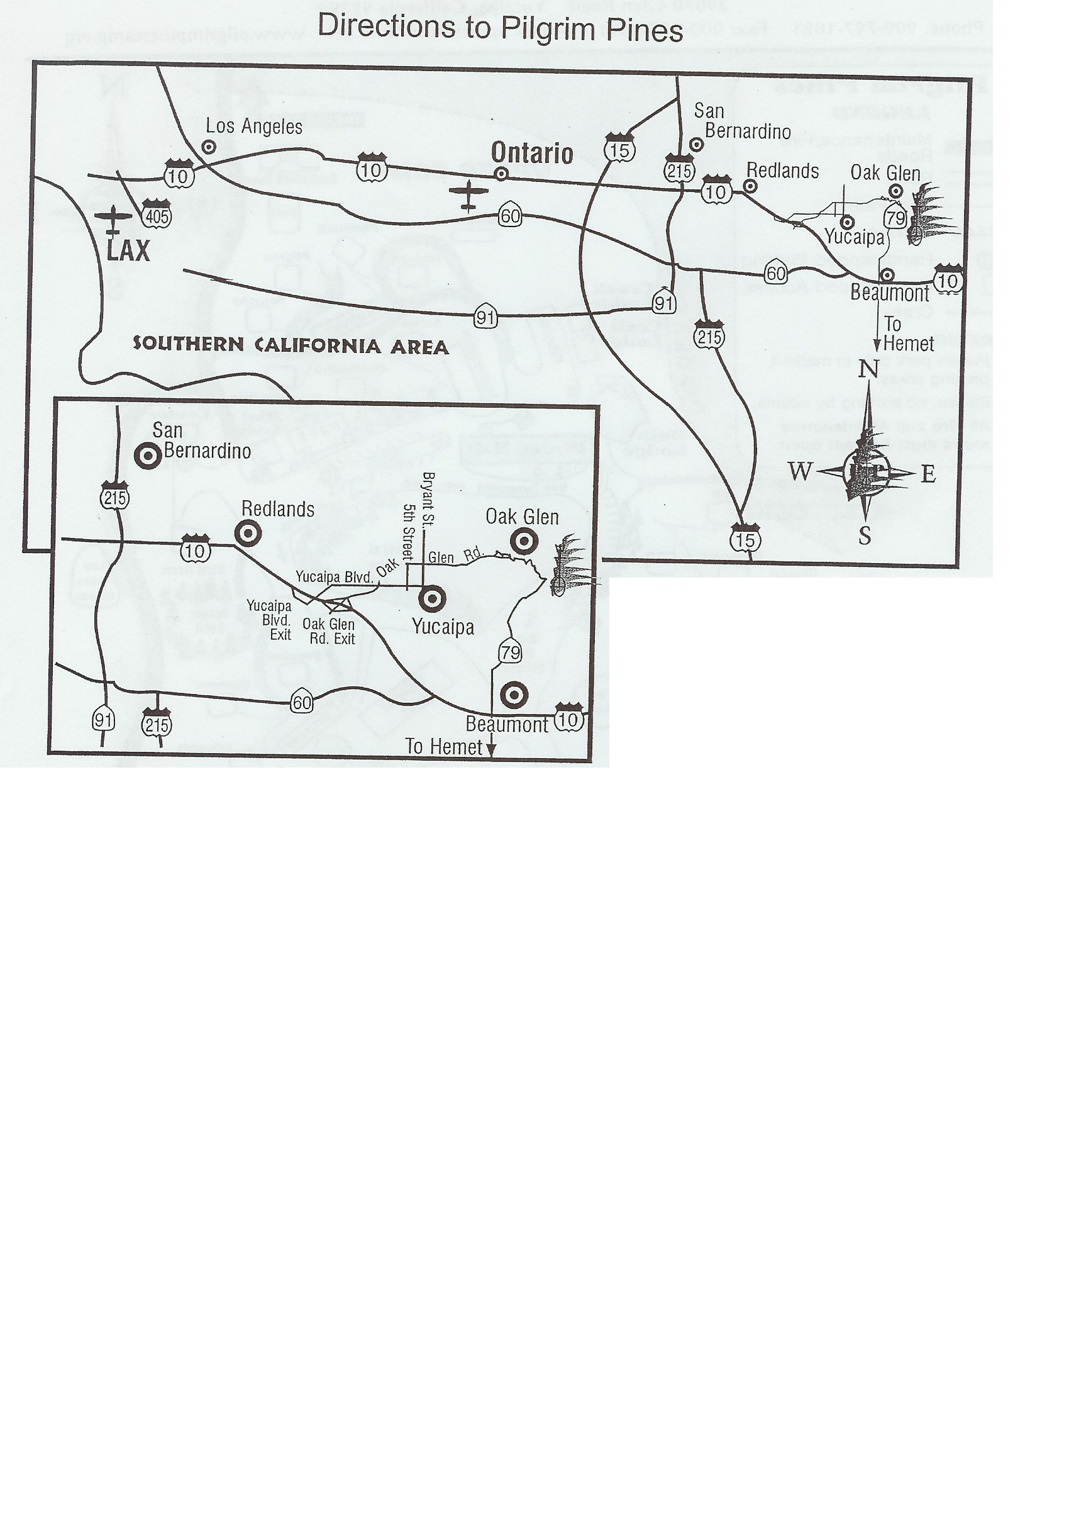

4-H Shooting Sports Workshop
Archery Discipline
Bakersfield, CA

Saturday, April 5, 2008 – 8:00 a.m. – 5:00 p.m.
Sunday, April 6, 2008 – 8:00 a.m. – 12:00 p.m.

A 4-H shooting sports workshop for the archery discipline will be held at the UC Cooperative Extension Office, 1031 S. Mt. Vernon Avenue in Bakersfield. Participants must attend both days of training to receive certification. Upon successful completion of the course, the participant will be certified as an archery volunteer and can lead an archery project at the club level or at summer camp. The cost for the course is $20 and includes Saturday lunch, snacks, and course materials. For more information contact Robert Claffy at 661-829-1658 or email: rclaffy656@aol.com

4-H Shooting Sports Workshop
Muzzle Loading Discipline
Lake County, CA

Saturday - May 31, 2008/8:00 a.m. – 6:00 p.m. &
Sunday – June 1, 2008/8:00 a.m. – 4:00 p.m.
Cost $25

A Muzzle Loading Trainer course will be held Saturday and Sunday, May 31 & June 1, 2008 in Lake County, CA. To receive certification you must attend both days. Upon successful completion of the course the participants will be certified as Muzzle Loading Trainers and will be able to conduct leader trainings as well as lead club projects. Cost for the course is $25 and includes meals and class materials. Breakfast and lunch will be provided both days. You must be an appointed 4-H leader to attend. Teen Leaders are encouraged to attend, with an adult, at no cost. Though Teen Leaders can not lead a project, they will benefit from the experience and training regarding the shooting sports project. Please send the Application for Certification (found at http://ca4h.org/projresource/shoootingsports/index.asp) and fees payable to “Lake County 4-H Council” to UCCE Lake County, 883 Lakeport Blvd., Lakeport, CA 95453. For more registration information contact Julie Frazell at (707) 263-6838 ex. 119 or jfrazell@ucdavis.edu. If you have questions about the course, contact the instructor, John Borba at jaborba@ucdavis.edu or call (661) 868-6216.

Cultural Arts
Shannon Palmer Monte Vista Blue
James Palmer Monte Vista Blue
Andrew Viloria Monte Vista Blue
Allison Eggleson Monte Vista Gold
Megan Chiatovich Bloomington Gold
Jacob Badal Monte Vista Gold
Kathleen Carden Heritage Grove Gold
Amanda Chiatovich Bloomington County Winner
Fashion Revue
Purchased Outfit
Junior
Allison Eggleston Monte Vista County Winner
Intermediate
Janet Champlin Rockin Rebels County Winner
Traditional Outfit
Junior
Allison Eggleston Monte Vista County Winner
Senior
Tory Grainger Rockin Rebels County Winner
Expressive Arts
Primary Participants
Sophia Frye East Valley
Kevin Mackesy Snowline
Murat Coe Snowline
Esther Coe Snowline
Junior
Tom Frye East Valley Medalist
Autumn Jacobo Grand Terrace County Winner
Intermediate
Erin Mackesy Snowline Medalist
Wes Chamberlain Snowline County Winner
Senior
Henry Frye East Valley Medalist
Savanna Barnett East Valley Medalist
Brian Evans Monte Vista County Winner

High Desert Magic

The High Desert Magic club serves the Apple Valley area of the high desert with club leader Debbie McGee. The High Desert Magic club has approximately 37 members and 10 leaders. Their main projects are Dog Care and Training, Therapeutic Animals, Shooting Sports, Horse & Pony, Swine, Beef Cattle, Citizenship, Community Service, Poultry, Computers, Sheep and Leadership. As you can see – this is one busy club. You can find members of this club sharing their dogs with young children in a therapeutic reading program. This club also wins the POP TOP award (if there was such an award) for collecting the most pop tops around. Tyler McGee of the High Desert Magic would like to thank all of the great leaders in his club for all their hard work! Good job High Desert Magic and keep up the good work!

Ft. Irwin Field Day

We are putting on a Field Day for the 4-H members at Ft. Irwin. It will be a smaller version of our County Field Day having speeches, demos, Fashion Revue and expressive arts. It will be held on Wednesday, April 30th. We are looking for anyone who can come and help us with this event. Since it is during the day we are hoping that there are some youth out there that can afford to take a day off school or are home schooled or may be off track. This would be a great citizenship or community service for your record book. We can reimburse for gas. Please contact Cheryl at (909)387-2179 if you can help.

2008 Statewide 4-H Scholarships
Deadline: Applications must be postmarked by April 30, 2008, and sent to the California State 4-H Office. All required information must be included with the application to be considered. The California State 4-H Office will notify recipients by June 1, 2008. Checks will be sent by August 1, 2008.
Questions: Contact Steven Worker at smworker@ucdavis.edu or 530-754-8519
Eligibility: Candidates must be high school seniors or high school graduates between the ages of 16 and 25 as of April 30, 2008, who were in the California 4-H Youth Development Program at the time of their high school graduation. Applicants must be full-time students as defined by the applicant's institution. The Scholarships include the Dean Memorial Legacy Scholarship, Mabel W. Jacks Scholarship, ASFMRA Scholarship, Frank Woods Memorial Scholarship, and the David Steele Memorial Scholarship.
The application forms can be found on the State website at: http://www.ca4h.org/4hresource/ir/scholarship/index.asp

2008 County Scholarships
A packet containing all of the scholarships and applications has been sent out to all of the graduating seniors and each community leader. If you did not receive a packet or would like additional information please contact the 4-H office.



Senior
Henry Frye East Valley Red
Brittany Haynes A.V. Rattlers Gold
Brittany Kelly Monte Vista Gold
Team Presentations
Intermediate
Mckenna Chamberlain & Erin Mackesy Snowline Blue
Senior
Megan Ralph & Stephanie Keith A.V. Rattlers Blue
Impromptu Speech
Primary Participants
Murat Coe Snowline
Ester Coe Snowline
Intermediate
Jacob Badal Monte Vista
Pamela McGill Bloomington Red
San Frye East Valley Red
Trevor Van Dissel Bloomington Red
Samantha Hays A.V. Rattlers Blue
Megan Chiatovich Bloomington Gold
Danielle Johnson Bloomington Gold
Kathleen O'Connell Monte Vista Gold
Alex Aldrich Monte Vista Gold
Senior
Britany Kelly Monte Vista Red
Henry Frye East Valley Blue
Cody McKee H.D. Magic Gold
Amanda Chiatovich Bloomington Gold
Extemporaneous
Senior
Amanda Chiatovich Bloomington Blue
Sarah Wilson H.D. Challengers Blue
Audio-Visual Presentation
Senior
Brittany Haynes A.V. Rattlers Blue
Illustrated Talk
John Kane Monte Vista Blue
Share the Fun
Monte Vista Club Blue

San Bernardino County Field Day Results
Educational Displays
Primary Participants
Tiffany Marino Monte Vista
Kevin Mackesy Snowline
Junior
John Mackesy Snowline Gold
Allison Eggleston Monte Vista Gold
Intermediate
Madison Ferguson A.V. Rattlers Blue
Sam Frye East Valley Blue
Amber Meek Monte Vista Blue
Erin Mackesey Snowline Gold
Alex Aldrich Monte Vista Gold
Trevor Van Dissel Bloomington Gold
Stephanie Keith Bloomington Gold
Senior
Henry Frye East Valley Blue
Megan Ralph A.V. Rattlers Blue
Jared Gillespie A.V. Rattlers Blue
Andrew Viloria A.V. Rattlers Blue
Jenny Hilak Monte Vista Gold
Ashley Trammel East Valley Gold
Brittany Haynes A.V. Rattlers Gold
Individual Presentations
Primary Participants
Jared Badal Monte Vista
Murat Coe Snowline
Ester Coe Snowline
Junior
James Palmer Monte Vista Gold
Intermediate
Trevor Van Dissel Bloomington Blue
Janet Champlin Rockin Rebels Blue
Sam Frye East Valley Blue
John Kane Monte Vista Blue
Jacob Badal Monte Vista Gold
Shannon Palmer Monte Vista Gold
Kathleen O'Connell Monte Vista Gold
Alex Aldrich Monte Vista Gold



No club news was reported.



April 2008
Sun | Mon | Tue | Wed | Thu | Fri | Sat
 |  | 1 | 2 | 3 | 4 | 5 State Equine Educational Event
6 | 7 | 8 All Star Orientation 6:00 P.M.  Calendaring Mtg | 9 | 10 | 11 | 12 South Section Teen Council Meeting
13 | 14 | 15 | 16 | 17 | 18 | 19
20 | 21 | 22 | 23 | 24 | 25 | 26 State Leader's Council Meeting
27 | 28 | 29 | 30 Ft. Irwin Field Day
South Section Leaders Retreat

May 2008
Sun | Mon | Tue | Wed | Thu | Fri | Sat
 |  |  |  | 1 | 2 | 3 Horse Mastership
4 | 5 | 6 | 7 | 8 | 9 | 10
11 | 12 | 13 | 14 | 15 | 16 | 17 Sectional Field Day
18 | 19 | 20 County Council Elections Mtg  All-Star Applications Due | 21 | 22 | 23 | 24
25 | 26 Memorial Day | 27 | 28 | 29 | 30 | 31 State 4-H Field Day  San Bernardino County Leaders Retreat
SBC Fair
-----------------------San Bernardino County Fair--------------------
SBC
Fair

