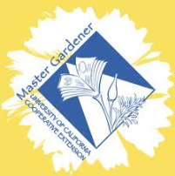
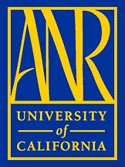
Do you Have What it Takes to Become
A University of California
Master Gardener?
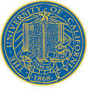
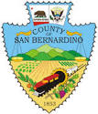
If you answer ‘Yes’ to the following questions,
we want to hear from you!

- Do you want to help ‘green your High Desert community in
a sustainable, responsible way?

- Do you have two hours of time per week from January – May, 2015 to read the 2nd edition of the UCCE Master Gardener handbook (hardcopy or e-book!) and take chapter quizzes online (on your own time)?

- Can you attend two Saturday training sessions in the Victorville area (3 hours each: dates TBA based trainees availability)?

- Do you have 50 hours of time to volunteer in 2015? (Opportunities include answering email and phone helpline calls; teaching workshops stressing sustainable landscaping, food production, and therapeutic horticulture; distributing information at public service events; and/or promoting UCCE through written, website, and social media.)
Download an application at http://cesanbernardino.ucanr.edu
(application deadline Nov. 30, 2014)

Questions? Contact Dona at: djenkins@ucanr.edu Ph: 951.750.0943

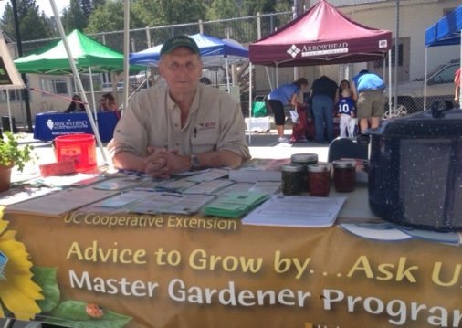
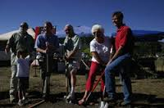
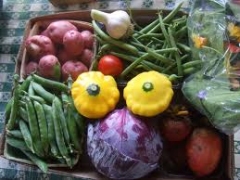
The University of California prohibits discrimination or harassment of any person in any of its programs or activities. (Complete nondiscrimination policy statement can be found at http://ucanr.org/sites/anrstaff/files/107734.doc) Inquiries regarding the University’s equal employment opportunity policies may be directed to Linda Marie Manton, Affirmative Action Contact, University of California, Davis, Agriculture and Natural Resources, 2801 The University of California prohibits discrimination or harassment of any person in any of its programs or activities. (Complete nondiscrimination policy statement can be found at http://ucanr.org/sites/anrstaff/files/107734.doc

